بسم الله الرحمن الرحيم



Computer System Engineering Department
ENCS 211
Digital Lab
Report for Experiment No. 1
Combinational Logic Circuits
- Students Name & ID: Laith Samara, 1080758

- Instructor: Dr. Iyad Tumar.
- Date: 31.8.2010.
- Section: (4).

Procedure:
Part 1: NOR Gate.
- We set the KL-26001 Module on the KL-22001 Basic Electricity circuit Lab.
- We Locate Block C on the KL-26001 Module.
- We apply + 5V DC from the fixed power supply on KL-22001 lab to the KL-26001 Module.
- We connect inputs A3; A4 on U2 gate to Data switches SW0, SW1, and the output F2 to the logic Indicator L1.
- We set SW0 to “0” and observe states of F2 at SW0 =”0”, SW1 = “1”, logically as shown in fig.1a.

(a)KL-26001 Block.

(b) Fig. (1)

The Results are:
- When SW1="0", F2= _______1________.
- When SW1="1", F2= _______0________.
We conclude from our observation, that NOR gate can be used as NOT gate, if we connect the circuit of fig.21; since (A3+A4) ' =A3', when A4=0.

Then, we complete the connections by referring to the wiring diagram in Fig.1 (a) and the circuit in Fig.1 (b). This is done by connecting A3 and A4 together (A3=A4), and connect A3 to Data Switch SWO and the output F2 to Logic Indicator L1.

Fig.2 (a) Wiring Diagram (KL-26001 block c).

Fig.2 (b) NOT Gate Using NOR Gate.
The results obtained are:
- When SW0="0", F2=______1_______.
- When SW0="1", F2=_______0______.
We conclude from our observation, that NOR gate can be used as NOT gate, if we connect the circuit of fig.2b; since (A3+A4) ' = (A3+A3)'=A3', when A4=A3.

After that, we complete the connections by referring to the wiring diagram in Fig.3 (a) and the circuit in Fig.3 (b). Connect A3 to Data Switch SW0 and the output F4 to Logic Indicator L1.

Fig.3 (a) Wiring Diagram (KL-26001, Block C)

Fig.3 (b) Buffer Using NOR Gate.

The result Obtained are:

- When SW0= "0", F4 =_______0______.
- When SW0= "1", F4 =_______1______.
We conclude from our observation, that NOR gate can be used as Buffer, if we connect the circuit of fig.3 (b);
Since ((A3+A4) ' + (A3+A4) ') '= ((A3+A3) ' + (A3+A3) ') '= ((A3+A3) ')'= A3, when A4=A3.

Then, we complete the connections by referring to the wiring diagram in Fig.4 (a) and the circuit in Fig.4 (b). And connect inputs A3 to SW0, A4 to SW1; and output F4 to Logic Indicator L1, then, follow the sequences of input A3 & A4 as in table.1, then complete it.

Fig.4 (a) Wiring Diagram (KL-26001), Block C.

Fig.4 (b) Buffer With 2-input using NOR Gate.
SWO(A3) | SW1 (A4) | F4
0 | 0 | 0
0 | 1 | 1
1 | 0 | 1
1 | 1 | 1
Table (1).

Part Two: Nand Gate circuit.
- We set the (KL-26001) module on (KL-22001) basic electricity circuit lab.
- We locate Block (B) on (KL-26001) module, and inserted bridging plug shown in fig. (5).
- We applied +5VDC form the fixed power on the (KL-22001) basic electricity circuit lab to (KL-26001) module.

Fig.5 (a) wiring diagram (KL-26001, block b).

Fig.5 (b) NAND Gate.
Then we Connected input A to Data switch SW1 and output F2 to Logic Indicator
L1. We Observed and recorded the output states.
When SW1 ="0", F2 = ______1_______.
When SW1 ="1", F2 = _______0______.
From the previous results we note that when we connect both inputs of the nand gate as one input, it works as a not gate, since (AB)' at A=b, is equivalent to (AA)' = A’, and that is shown at the gate on the left of fig.5 (b).
After that, we removed the bridging plug between A and A1, and connected input A1 to +5v (“1”), the other connections were unchanged, we observed and recorded the output states:
When SW1 ="0", F2 = ______1_______.
When SW1 ="1", F2 = _______0______.
The previous results shows that when we let one of the inputs of the nand gate to be “1” , nand gate works as a not gate , since (A. 1)' = A', the figure that represent that is in the right of fig.5(b).
We completed the connections as shown in Fig. (6) And Connected A to SW1, A1 to SW2 and F4 to L1.

Fig.6 (a) wiring diagram (KL-26001, block b)

Fig.6 (b) AND Gate using 2-NAND Gate.

We note from the results above that a combination of two nand gates let it to work as an AND gate, since (1) (AB)' = A' + B',
(2) ((A' + B'). (A' + B')) '= (A' + B')' + (A' + B')' = (AB) + (AB) = (AB). (According to De Morgan’s low), the diagram of fig.6 (b) shows that.

We followed the input sequences and recorded the outputs in Table. (2).

SW2(A1) | SW1(A) | F4
0 | 0 | 0
0 | 1 | 0
1 | 0 | 0
1 | 1 | 1
Table. (2)

We Completed the connections by referring to the wiring diagram in Fig.7 (a) and the circuit in Fig.7 (b) and Connect A to SW1; D to SW2, and F4 to L1.

Fig.7 (a) Wiring diagram(KL-26001, block b)

Fig.7 (b) OR Gate using 3-NAND Gate.
We note from the results above that a combination of three nand gates let it to work as an OR gate, since (1) (AA)' = A’, (2) (BB)' = B', (3) (A'B') ‘= A+B (De Morgan’s law), the diagram of Fig.7 (b) shows that.
We followed the input sequences and recorded the outputs in Table. (3)

SW2(A1) | SW1(A) | F4
0 | 0 | 0
0 | 1 | 1
1 | 0 | 1
1 | 1 | 1
Table. (3)

Part Three: XOR Gate Circuit.
- We set the (KL-26001) module on the (KL-22001) logical electricity lab circuit.
- We locate block b, and then complete connections by referring to the wiring diagram in fig.(8).
- We connect inputs A to SW0, D to SW1, outputs F1 to L1, F2 to L2, F3 to L3, F4 to L4.
- We apply +5VDC from the fixed power on the (KL-22001) logical electricity lab circuit to (KL-26001) module.

Fig.8 (a) wiring diagram (KL-26001, block b).

Fig.8 (b) Equivalent Circuit XOR-Gate using 4-Nand Gates.
After following the input of sequences for A and D in Table.(4) and record the outputs.

SW2(D) | SW1(A) | F1 F2 F3 F4
0 | 0 | 1 1 1 0
0 | 1 | 1 1 0 1
1 | 0 | 1 0 1 1
1 | 1 | 0 1 1 0
Table. (4)
The truth table.4 shows that XOR gate can be implemented by four NAND gates, if we use fig.8 (b) to show that:
(AD) ' = A' + D' = F1, (A.F1)' = (A. (A'+ D'))' = A' + AD = F2.
(D. (A' + D'))' = D' + AD = F3.
((A' + AD) (D' + AD))' = ((AD) '. D) + (A. (AD)')
= (A' + D') .D +A. (A' + D') = A'D + D'D + AA' +AD'
= A'D + AD' (which represents xor gate).
- We set the (KL-26001) Module on the (KL-22001) Basic Electricity Circuit Lab.
- We locate block a. Complete the connections by referring to the wiring diagram in Fig.9 (a).
- We Apply +5VDC from the Fixed Power on (KL-22001) Basic Electricity Circuit Lab to (KL-26001) Module and we connected inputs A, B to SW1, SW2; outputs F1, F2 & F3 to L1, L2 & L3.

Fig.9 (a) Wiring diagram (KL-26001 block a)

Fig.9 (b) Equivalent circuit, XOR-Gate using AND, Inverter, OR Gates
We observed that we can get XOR gate by the basic gates; since in fig.9 (b), (AB') =F1, (A'B) =F2, F1 + F2 = A'B + AB' = Xor (A, B).
We Followed the input sequences for A and B in Table.(5), and record the outputs.

SW2(B) | SW1(A) | F1 F2 F3
0 | 0 | 1 1 0
0 | 1 | 0 1 1
1 | 0 | 1 1 0
1 | 1 | 0 1 1
Table.(5)
Part Four: AOI Gate Circuit.
- We set (KL-26001) module on (KL-22001) Basic electricity circuit lab.
- We locate block (a), as shown in fig.9 (a) & (b).
- We connect inputs A, A1, B, B1 to data switches SW0, SW1, SW2, SW3, respectively and outputs F3, F4 to logic indicator L1 and L2.
- We apply +5VDC from the fixed power on (KL-22001) lab to (KL-26001) module.
- Then we set B.B’ to”0”, and then follow the input sequence for A, and, A1 then, record outputs in Table (6).

Fig.10 (a) Wiring diagram (KL-26001 block a)

Fig.10 (b) Equivalent circuit.

Fig.10 (c) Actual circuit.

We note that F3 works as AND gate between A1 & A when B.B1=0; since F3= ((AA1)’. (BB1)')'= ((AA1)’.1)'= AA1. Also, F4=F3' When BB1≠0 ➔F3≠ AA1; since F3= ((AA1)’. 0)'= (0)'= 1. When A-A1=0

A1 | A | F3 | F4
0 | 0 | 0 | 1
0 | 1 | 0 | 1
1 | 0 | 0 | 1
1 | 1 | 1 | 0
Table (6).
After following the input sequences for B and B1 in Table. (7), and Record the outputs. We note that F3 works as AND gate between B1 & B when A.A1=0; since F3= ((AA1)’. (BB1)')' = ((BB1)’.1)'= BB1. Also, F4=F3'.When AA1≠0 ➔F3≠ BB1; since F3= ((BB1)’. 0)'= (0)'= 1.➔ F3= ((AA1)’. (BB1)')'= ((AA1)')' + ((BB1)')'= AA1+BB1.

B1 | B | F3 | F4
0 | 0 | 0 | 1
0 | 1 | 0 | 1
1 | 0 | 0 | 1
1 | 1 | 1 | 0
Table. (7)

Part Five: Logic Problem & Design.

A given logic system is shown in Fig. 1-5-1; output of the system F is in”1”state in each of the following condition:
Fig. (1-5-1)
- C and D are in the “1” state.
- A, B and D are in the “1” state, C is in "0" state.
- B and D are in the "1" state, A and C are in "0" state.
- C and B are in the “1” state, A and D are in “0” state.
- C is in the “1” state, A, B and D are in the “0” state.

- Complete the truth table of the above logic system. Table.(8) shows the truth table of the above function.

A | B | C | D | F
0 | 0 | 0 | 0 | 0 (m0)
0 | 0 | 0 | 1 | 0 (m1)
0 | 0 | 1 | 0 | 1 (m2)
0 | 0 | 1 | 1 | 1 (m3)
0 | 1 | 0 | 0 | 0 (m4)
0 | 1 | 0 | 1 | 1 (m5)
0 | 1 | 1 | 0 | 1 (m6)
0 | 1 | 1 | 1 | 1 (m7)
1 | 0 | 0 | 0 | 0 (m8)
1 | 0 | 0 | 1 | 0 (m9)
1 | 0 | 1 | 0 | 0 (m10)
1 | 0 | 1 | 1 | 1 (m11)
1 | 1 | 0 | 0 | 0 (m12)
1 | 1 | 0 | 1 | 1 (m13)
1 | 1 | 1 | 0 | 0 (m14)
1 | 1 | 1 | 1 | 1 (m15)
Table. (8)

- Write the Boolean equation as canonical sum.

F (A, B, C, D) = ∑ (2, 3, 5, 6, 7, 11, 13, 15)

=A'B'CD'+ A'B'CD+ A'BC'D+ A'BCD'+ A'BCD+ AB'CD+ ABC'D+ ABCD.
- Minimize the expression that you obtained using laws of Boolean algebra. Write down reduced equation.

F = A'B'CD'+ A'B'CD+ A'BC'D+ A'BCD'+ A'BCD+ AB'CD+ ABC'D+ ABCD

= A'B'C (D+ D') + A'BC (D+D') + BC'D (A+A') + ACD (B+B')

= A'C + ACD + BC'D

- Draw the k-map of logic problem and indicate columns and rows circle the sub-cubes and write down the equation that you obtained is the equation identical to the one that you obtained in paragraph 3.
0 | 0 | 1 | 1
0 | 1 | 1 | 1
0 | 1 | 1 | 0
0 | 0 | 1 | 0
K-map.
F (A, B, C, D) = A'C+ CD+ BD.
The two functions in 2 & 3 are different, but they give the same outputs for F.

Questions:
- Draw the logic diagram showing the implementation of the following Boolean equation using “AND” gates F = AB (CA)
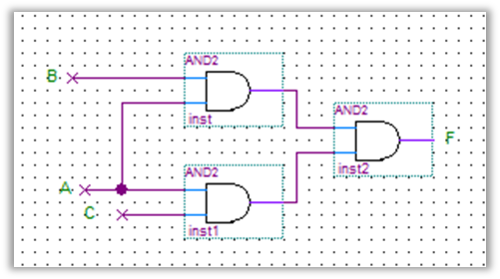

Fig.(13)

- Draw the logic diagram of the following Boolean equations:
- F1= (A+B) (CD+A).
- F2= (ABC+D) C.

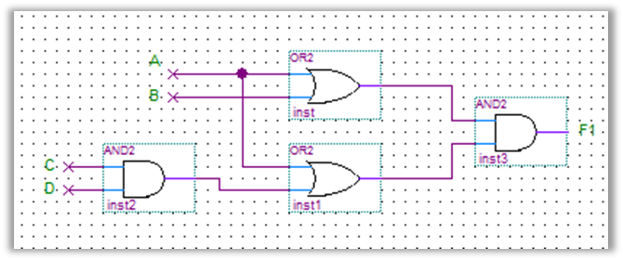
Fig.(14)
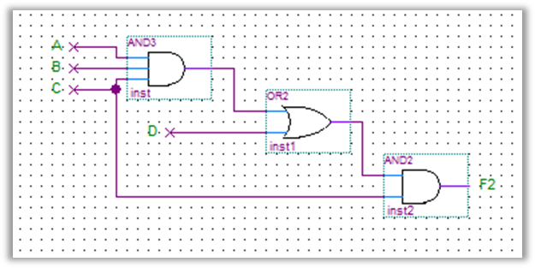
Fig.(15)
- Implement the OR operation using AND, NOT gate.
F=A+B = ((A+B)’)' = (A’.B’)’.

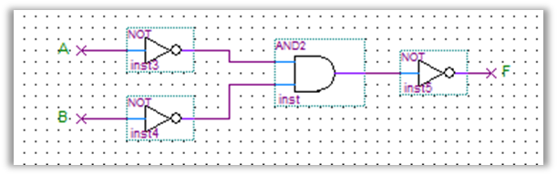
Fig.(16)

- Implement the AND gate using OR, NOT gate. Draw the logic diagram used in both cases and write Boolean equation. F= A.B = ( (A.B)' )' = ( A'+B')' .
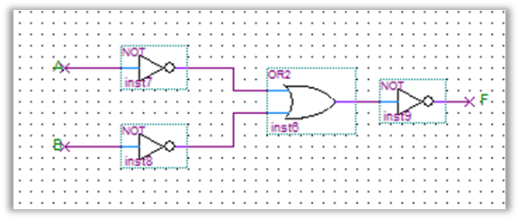
Fig.(17)
- Prove that the equality operation F l =AB+A’B’ is the inverse of exclusive OR operation F2=AB’+A’B (use De Morgan’s theorem).

F₂'= (A’B+ AB’)'= (A'B)'. (AB')' = (A+B'). (A’+B)
=AA'+AB+A'B'+BB'
= AB + A'B' = F1.
- Suggest a logic diagram which will give a NAND gate with four inputs using two input NAND gates, Implement suggested network.
F = (ABCD)' = (AB)' + (CD)' = (( (AB)' + (CD)’)’)'= (((AB)')’. ((CD)')’)'

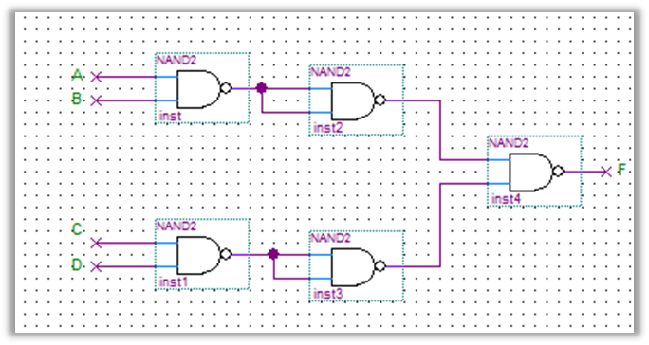
Fig.(18)
- Show how is it possible to reduce Boolean expressions by means of k_map.
Implement the minimal expressions using NAND gates.
- F1 = A'BCD + ABCD' + A'BCD' + ABCD'.
=m7+ m14+ m6+ m14 = ∑(6, 7, 14).

0 | 0 | 0 | 0
0 | 0 | 1 | 1
0 | 0 | 0 | 1
0 | 0 | 0 | 0
K-map.
F1=A'BC+ BCD'.

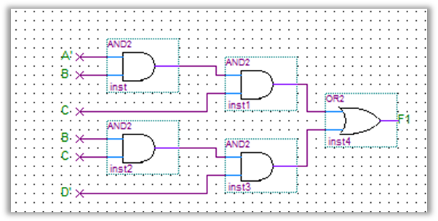 (a)
➔Using NAND Gates:
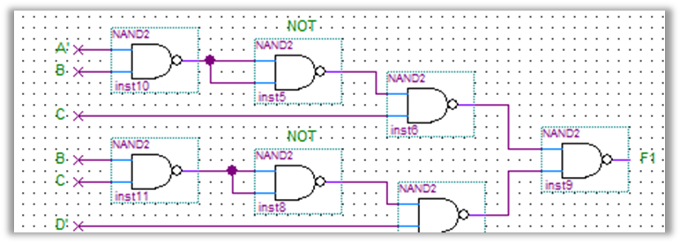
(b)

Fig.(19)

- F2 = A'B'C'D' + AB'CD' + A'B'CD' + A'BC'D'.
=m0+ m10+ m2+ m4= ∑(0, 2, 4, 10).

1 | 0 | 0 | 1
1 | 0 | 0 | 0
0 | 0 | 0 | 0
0 | 0 | 0 | 1
K-map

F2= A'C'D'+ B'CD.

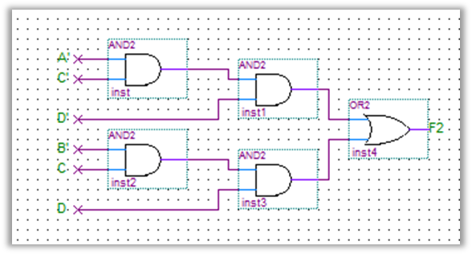
(a)

➔Using NAND Gates:

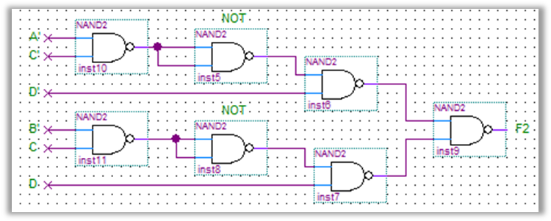 (b)
Fig.(20)

