بسم الله الرحمن الرحيم


Faculty of Information Technology
Computer System Engineering Department
ENCS 211
DIGITAL ELECTRONICS AND COMPUTER ORGANIZATION LAB
Report of Experiment No. 5
Sequential Logic Circuit
Student Names and IDs: Laith Samara 1080758. ---- Ahmad Mafarjah 1080429.
Instructor Name: Dr. Iyad Tumar.
Teacher Assistant: Eng. Anas Abd-elrazeq.
Date: 21.9.2010.
Section: 4.

- Procedure:
In some circuits we need to save or use previous result , in such circuits we use type of circuit called sequential circuit , these circuits contain from combination circuit & memory element , the output in these circuit depends on the input and previous result.
5.5.1 Latches and Flip flops:
RS-Latches:
Circuits its timing to change the output not controlled, to solve these problems we using controlling input which allows changing in the output only if its value is 1.
Constructing RS latch with Basic Logic Gates
We use KL-26006 module to implement the circuit of Fig.1.Then, we connect switches to S and R inputs, and connect Q and Q’ output to logic indicator. And follow the sequence of inputs (S & R), and fill Table.1.
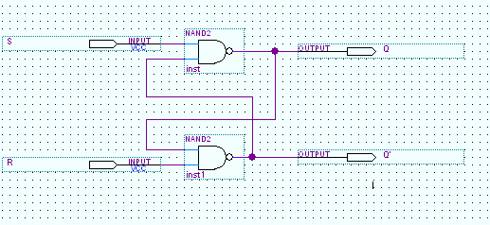
Fig₁ (RS-Latches)

S | R | Q | Q' | State
0 | 0 | 1 | 1 | Indeterminate
0 | 1 | 1 | 0 | Set q
1 | 0 | 0 | 1 | Reset q
1 | 1 | 0 | 1 | No change (q)
Table ₁
We note that, this circuit works in the active low mode (input) since there is no clock rate for synchronization, and the outputs has four states: no change State QQ'=01 when SR=11, and Set state QQ'=10 when SR=01, and Reset state QQ'=01 when SR=10, and indeterminate state QQ'=11 when SR=00.
Constructing RS latch with control input.
We use KL-26006 module to connect the circuit shown in fig.2, by connecting CK2 (control input) to logic 1 (+5V), and S & R to data switches. And follow the input sequence in Table.2.
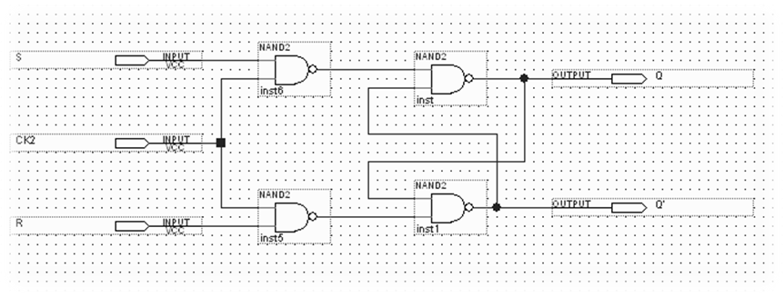
Fig.₂ (RS-Latches with control input)

S | R | Q | Q' | State
0 | 0 | 0 | 1 | No change (Q)
0 | 1 | 0 | 1 | Reset Q
1 | 0 | 1 | 0 | Set Q
1 | 1 | 1 | 1 | Indeterminate
Table.₂
As we noticed from the truth table, the circuit in figure.₂ works as the one in part (A) but with active law mode input.
D-Latches:
Circuits its output value is the same as the input value and change at the clock level, it built by developed the RS Latch.
C. Constructing D latch with RS latch.
We use KL-26006 module to connect the circuit shown in fig.3, by connecting CK2 (control input) to Pulse switch and D to data switch. And follow the input sequence in Table.3.
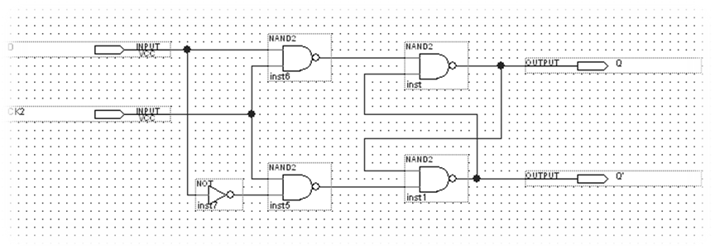
Fig.₃ ₍D-Latches with RS-Latches)

CK2 | D | Q | Q' | State
0 | 0 | 0 | 1 | No Change
0 | 1 | 0 | 1 | No Change
 | 0 | 0 | 1 | Q= D  Q'= D'
 | 1 | 1 | 0 | Q= D  Q'= D'
Table.₃
As we can see from Table.3 the value of Q =D only when we provide a pulse for the Clock Pulser; otherwise Q maintain its previous value.
Constructing JK latch with RS latch
We use KL-26006 module to connect the circuit of fig.4, by connecting CK2 to Pulse switch and J & K to switches s1 & s0, and Q, Q' to logic indicators. And follow the input sequence of Table.4.
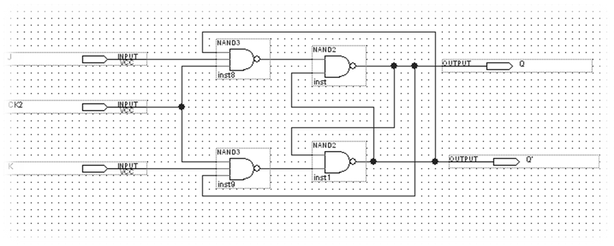
Fig.₄ (JK-Latch with RS-Latch)

CK2 | J | K | Q | Q' | State
 | 0 | 0 | 0 | 1 | No change (Q)
 | 0 | 1 | 0 | 1 | Reset Q
 | 1 | 0 | 1 | 0 | Set Q
 | 1 | 1 | 0 | 1 | Complement(Q)
Table.₄
This type of latch (JK) works as SR latch in No change state JK = 00, Reset state JK = 01 & Set state JK = 10. But at state JK = 11 it complements the previous value of Q & so Q'. As shown in Table.4.
Flip Flops:
Memory element that storage binary information; it built using two Latches connecting together. There are three types of flip-flops: (D flip-flop, JK flip-flop, T flip-flop).
Constructing JK Flip-flop with master- slave RS latches:
We use KL-26006 module to connect the circuit of fig.5, by connecting CK1 to Pulser switch and J & K to data switches , and S, R, Q, Q' to logic indicators. And follow the input sequence of Table.5.
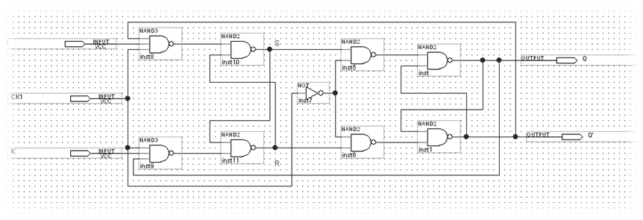
Fig.₅ (JK flip-flop with master-slave RS latches)

CK1 | J | K | S | R | Q | Q' | -> | S | R | Q | Q' | State
 | 0 | 0 | 1 | 0 | 1 | 0 | -> | 0 | 1 | 0 | 1 | No change
 | 0 | 1 | 0 | 1 | 0 | 1 | -> | 0 | 1 | 0 | 1 | Reset
 | 1 | 0 | 1 | 0 | 1 | 0 | -> | 1 | 0 | 1 | 0 | Set
 | 1 | 1 | 0 | 1 | 0 | 1 | -> | 0 | 1 | 0 | 1 | complement
 | 1 | 1 | 0 | 1 | 0 | 1 | -> | 0 | 1 | 0 | 1 | complement
Table.₅
The circuit of fig.5 is working as JK flip flop (works as JK latch, but it is synchronized), which constructed using master_ slave SR latch.
While we were working on the KL-26006 sequence Logic Circuit Experiment Module in the section of latches and flip-flops the result we were write down were the same and not changing with any state we asked our teacher assistant and he checks our connections and he told us that the connection were all correct and our work was true he told us to leave this section to the end of the lab and he change it for us and after that the experiment works probably true and the result was as shown in the table above.
5.5.2 Registers:
Sequential circuit that hold n-bit of information , it contains from n-flip flop , the change in the value can be in serial input that need many of clock or parallel load which need only to one clock.
Constructing Shift Register with D Flip-Flops
Use KL-26006 module (block a) to construct the circuit shown in fig.6 Connect A (serial input) to switch. Connect B (clear) to other switch. Connect the outputs F₁, F₂, F₃ and F₄ to indication lamps. Connect CK to Pulser Switch. Set B switch to 1 to clear the register, and then keep it on 0. Set A to 1, then, apply three clock pulses to CK using the Pulser.
Fig.₆ (Shift Register with D flip-flop).
After doing the last step, we note that the value on the output (F₁F₂F₃F₄=1110); since three clocks is applied to the shift right register. At First the value was F₁F₂F₃F₄=1000, thenF₁F₂F₃F₄=1100, then F₁F₂F₃F₄=1110, and to load 1011 value into the register we follow the sequence: 1, 1, 0 then 1. F₁F₂F₃F₄=1011.

5.5.3 Counters:
Sequential circuit that use to count from zero to specific number, it contain from many of flip flop depends on the limit of the number. There are two types of counter: synchronous all flip flop have the same clock, ripple in this kind there are delay on the output because the change don’t happen on the same time.
- 2-bit Synchronous Counter.
We use KL-26007 module, block c, which contains three separated JK flip flops to implement the 2-bit synchronous counter shown in fig.₇. Connect CLK input to Pulser switch. Connect counter outputs Q₁ and Q₀ to indication lamps. And Apply counter outputs Q₁ and Q₀ to D₁ display inputs. Apply clock pulses to CLK input. Observe and record the outputs in Table.6
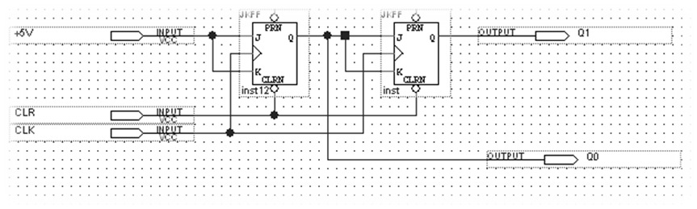
Fig.₇ (2-bit Synchronous Counter)
CLK | Q1 Q0 | D1
 | 0 0 | 0
 | 0 1 | 1
 | 1 0 | 2
 | 1 1 | 3
 | 0 0 | 0
 | 0 1 | 1
 | 1 0 | 2
 | 1 1 | 3
Table.6
We note that this counter counts from 0 to 3 and reset the counter to zero then start counting again; also the counter is synchronous; since the same clock is connected to all flip-flops. The next value is set to the counter only when a clock is applied.
- 3-bit (divide-by-eight) Ripple Counter:
Use KL-26007 module, block c, which contains three separated JK flip flops to implement the 3-bit (divide by eight) Ripple counter shown in Figure.₈. Connect CLK input to Pulser switch. Connect counter outputs Q₂, Q₁ and Q₀ to indication lamps. Apply clock pulses to CLK input. Then we Apply counter outputs Q₂, Q₁ and Q₀ to D₁ display inputs. Observe and record the outputs in Table.7
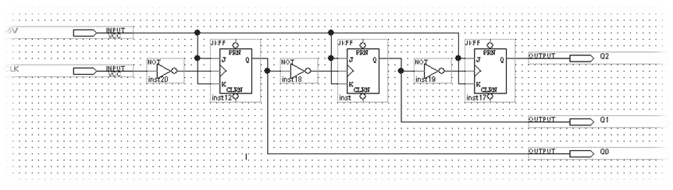
Fig.₈ (3-bit (divide-by-eight) Ripple Counter)
CLK | Q2 Q1 Q0 | D1
 | 0 0 0 | 0
 | 0 0 1 | 1
 | 0 1 0 | 2
 | 0 1 1 | 3
 | 1 0 0 | 4
 | 1 0 1 | 5
 | 1 1 0 | 6
 | 1 1 1 | 7
Table.7
We note that this counter counts from 0 to 7 then reset to zero then start counting again, also the counter is ripple; since not the same clock is connected to all flip flops. The next value is set to Q0 of the counter only when a clock is applied and other digits vary depending on the varying of previous digit.
- BCD Counter.
We locate BCD counter (IC 7490) on KL-26007 module, block b. Then, connect the circuit shown in Figure.10. Then, connect RO (1) and RO (2) (pins _{2 & 3}) to 0v, note that RO (1) and RO (2) are two inputs to internal NAND gate which used to reset the counter. Connect clock INPUT 1 (pin ₁₄) to Pulser switch or to the frequency switch. Connect the outputs A, B, C, and D to indication lamps or to the 7-segment display which is held on the KL-22001 module. Apply clock pulses to INPUT 1, and observe the count sequence (0000-1001). Apply counter outputs A, B, C, and D to D₁ display inputs. Apply clock pulses to INPUT 1. Observe the count sequence on the display. Connect the INPUT 1 to the output of the clock generator. Observe the count sequence on the display.
Fig.₉ (BCD-counter IC-7490)
The counter works perfectly and counts from 0000 to 1001 when a clock is provided.
D.Divide-by-8 counter using BCD chip counter.
Connect RO (2) (pin₃) to +5V, and connect RO (1) (pin₂) to QD (pin₁₁) output. This will make counter reset after 111 (or 7) before the value of D becomes 1 at the first time (DCBA=1000//8) the pin reset of the counter is 0 (active low), so the counter is reset DCBA=0000, then starts the count again. Then, we connect clock INPUT 1 (pin ₁₄) to Pulser switch. Connect the outputs A, B, C, and D to indication lamps. Apply clock pulses to INPUT 1, and observe the count sequence (0000-0111). Apply counter outputs A, B, C, and D to D₁ display inputs. Apply clock pulses to INPUT 1.

Conclusion:
In these experiments we learned a new kind of circuit which was the sequential circuit how it worked and many applications on it like counter and register. Also we learned the differences between the latch and flip flop and how we can built flip flop using latch. In addition we learned how register work and how can we built it, finally the differences between ripple and synchronous counter and the way that change from one type to another.

- TASKS:
- Task1:
- We make a shift left register using (IC7495 )by taking the output in reverse order of the shift left mode; since the mode is shift right with output instead of F₁F₂F₃F₄ (to logic indicators L₃L₂L₁L₀) take them F₄F₃F₂F₁ to logic indicators L₃L₂L₁L₀.
- We make shift left operation using parallel mode by connecting F₄F₃F₂F₁ to logic indicators L₃L₂L₁L₀, and connecting the inputs ABCD to F₂F₃F₄ & SI(serial input) and load any value using serial input pin.
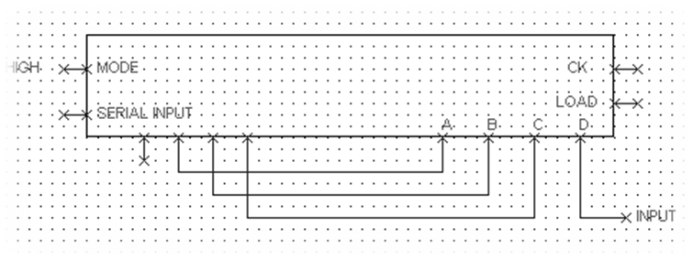
Fig.₁₀ (Serial Shift-Left)

- Task2:
In order to make a three bit synchronous counter, we make the design below.
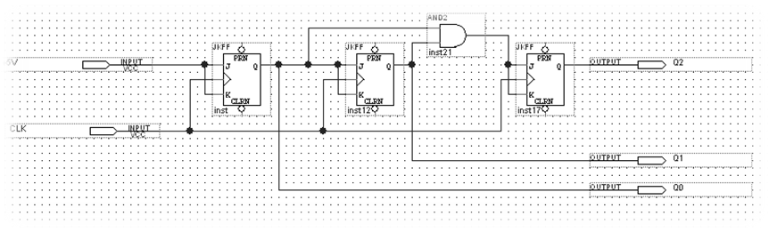
Fig.₁₁ (3-bit Synchronous counter)

- Task3:
- To make the BCD counter counts from 0000 to 0101, we reset the counter just before it becomes 6. We done that by connecting C & B pins to RO (1) & RO (2).
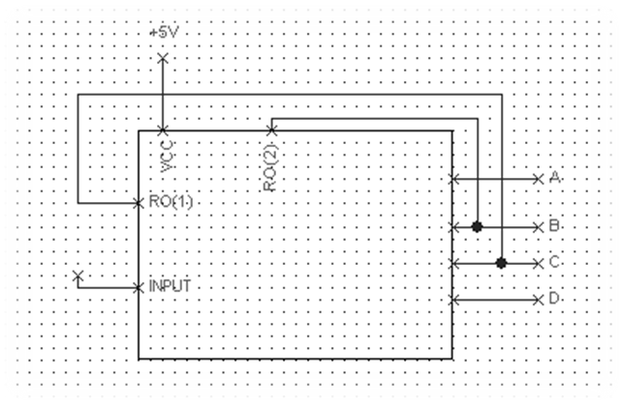
Fig.₁₂: (0-5 Counter)
In this part of the experiment the circuit was not work probably true at first we asked our teacher assistant and he check the connections and he told us that the connections are true and then he told us that the Display in on the KL-22001 module is faulty and after connect the outputs to the indicator lamp we conclude that the circuit works probably.

- To make the BCD counter counts from 0000 to 0100, we reset the counter just before it becomes 5. We done that by connecting C & A pins to RO (1) & RO (2).
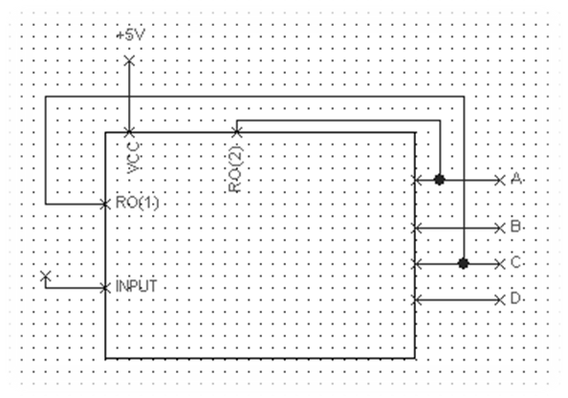
Fig.₁₃: (0-4 Counter)

- Discussion:
- Although latches are useful for storing binary information, they are rarely used in the sequential circuits design, why?
The latches are useful for storing information; since they are faster than flip flops (flip flops are master-slave latches), and there size also less than flip flop’s size and they consume less power. But they make many problems; they make the system asynchronous so increase the probability of glitches in the circuits that use them; since they are level triggering chips.

- What is the disadvantage of the RS flip flops?
The main disadvantages of SR latches is when S=R=1➔ in this state the latch make a set & reset to itself at the same time, so Q=Q'=1, and this is indeterminate state. So it is the responsibility of the designers to be ensure that S & R are not 1 at the same time

- What is the difference between “synchronous” and “ripple” counters?
- Ripple counter: the clock is not connected to all flip-flops➔there are no synchronization; since the output of flip-flop transition serves when the output of triggering flip-flop changes.
- Synchronous counter: there are common clock that connected to all flip-flops. All flip-flop’s output are adjusted only at the clock.
- References:
- Manual Lab of Birzeit University Experiment No.5.
- Morris Mano Digital Design 3rd Edition Chapter 5&6(p.167-271).
- Note: The graphs in the experiment we draw it using quartus program.

