بسم الله الرحمن الرحيم


Information Technology Faculty
Computer Systems Engineering Department
ENCS 211
DIGITAL ELECTRONICS AND COMPUTER ORGANIZATION LAB
Report for Experiment NO.10
Introduction to DEBUG Program

Students Names & IDs:

Laith Samara 1080758, Ahmad Mafarjah 1080429.

Instructor Name: Dr. Iyad Tumar.

Teacher Assistant: Eng. Anas Abd-elrazeq.

Date: 9-11-2010.
Section: 4.

- Part 1: Immediate Operands.
- Activity 1.1:
At the begging of the experiment we opened the COMMAND screen (CMD), and we activated the debug by wrote (DEBUG) on the console of CMD screen the, we typed (A100) in order to start writing on this location and then we wrote assembly code consist of the following instruction as shown in figure.₁.
MOV AX, 2864
ADD AX, 3749
MOV BX, AX
SUB BX, 2805
NOP
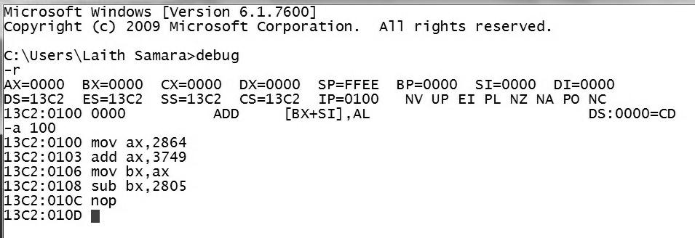
Fig.₁
- Activity 1.2:
Then we used the command U to unassembled the instructions and we get the machine code that is represented in table (1):
Assembly code | Machine code
MOV AX, 2864 | B8 64 28
ADD AX, 3749 | 05 49 37
MOV BX, AX | 89 C3
SUB BX, 2805 | 81 EB 05 28
NOP | 90
Table (1)
We notice that we get the machine code for each instruction as shown in figure.₂.

Activity 1.3:
By this command we also can get the number of bytes needed for each instruction, which is shown in table (2).
Assembly code | Machine code
MOV AX, 2864 | 3
ADD AX, 3749 | 3
MOV BX, AX | 2
SUB BX, 2805 | 4
NOP | 1
Table (2)
As we note the number of bytes is differ from one instruction to another.
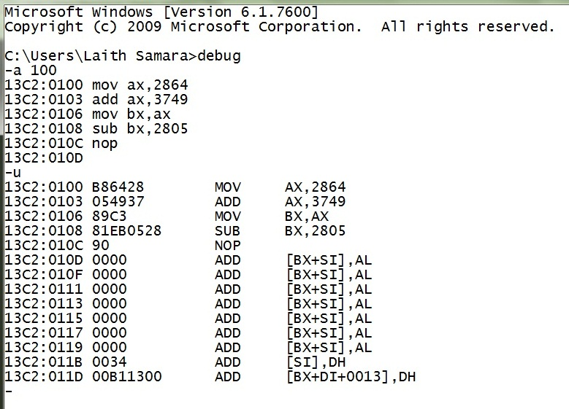
Fig.₂

- Activity (1.4):
The immediate data value (2864) stored in location 101H, by situate:
64 in location 101 H
28 in location 102 H
This result is dependent that the system is little Indian, so the lowest byte is put in the first location, and the highest one on the next one …
- Activity 1.5:
Then we used the command R, which we used to determine the contents of the registers as shown in table (3) below:
Register | Content
CS | 13C2
IP | 0100
AX | 0000
BX | 0000
Table (3)
We note from the results we get in the previous table, since we didn’t execute the instructions yet, the value of code segment represent the location of the code, the instruction pointer (IP) represent where we want to be the code segment which is location 100h that we wrote our instructions from, the other registers (AX, BX) have no initial values yet…
- Activity 1.6:
The predictions of the contents of CS, IP, AX and BX:
Register | MOV AX, 2864 | ADD AX, 3749 | MOV BX, AX | SUB BX, 2805
CS | 13C2 | 13C2 | 13C2 | 13C2
IP | 0103 | 0106 | 0108 | 010C
AX | 2864 | 5FAD | 5FAD | 5FAD
BX | 0000 | 0000 | 5FAD | 37A8
Table (4)
We note from the results above that the expected value of the instruction pointer is changing or increasing by the same number of bytes for each instruction as shown in table (2) , and also the expected values of AX , BX is changing according to the instructions will be executed .

- Activity 1.7:
After executing the instructions by command T, the real contents of CS, IP, AX and BX are as follows:
Register | MOV AX, 2864 | ADD AX, 3749 | MOV BX, AX | SUB BX, 2805
CS | 13C2 | 13C2 | 13C2 | 13C2
IP | 0103 | 0106 | 0108 | 010C
AX | 2864 | 5FAD | 5FAD | 5FAD
BX | 0000 | 0000 | 5FAD | 37A8
Table (5)
We note that the real is identical to the predict values, to the reasons we mentioned in the last activity …
- Activity 1.8:
The content of IP changes after each instruction is executed so that it points to the next instruction to be executed; the amount of change in the IP indicates how many bytes the instruction took to be represented in machine code as shown in figure.₃.
- Activity 1.9:
The offset address of the second MOV instruction is 106 H.
Its logical address = 13C2: 0106.
Its physical address = 13C2 * A H + 0106 H = C69A H
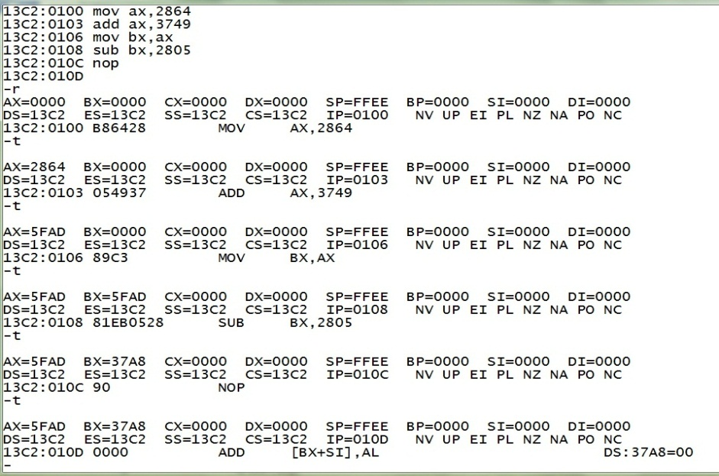
Fig.₃

Part 2: Memory addressing.
- Activity 2.1:
We enter the following data at the offset memory location 200h using DEBUG command E.
E DS: 200 1B 9F
E DS: 202 36 4A 00 00
E DS: 206 2A 2A 2A
But here while we were inserted 2A in the command line we faced a problem about the size of registers in and was not shown there except 2A twice only as shown in figure.₄.
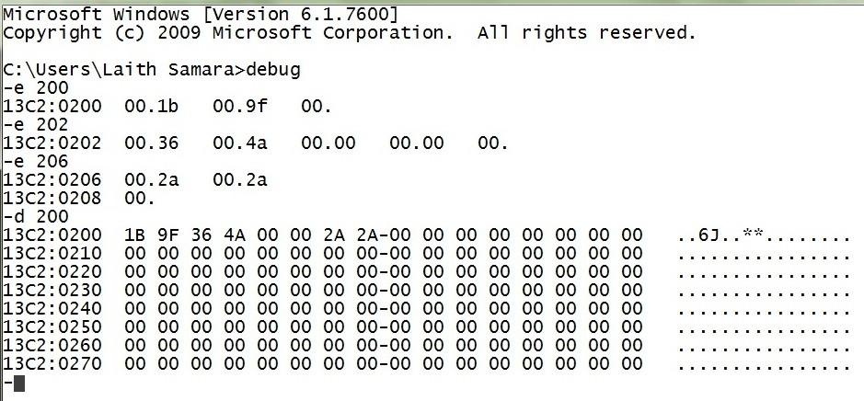
Fig.₄
- Activity 2.2:
Using DEBUG command E, the following program instructions in machine code is entered at the offset memory location 100h.
E CS: 100 A1 00 02
E CS: 103 8B 1E 02 02
E CS: 107 01 C3
E CS: 109 89 1E 04 02
E CS: 10D 90
As shown in figure._{5,} below
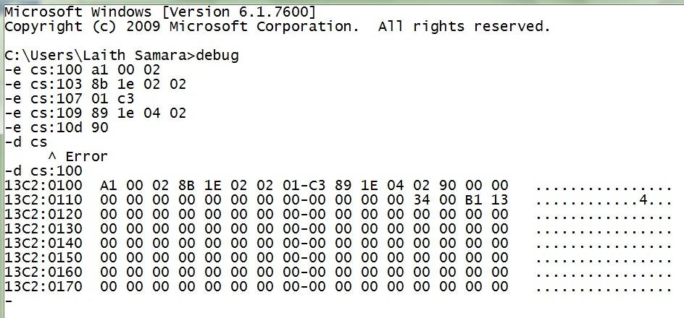
Fig.₅
- Activity 2.3:
We use DEBUG command U (unassemble) to know the assembly code corresponding to each machine code Instructions (in activity 2.2). The results are in the table below and the figure.₆:

Assembly code | Machine code
MOV AX, [0200] | A10002
MOV BX, [0202] | 8B1E0202
ADD BX,AX | 01C3
MOV [0204], BX | 891E0402
NOP | 90
Table (6)

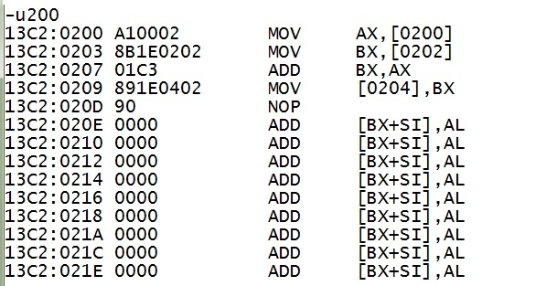

- Activity 2.4:
The 8-bit data value stored at DS: 0200 after the data in Activity 2.1 has been entered is 1B H. Since the 8086 MP is little endian; the low byte is stored at low address.
- Activity 2.5:
The16-bit data value stored at DS: 0200 after the data in Activity 2.1 has been entered is 1B 9F H. Since; [200] = 1B, and [201]= 9F. Low byte is at low address (Little Endian).
- Activity 2.6:
The 8-bit data value stored at DS: 0204 after the data in Activity 2.1 has been entered is 51 h. Since; [200] = 1B H, and [201] = 9F H. [202] = 36 H, and [203] = 4A H. Low byte is at low address (Little Endian).
- MOV AX, [0200]. ➔ AX=9F1B H.
- MOV BX, [0202]. ➔BX=4A36 H.
- ADD BX, AX. ➔BX=9F1B H +4A36 H= E951.
- MOV [0204], BX. ➔[204] = 51. (1 Byte data)

- Activity 2.7:
The content of register AX after the instruction A10002 is executed:
MOV AX, [0200]. ➔ AX = 9F1B H.

- Activity 2.8:
Before we do these instructions: [204] = 00 H.
The content of memory offset 0204 after each instruction is as shown in the table below (Table (7)):

 | A10002 | 8B1E0202 | 01C3 | 891E0402
DS: 204 | 00 | 00 | 00 | 51
Table (7)
Only the last instruction affects the value stored in address 204.
➔ mov [204], bx.

- Part 3: Entering assembly code in DEBUG.
- Activity 3.1:
We enter the following assembly code using DEBUG command A at offset 100H:
MOV CL, 42
MOV DL, 2A
ADD CL, DL
NOP
- Activity 3.2:
We execute the program using the T command. And determine the content of CL, DL, and IP. The results are as shown in the table below:

 | MOV CL,42 | MOV DL,2A | ADD CL,DL
CL | 42 | 42 | 6C
DL | 00 | 2A | 2A
IP | 102 | 104 | 106
Table (8)
The initial values of CL, DL, and IP are 00H, 00H, and 100H respectively.
After executing MOV CL, 42➔ CL= 42H, IP becomes 102H➔ the size of this instruction is 2 bytes.
After executing MOV DL, 2A➔ CL= 42H, DL=2AH, and IP becomes 104H➔ the size of this instruction is 2 bytes.
After executing ADD CL, DL➔ CL= 6CH, DL=2AH, IP becomes 102H➔ the size of this instruction is 2 bytes. CL= 42H + 2AH= 6CH.

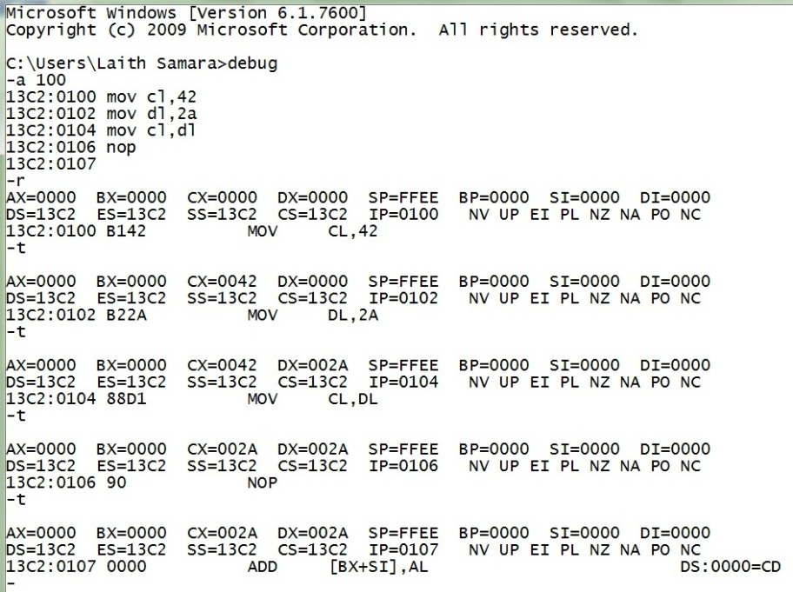

- Conclusion:
At the end of this experiment, we were more familiarized with the Command screen and the DEBUG program and introduced to its different command which each one has a different use. And it’s useful for trapping the code and saw the effect of each simple instruction and the effect on the memory and its registers.

