***بسم الله الرحمن الرحيم***

**

**

***Computer System Engineering Department***

***ENCS 211***

***Digital Lab***

***PRELAB for Experiment NO.2***

***Comparators, Adders and Subtractors.***

* Student name: Laith Samara
* ID#: 1080758.
* Instructor Name: Dr. Iyad Tumar.
* Teacher Assistant: ENG. Anas Abd-elrazeq.
* Date: 7.9.2010.
* Section**: 4.**

1. Design a three-bit comparator (using the basic comparator).

The Design is as shown in Fig (1) .

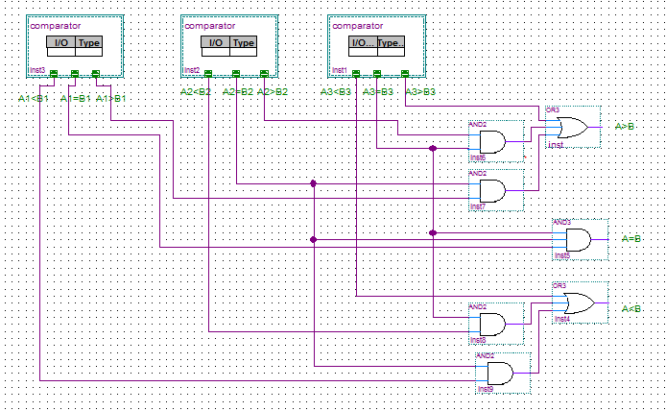

*Fig (1)*

1. Design Logic Diagram, Boolean function, and truth table of half and full adder.

* Half-Adder :

The Truth table is shown in Table.1.

|  |  |  |  |
| --- | --- | --- | --- |
| A | B | C-out | Sum |
| 0 | 0 | 0 | 0 |
| 0 | 1 | 0 | 1 |
| 1 | 0 | 0 | 1 |
| 1 | 1 | 1 | 0 |

Table.1

The Boolean functions for C-out & Sum are as follow:

|  |  |
| --- | --- |
| 0 | 0 |
| 0 | 1 |

|  |  |
| --- | --- |
| 0 | 1 |
| 1 | 0 |

*C-out=AB. Sum= AB'+A'B = A⊕B.*

*The Logic Diagram is as shown in Fig (2).*

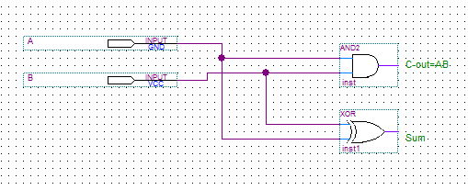

*Fig.(2)*

* Full-Adder :

*The Truth table is shown in Table.2.*

|  |  |  |  |  |
| --- | --- | --- | --- | --- |
| *A* | *B* | *C-in* | *C-out* | *Sum* |
| *0* | *0* | *0* | *0* | *0* |
| *0* | *0* | *1* | *0* | *1* |
| *0* | *1* | *0* | *0* | *1* |
| *0* | *1* | *1* | *1* | *0* |
| *1* | *0* | *0* | *0* | *1* |
| *1* | *0* | *1* | *1* | *0* |
| *1* | *1* | *0* | *1* | *0* |
| *1* | *1* | *1* | *1* | *1* |

*Table.2*

*The Boolean functions for C-out & Sum are as follow:*

|  |  |  |  |
| --- | --- | --- | --- |
| *0* | *0* | *1* | *0* |
| *0* | *1* | *1* | *1* |
| *0* | *1* | *0* | *1* |
| *1* | *0* | *1* | *0* |

*C-out= AB + (A*⊕*B) C-in. Sum=A*⊕*B*⊕*C-in.*

*The Logic Diagram is as shown in fig.(3).*

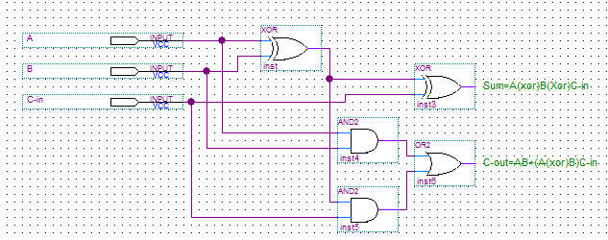Fig.(3)

1. Design logic Diagram, Boolean function, and truth table of half- and full- Subtractor.

* BW: Borrow.
* Dif: Difference.
* Half-Subtractor:

The Truth table is shown in Table.3.

|  |  |  |  |
| --- | --- | --- | --- |
| A | B | Dif | BW |
| 0 | 0 | 0 | 0 |
| 0 | 1 | 1 | 1 |
| 1 | 0 | 1 | 0 |
| 1 | 1 | 0 | 0 |

Table.3

The Boolean functions for BW & Dif are as follow:

|  |  |
| --- | --- |
| 0 | 1 |
| 0 | 0 |

|  |  |
| --- | --- |
| 0 | 1 |
| 1 | 0 |

*BW=A'B. Dif= AB'+A'B = A⊕B.*

*The Logic Diagram is as shown in Fig (4).*

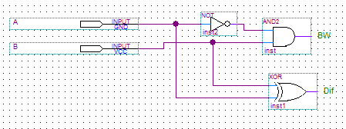

*Fig (4)*

* Full-Subtractor:

*The Truth table is shown in Table.4.*

|  |  |  |  |  |
| --- | --- | --- | --- | --- |
| *A* | *B* | *C* | *Dif* | *BW* |
| *0* | *0* | *0* | *0* | *0* |
| *0* | *0* | *1* | *1* | *1* |
| *0* | *1* | *0* | *1* | *1* |
| *0* | *1* | *1* | *0* | *1* |
| *1* | *0* | *0* | *1* | *0* |
| *1* | *0* | *1* | *0* | *0* |
| *1* | *1* | *0* | *0* | *0* |
| *1* | *1* | *1* | *1* | *1* |

*Table.4*

*The Boolean functions for BW & Dif are as follow:*

|  |  |  |  |
| --- | --- | --- | --- |
| *0* | *1* | *1* | *1* |
| *0* | *0* | *1* | *0* |
| *0* | *1* | *0* | *1* |
| *1* | *0* | *1* | *0* |

*BW= A'C +BC+A'B. Dif= (A*⊕*B)*⊕*C.*

*The Logic Diagram is as shown in Fig (5).*

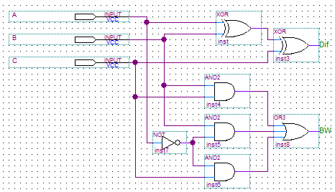

*Fig (5)*