

ENCS2110

DIGITAL ELECTRONICS AND COMPUTER ORGANIZATION LABORATORY

Experiment 8: Introduction to QUARTUSII Software

Name: Sara Totah

Student ID: 1181779

Instructor: Khader Mohammed

T.A: Enas Jawabreh

Date: 11/04/2021

1-bit Full-Adder:



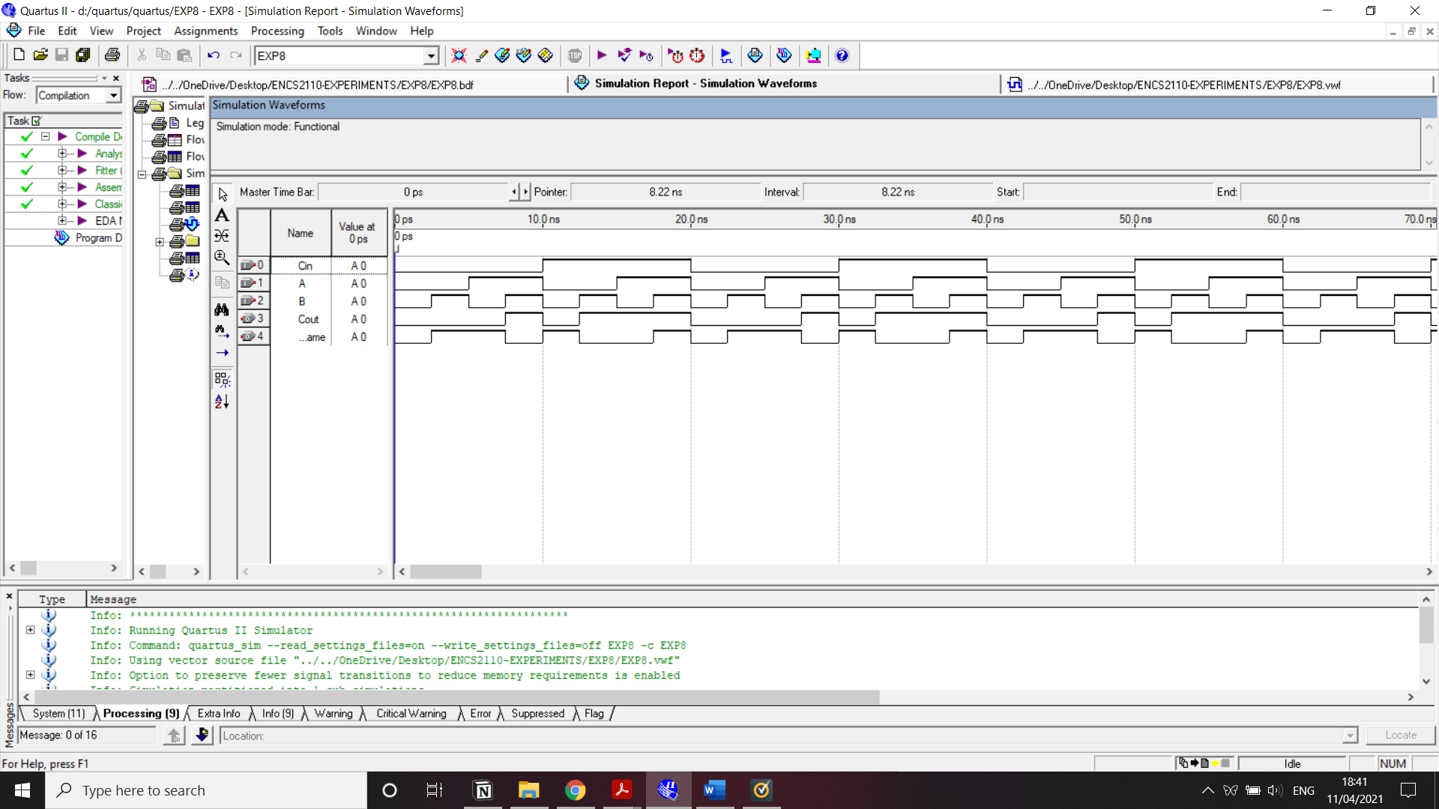

4-bit Full-Adder:



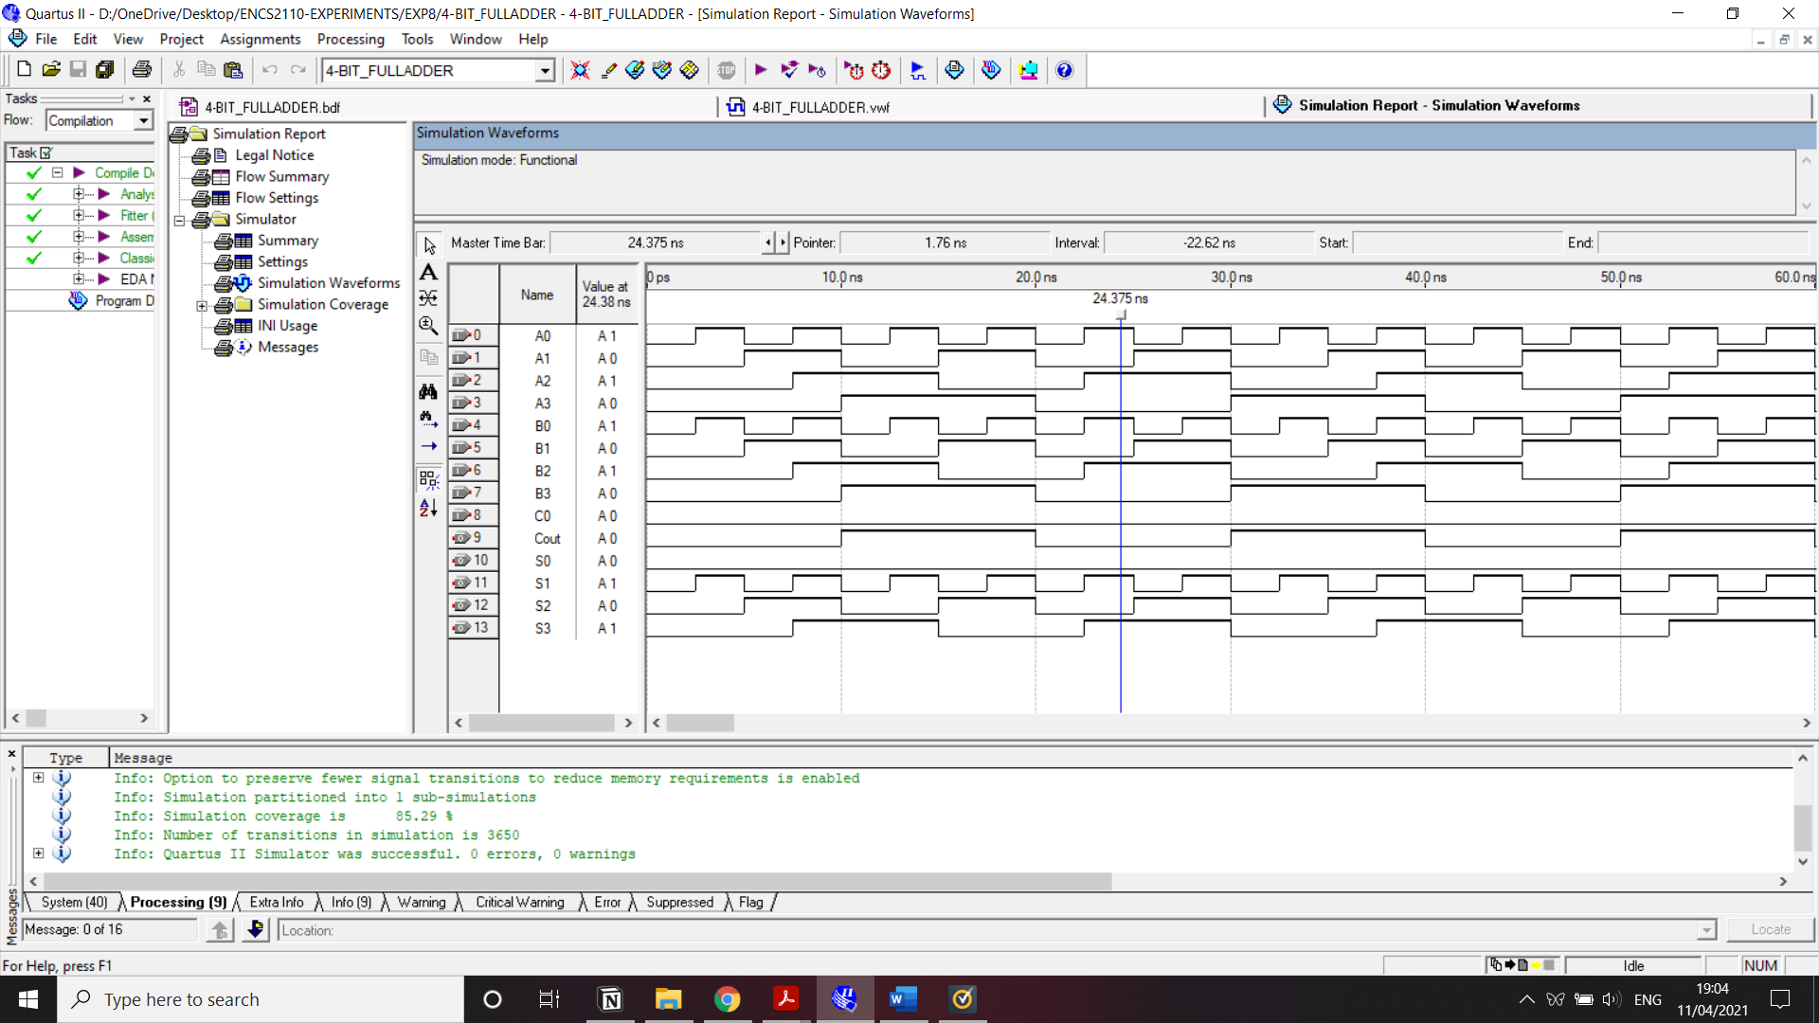

1-bit Comparator



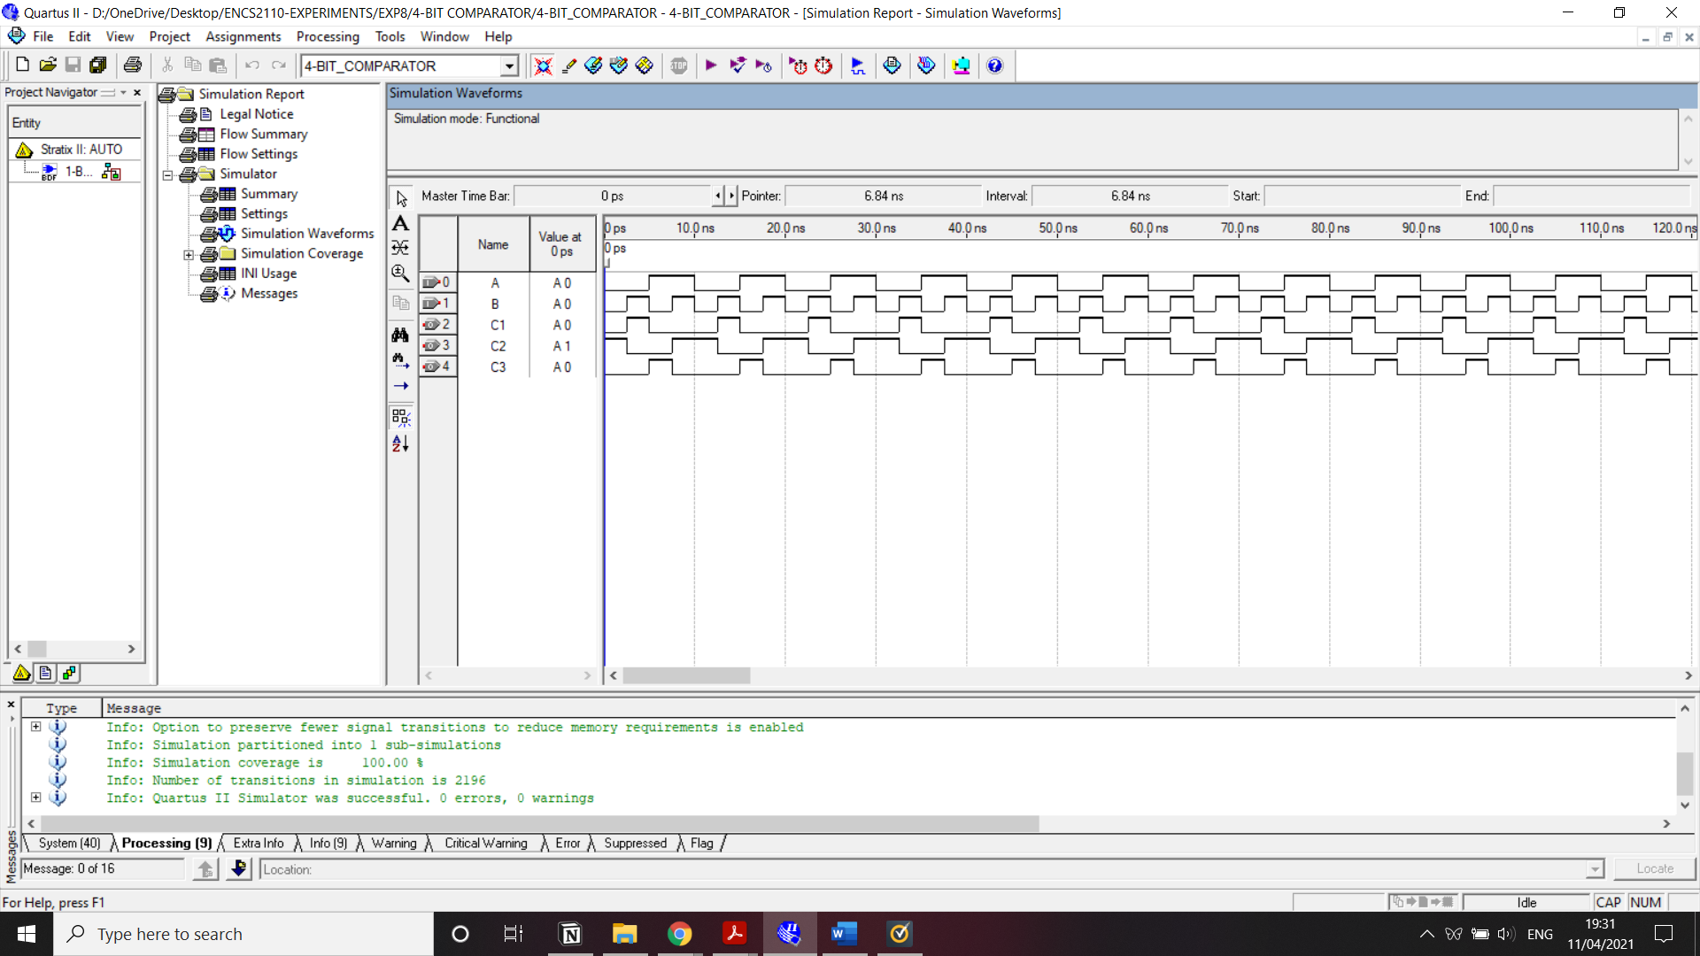

4-bit Comparator



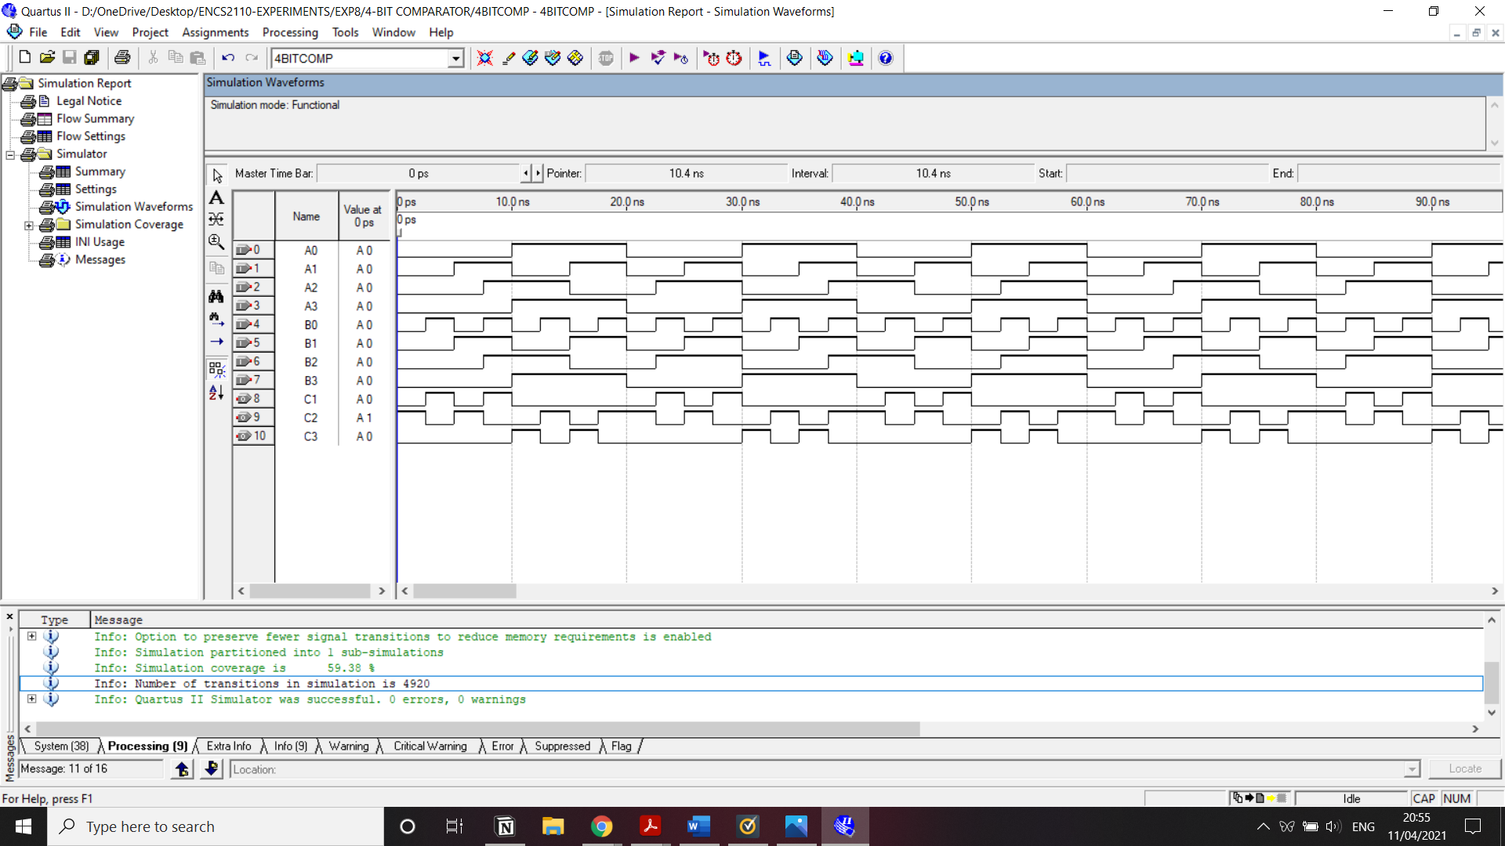

2 to 1 multiplexer



