

ENCS2110

DIGITAL ELECTRONICS AND COMPUTER ORGANIZATION LABORATORY

Name: Sara Totah

Student ID: 1181779

Instructor: Khader Mohammed

T.A: Enas Jawabreh

Date: 22/2/2021

**NOR Gate Circuit:**

1. NOR gate used as NOT gate:



* When SW1 = 0, F1 = 1
* When SW1 = 1, F1 = 0
* Does the circuit act as a NOT gate?

Yes it does

* When SW0 = 0, F1 = 1
* When SW0 = 1, F1 = 0

1. NOR gate used as Buffer:



* When SW0 = 0, F3 = 0
* When SW0 = 1, F3 = 1
* Does the circuit act as a buffer?

Yes

1. NOR gate used as OR gate:



|  |  |  |
| --- | --- | --- |
| SW1 (B) | SW0(A) | F3 |
| 0 | 0 | 0 |
| 0 | 1 | 1 |
| 1 | 0 | 1 |
| 1 | 1 | 1 |



|  |  |  |
| --- | --- | --- |
| SW1 (B) | SW0(A) | F3 |
| 0 | 0 | 0 |
| 0 | 1 | 0 |
| 1 | 0 | 0 |
| 1 | 1 | 1 |

**NAND Gate Circuit:**

1. NOT gate constructed with NAND gate:



* When SW1 = 0, F2 = 1
* When SW1 = 1, F2 = 0
* Does the circuit act as a NOT gate?

Yes it does

1. AND gate constructed with NAND gate:



|  |  |  |
| --- | --- | --- |
| SW1 (B) | SW0(A) | F3 |
| 0 | 0 | 0 |
| 0 | 1 | 0 |
| 1 | 0 | 0 |
| 1 | 1 | 1 |

1. OR gate constructed with NAND gates:



|  |  |  |
| --- | --- | --- |
| SW1 (B) | SW0(A) | F3 |
| 0 | 0 | 0 |
| 0 | 1 | 1 |
| 1 | 0 | 1 |
| 1 | 1 | 1 |

**XOR Gate Circuit:**

1. XOR gate using NAND gates:



|  |  |  |  |  |  |
| --- | --- | --- | --- | --- | --- |
| INPUT | | OUTPUT | | | |
| D | A | F1 | F2 | F3 | F4 |
| 0 | 0 | 1 | 1 | 1 | 0 |
| 0 | 1 | 1 | 1 | 0 | 1 |
| 1 | 0 | 1 | 0 | 1 | 1 |
| 1 | 1 | 0 | 1 | 1 | 0 |

1. XOR gate using Basic gates:



|  |  |  |  |  |
| --- | --- | --- | --- | --- |
| INPUT | | OUTPUT | | |
| SW2(B) | SW1(A) | F1 | F2 | F3 |
| 0 | 0 | 0 | 0 | 0 |
| 0 | 1 | 0 | 1 | 1 |
| 1 | 0 | 1 | 0 | 1 |
| 1 | 1 | 0 | 0 | 0 |

1. AOI circuit:



When B X B1 is set to 0

|  |  |  |  |
| --- | --- | --- | --- |
| A1 | A | F3 | F4 |
| 0 | 0 | 0 | 1 |
| 0 | 1 | 0 | 1 |
| 1 | 0 | 0 | 1 |
| 1 | 1 | 1 | 0 |

* Does F3 act as an AND gate between A and A1?

Yes.

When A XA1 is set to 0

|  |  |  |  |
| --- | --- | --- | --- |
| B1 | B | F3 | F4 |
| 0 | 0 | 0 | 1 |
| 0 | 1 | 0 | 1 |
| 1 | 0 | 0 | 1 |
| 1 | 1 | 1 | 0 |

* When A×A1 is “0”, does F3 act as an AND gate between B and B1?

Yes.

* Does F3 equal to A×A1+B×B1?

Yes.

**Logic Problems:**

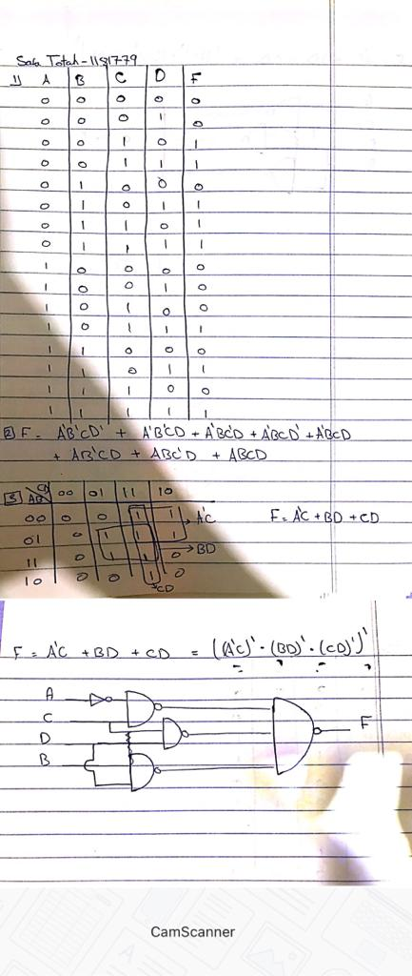

**Post-Lab:**

