

ENCS2110

DIGITAL ELECTRONICS AND COMPUTER ORGANIZATION LABORATORY

Name: Sara Totah

Student ID: 1181779

Instructor: Khader Mohammed

T.A: Enas Jawabreh

Date: 03/03/2021

Table of Contents

Table of Figures: 3

Pre-Lab: 4

**Three-Bit Comparator:** 4

Abstract: 5

Theory: 5

First: Comparator Circuit: 5

**1-Bit Comparator:** 5

**4-Bit Comparator:** 6

Second: Half- and Full- Adder Circuits: 7

**Half-Adder:** 7

**Full-Adder:** 7

Third: Half- and Full- Subtractor Circuits: 8

**Half-Subtractor:** 8

**Full-Subtractor:** 9

Procedure: 10

Comparator Circuits: 10

**A.** **Constructing Comparator with Basic Logic Gates:** 10

**B.** **Constructing Comparator with an IC:** 10

Half- and Full-Adder Circuits: 11

**A.** **Constructing Half- and Full-Adders with Basic logic Gates:** 11

**B.** **Full-Adder with Basic logic Gates:** 11

**C.** **Constructing BCD Adder:** 12

Half- and Full-Subtractor Circuits: 12

**A.** **Half-Subtractor** 12

**B.** **Full-Subtractor** 13

Conclusion: 14

References: 14

# Table of Figures:

Figure 1: Three-Bit comparator 4

Figure 2: N - bit Comparator 5

Figure 3: 1-bit comparator circuit 5

Figure 4: 4-bit Comparator Circuit diagram 6

Figure 5: 4-bit comparator constructed with1-bit comparator 7

Figure 6: Half Adder Logic circuit 7

Figure 7: Full-Adder circuit diagram 7

Figure 8:Full-Adder logic diagram 8

Figure 9:Half-Subtractor Logic Circuit 8

Figure 10:Full-Subtraction Circuit Diagram 9

Figure 11: Full-Subtractor Logic Diagram 9

Figure 12: Implemented 1-bit Comparator 10

Figure 13: Comparator constructed with an IC 10

Figure 14: Implemented Half-Adder 11

Figure 15: Implemented Full-Adder 11

Figure 16: 4-bit Full Adder constructed with IC 12

Figure 17: Half-Subtractor 12

Figure 18: Full-Subtractor 13

# Pre-Lab:

## **Three-Bit Comparator:**



Figure 1: Three-Bit comparator

|  |  |  |  |  |  |  |  |  |
| --- | --- | --- | --- | --- | --- | --- | --- | --- |
| A2 | A1 | A0 | B2 | B1 | B0 | A>B | A<B | A=B |
| 0 | 0 | 0 | 0 | 0 | 0 | 0 | 0 | 1 |
| 0 | 0 | 0 | 0 | 0 | 1 | 0 | 1 | 0 |
| 0 | 0 | 0 | 0 | 1 | 0 | 0 | 1 | 0 |
| 0 | 0 | 0 | 0 | 1 | 1 | 0 | 1 | 0 |
| 0 | 0 | 0 | 1 | 0 | 0 | 0 | 1 | 0 |
| 0 | 0 | 0 | 1 | 0 | 1 | 0 | 1 | 0 |
| . | . | . | . | . | . | . | . | . |
| . | . | . | . | . | . | . | . | . |
| 1 | 1 | 1 | 0 | 1 | 1 | 1 | 0 | 0 |
| 1 | 1 | 1 | 0 | 0 | 0 | 1 | 0 | 0 |
| 1 | 1 | 1 | 1 | 0 | 1 | 1 | 0 | 0 |
| 1 | 1 | 1 | 1 | 1 | 0 | 1 | 0 | 0 |
| 1 | 1 | 1 | 1 | 1 | 1 | 0 | 0 | 1 |

# Abstract:

The Aim of the experiment: To understand the principle of the digital comparators, half-adders, full-adders, half-subtractor and full- subtractor, and how to implement each one of them.

Equipment Used in the experiment:

*Since the experiment was implemented online, we used a simulator called **Proteus.**

# Theory:

## First: Comparator Circuit:

Comparator Circuits are made of basic gates such as AND, NOR & NOT, these circuit should be able to determine whether the value of the input A is greater than, equal or smaller than the value of the input B.

The magnitude comparator has three output: One for equality A = B, another for greater than A > B, and the last one for less than A < B.

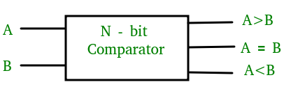

Figure : N - bit Comparator

### **1-Bit Comparator:**

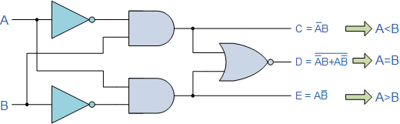

Figure : 1-bit comparator circuit

|  |  |  |  |  |
| --- | --- | --- | --- | --- |
| Inputs | | Outputs | | |
| B | A | A>B | A=B | A<B |
| 0 | 0 | 0 | 1 | 0 |
| 0 | 1 | 1 | 0 | 0 |
| 1 | 0 | 0 | 0 | 1 |
| 1 | 1 | 0 | 1 | 0 |

Table : 1-bit comparator Truth table

#### **K-map for 1-bit comparator:**

A > B

|  |  |  |  |
| --- | --- | --- | --- |
| A B | 0 | 1 | A > B equation = A.B’ |
| 0 | 0 | 0 |
| 1 | 1 | 0 |

A = B

|  |  |  |  |
| --- | --- | --- | --- |
| A B | 0 | 1 |  |
| 0 | 1 | 0 | A = B equation = A’B’ + AB |
| 1 | 0 | 1 |  |

A < B

|  |  |  |  |
| --- | --- | --- | --- |
| A B | 0 | 1 |  |
| 0 | 0 | 1 | A < B equation = A’B |
| 1 | 0 | 0 |  |

### **4-Bit Comparator:**

In order to design a 4 – bit comparator, each bit of the 4 – bit numbers should be compared on it’s own, and based on this comparison we can explain how to design the 4-bit comparator.

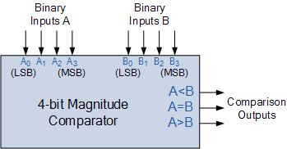

Figure : 4-bit Comparator Circuit diagram

**A = B:**

In order to equal the two inputs, each bit of the first number A should be equal to same bit of the second number B such as;

A0 = B0, A1 = B1, A2 = B2, A3 = B3

**A > B:**

There are multiple occasions where this output is true:

1. When A3 > B3
2. When A3 = B3 AND A2 > B2
3. When A3 = B3 AND A3 = B3 AND A2 > B2
4. When A3 = B3 AND A3 = B3 AND A2 = B2 AND A1 > B1
5. When A3 = B3 AND A3 = B3 AND A2 = B2 AND A1 = B1 AND A0 > B0

**A > B:**

There are multiple occasions where this output is true:

1. When A3 < B3
2. When A3 = B3 AND A2 < B2
3. When A3 = B3 AND A3 = B3 AND A2 < B2
4. When A3 = B3 AND A3 = B3 AND A2 = B2 AND A1 < B1
5. When A3 = B3 AND A3 = B3 AND A2 = B2 AND A1 = B1 AND A0 < B0



Figure : 4-bit comparator constructed with1-bit comparator

## Second: Half- and Full- Adder Circuits:

### **Half-Adder:**

The addition of two bits is done using a combinational circuit called Half-Adder:

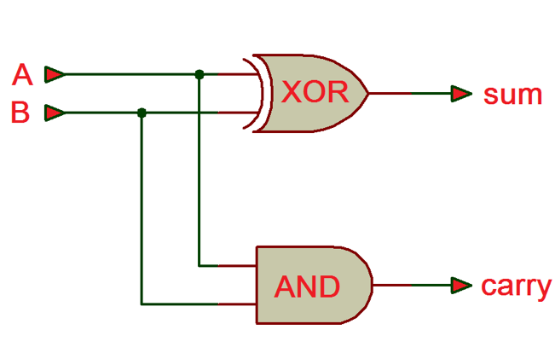

Figure : Half Adder Logic circuit

|  |  |  |  |
| --- | --- | --- | --- |
| Inputs | | Outputs | |
| B | A | S | C |
| 0 | 0 | 0 | 0 |
| 0 | 1 | 1 | 0 |
| 1 | 0 | 1 | 0 |
| 1 | 1 | 0 | 1 |

Table : Half-Adder Truth Table

### **Full-Adder:**

The full-adder can perform addition or subtraction, it adds together two binary digits and carry in digit, which means it has three inputs and comes up with two outputs.

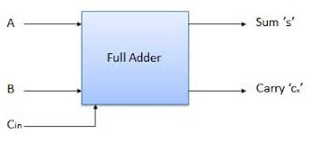

Figure : Full-Adder circuit diagram

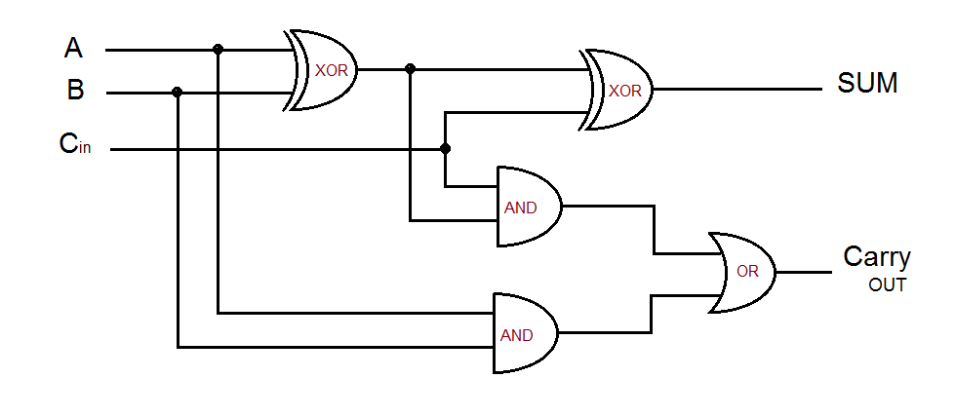

Figure :Full-Adder logic diagram

|  |  |  |  |  |
| --- | --- | --- | --- | --- |
| Inputs | | | Outputs | |
| A | B | Cin | Sum | Carry Out |
| 0 | 0 | 0 | 0 | 0 |
| 0 | 0 | 1 | 1 | 0 |
| 0 | 1 | 0 | 1 | 0 |
| 0 | 1 | 1 | 0 | 1 |
| 1 | 0 | 0 | 1 | 0 |
| 1 | 0 | 1 | 0 | 1 |
| 1 | 1 | 0 | 0 | 1 |
| 1 | 1 | 1 | 1 | 1 |

Table : Full-Adder Truth Table

## Third: Half- and Full- Subtractor Circuits:

### **Half-Subtractor:**

The circuit of half-subtractor can be built with NAND and XOR gates

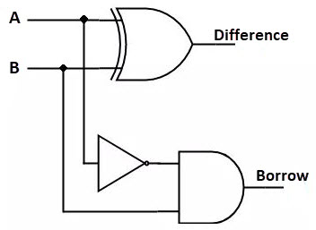

Figure :Half-Subtractor Logic Circuit

|  |  |  |  |
| --- | --- | --- | --- |
| Inputs | | Outputs | |
| B | A | Difference | Borrow |
| 0 | 0 | 0 | 0 |
| 0 | 1 | 1 | 1 |
| 1 | 0 | 1 | 0 |
| 1 | 1 | 0 | 0 |

### **Full-Subtractor:**

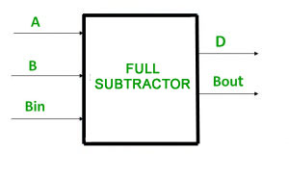

Figure :Full-Subtraction Circuit Diagram

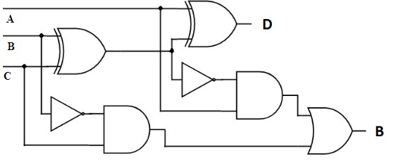

Figure : Full-Subtractor Logic Diagram

|  |  |  |  |  |
| --- | --- | --- | --- | --- |
| Inputs | | | Outputs | |
| A | B | Bin | D | BOUT |
| 0 | 0 | 0 | 0 | 0 |
| 0 | 0 | 1 | 1 | 1 |
| 0 | 1 | 0 | 1 | 1 |
| 0 | 1 | 1 | 0 | 1 |
| 1 | 0 | 0 | 1 | 0 |
| 1 | 0 | 1 | 0 | 0 |
| 1 | 1 | 0 | 0 | 0 |
| 1 | 1 | 1 | 1 | 1 |

Table : Full-Subtractor Truth Table

# Procedure:

## Comparator Circuits:

### **Constructing Comparator with Basic Logic Gates:**



Figure : Implemented 1-bit Comparator

The circuit above was implemented using Proteus, and the output was recorded.

|  |  |  |  |  |  |
| --- | --- | --- | --- | --- | --- |
| Inputs | |  | Outputs | | |
| B | A | F1 | F2 | F5 |
| (SW2) | (SW1) | (L1) | (L2) | (L3) |
| 0 | 0 | A = B | 1 | 1 | 0 |
| 0 | 1 | A > B | 0 | 1 | 1 |
| 1 | 0 | A < B | 1 | 0 | 1 |
| 1 | 1 | A = B | 1 | 1 | 0 |

Table : 1-bit comparator Truth Table

After comparing the truth table in the theory with this one, it’s clear that the are exactly the opposite since we used NAND and XOR gates instead of NOT, AND & NOR.

### **Constructing Comparator with an IC:**



Figure : Comparator constructed with an IC

The circuit above was connected and A was set to equal B and the output was recorded

|  |  |  |  |  |  |
| --- | --- | --- | --- | --- | --- |
| INPUTS | | | OUTPUTS | | |
| A > B | A = B | A < B | A > B | A = B | A < B |
| 0 | 0 | 1 | 0 | 0 | 1 |
| 0 | 1 | 0 | 0 | 1 | 0 |
| 0 | 1 | 1 | 0 | 1 | 0 |
| 1 | 0 | 0 | 1 | 0 | 0 |
| 1 | 0 | 1 | 0 | 0 | 0 |
| 1 | 1 | 1 | 0 | 1 | 0 |

## Half- and Full-Adder Circuits:

### **Constructing Half- and Full-Adders with Basic logic Gates:**



Figure : Implemented Half-Adder

|  |  |  |  |
| --- | --- | --- | --- |
| INPUTS | | OUTPUTS | |
| SW1 (B) | SW0 (A) | CARRY (F1) | SUM (F2) |
| 0 | 0 | 0 | 0 |
| 0 | 1 | 0 | 1 |
| 1 | 0 | 0 | 1 |
| 1 | 1 | 1 | 0 |

Table : Half-Adder Truth table

|  |  |  |  |  |  |  |
| --- | --- | --- | --- | --- | --- | --- |
| A B | 0 | 1 |  | A B | 0 | 1 |
| 0 |  | 1 |  | 0 | 0 | 0 |
| 1 | 1 |  |  | 1 | 0 | 1 |

Sum Carry

After implementing the k-map on this truth table the functions of the sum and the carry were:

Carry = AB = A AND B

Sum = AB’ + A’B = AXOR B

### **Full-Adder with Basic logic Gates:**



Figure : Implemented Full-Adder

|  |  |  |  |  |  |
| --- | --- | --- | --- | --- | --- |
| INPUTS | | | OUTPUTS | | |
| SW3 (C) | SW2 (B) | SW1 (A) | CARRY | SUM |
| 0 | 0 | 0 | 0 | 0 |
| 0 | 0 | 1 | 0 | 1 |
| 0 | 1 | 0 | 0 | 1 |
| 0 | 1 | 1 | 1 | 0 |
| 1 | 0 | 0 | 0 | 1 |
| 1 | 0 | 1 | 1 | 0 |
| 1 | 1 | 0 | 1 | 0 |
| 1 | 1 | 1 | 1 | 1 |

Table : Full-Adder Truth Table

|  |  |  |  |  |  |  |  |  |  |  |
| --- | --- | --- | --- | --- | --- | --- | --- | --- | --- | --- |
| Cin AB | 00 | 01 | 11 | 10 |  | CIN AB | 00 | 01 | 11 | 10 |
| 0 | 0 | 1 | 0 | 1 |  | 0 | 0 | 0 | 1 | 0 |
| 1 | 1 | 0 | 1 | 0 |  | 1 | 0 | 1 | 1 | 1 |

Sum Carry

After implementing the k-map on this truth table the functions of the sum and the carry were:

Carry = AC + BC + AB

Sum = CA’B’ + C’AB’ + CBA + C’BA’

### **Constructing BCD Adder:**



Figure : 4-bit Full Adder constructed with IC

## Half- and Full-Subtractor Circuits:

### **Half-Subtractor**



Figure : Half-Subtractor

|  |  |  |  |
| --- | --- | --- | --- |
| Inputs | | Outputs | |
| A | B | Diff | Borrow |
| 0 | 0 | 0 | 0 |
| 0 | 1 | 1 | 1 |
| 1 | 0 | 1 | 0 |
| 1 | 1 | 0 | 0 |

|  |  |  |  |  |  |  |
| --- | --- | --- | --- | --- | --- | --- |
| A B | 0 | 1 |  | A B | 0 | 1 |
| 0 |  | 1 |  | 0 | 0 | 0 |
| 1 | 1 |  |  | 1 | 1 | 0 |

Diff Carry

After implementing the k-map on this truth table the functions of the sum and the carry were:

Carry = AB = A AND B

Diff = AB’ + A’B = AXOR B

### **Full-Subtractor**



Figure : Full-Subtractor

|  |  |  |  |  |
| --- | --- | --- | --- | --- |
| Inputs | | | Outputs | |
| A | B | Cin | Diff | Borrow |
| 0 | 0 | 0 | 0 | 0 |
| 0 | 0 | 1 | 1 | 1 |
| 0 | 1 | 0 | 1 | 1 |
| 0 | 1 | 1 | 0 | 1 |
| 1 | 0 | 0 | 1 | 0 |
| 1 | 0 | 1 | 0 | 0 |
| 1 | 1 | 0 | 0 | 0 |
| 1 | 1 | 1 | 1 | 1 |

|  |  |  |  |  |  |  |  |  |  |  |
| --- | --- | --- | --- | --- | --- | --- | --- | --- | --- | --- |
| A BCin | 00 | 01 | 11 | 10 |  | A BCin | 00 | 01 | 11 | 10 |
| 0 | 0 | 1 | 0 | 1 |  | 0 | 0 | 1 | 1 | 1 |
| 1 | 1 | 0 | 1 | 0 |  | 1 | 0 | 0 | 1 | 0 |

Sum Carry

After implementing the k-map on this truth table the functions of the sum and the carry were:

Borrow = A’Cin + A’B + BCin

Diff= A’B’Cin + AB’Cin’ + A’BCin + A’BCin

# Conclusion:

The experiment went smoothly with no complications, it took me about hour and a half to finish it, and the results satisfied the theory part of the report, the experiment helped with understanding more about comparators and adders and subtractors, but I couldn’t solve the post lab on my own I was able to write the truth table and the k-maps but I couldn’t build a proper design.

Text size: 12

# References:

<https://www.geeksforgeeks.org/full-adder-in-digital-logic/>

<https://www.electronics-tutorials.ws/combination/comb_8.html>

Digital Lab manual