**Digital Project**

**Name : Samer Demaidi  
ID : 1131785   
Section : 1**

***Description :*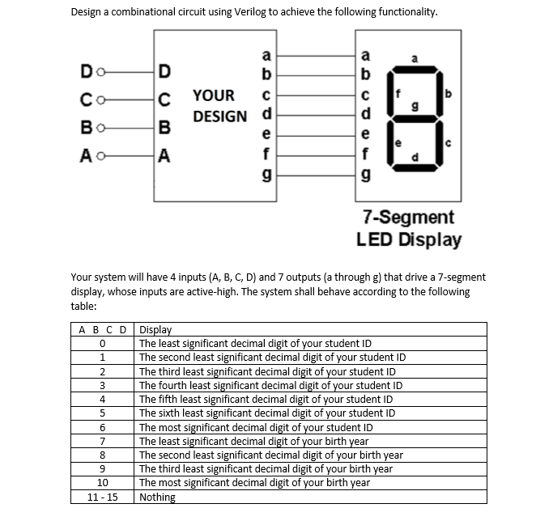**

**Design :**

1. **Code:**

module samer_7_segmentDesign(a,b,c,d,A,B,C,D,E,F,G);

input a,b,c,d; //inputs

output A,B,C,D,E,F,G; //outputs

assign A=(!b && !c )||(!a && !c && !d) || (!a && !b && !d ) || (!a && b && c && d ) ; //equation of output A

assign B=(a &&!b && !c )||(!b && !c && d) || (!a && !b&& c && !d ) || (!a && b && !c && !d ) ;//equation of output B

assign C=(!b && !c )||(!a && !c && !d) || (!a && !b && !d ) || (!a && b && c && d ) ; //equation of output C

assign D=(!b && !c )||(!a && !c && !d) || (!a && b && c && d ) ;//equation of output D

assign E=(!a && !b && d )||(!a && !c && d) || (!a && b && c && !d ) || (a && !b && c && !d ) ; //equation of output E

assign F=(!a && d )||(!b && !c ) || (!a && b && c ) || (a && !b && !d ) ; //equation of output F

assign G=(!b && !c )||(!a && !c && !d) || (!a && b && c && d ) ;//equation of output G

//outputs will be obtained from those equations

endmodule

1. ***simulation to show that the code works well :***

