**  
DIGITAL PROJECT  
ENCS234  
Name : Maryam Shaheen  
ID# : 1140427  
Section : 1  
D.Abdel salam sayaad**

**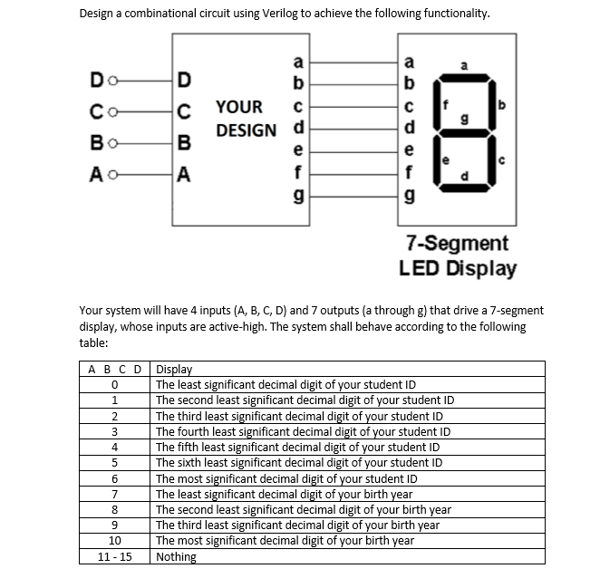*1.Description :***

**2.My Design**

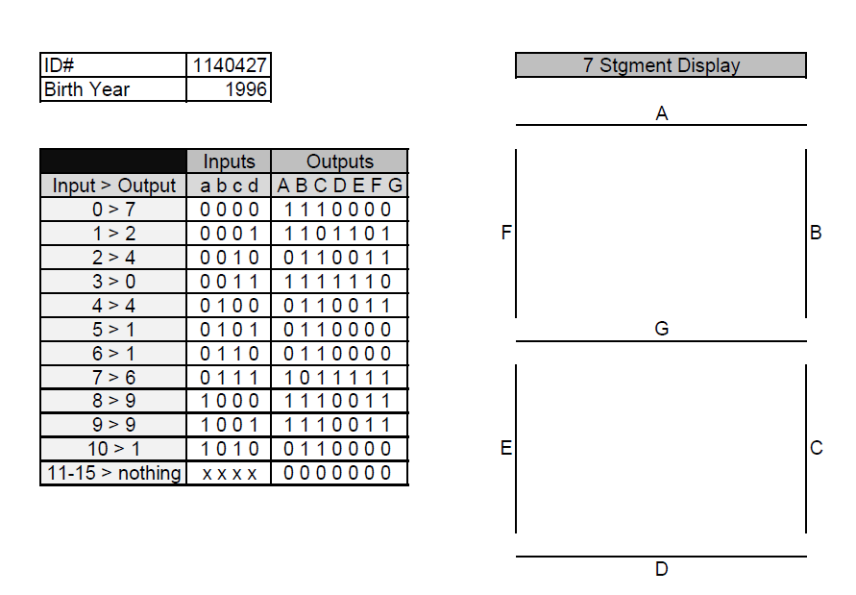**i.Truth Table**

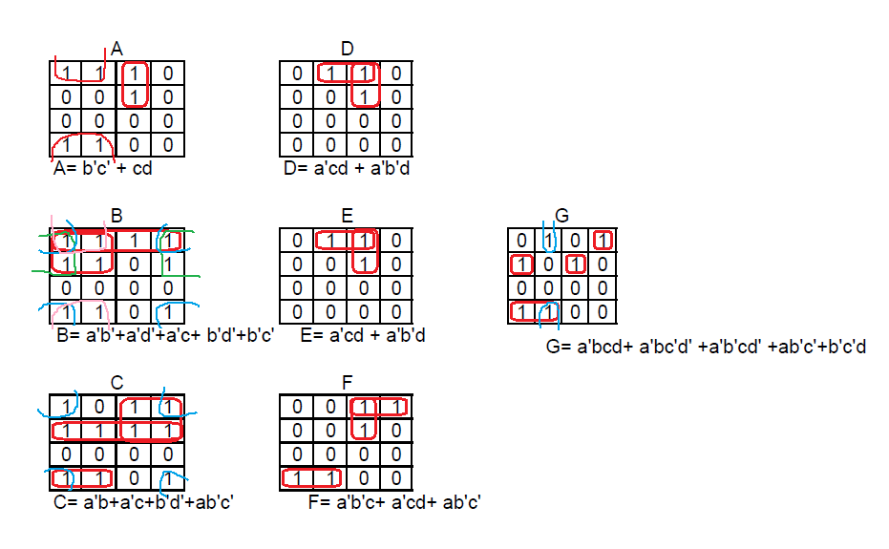**ii.k-maps**

**iii. Code :  
 module maryam_1140427(a,b,c,d,A,B,C,D,E,F,G);**

**input a,b,c,d; // inputs**

**output A,B,C,D,E,F,G; // outputs**

**/\***

**A,B,C,D,E,F,G are equations for optainig the outputs :**

**/\***

**assign A= ( !b && !c )||(!a && c && d); // the equasion of A**

**assign B= ( !a && !b ) || ( !b && !d ) || ( !a && !d ) || (!a && !c) || (!b && !c); // the equasion of B**

**assign C= ( !a && b) || (!a && c) || ( !b && !d ) || (a && !b && !c); // the equasion of C**

**assign D= ( !a && c && d) || ( !a && !b && d ); // the equasion of D**

**assign E= ( !a && c && d) || ( !a && !b && d ); // the equasion of E**

**assign F= ( !a && !b && c )|| (!a && c && d ) || ( !a && !b && !c ); // the equasion of F**

**assign G= ( !a && b && c && d) || ( !a && b && !c && !d ) || ( !a && !b && c && !d )||   
 ( a && !b && !c)||(!b && !c && d) ; // the equasion of G**

**endmodule**

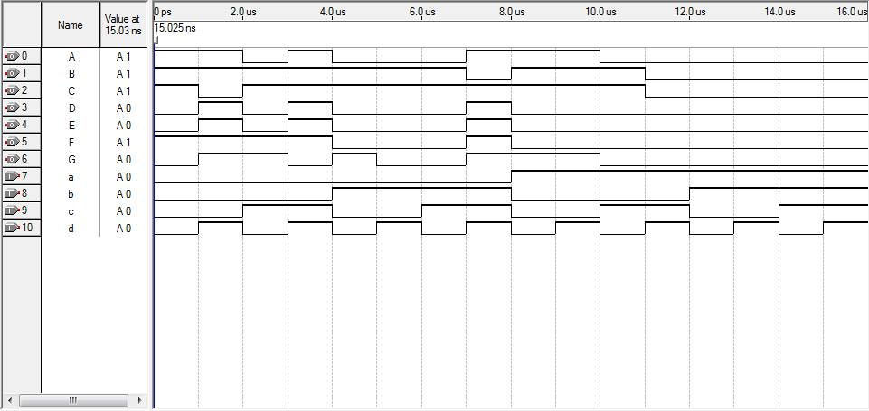**iv.Simulation:**