Shereen ibdah 1200373

Q1: solution

1. HDL CODE OF 2x1 MUX :

module Ibdah(I0,I1,s,f);

input I0,I1,s;

output f;

assign f= (I0 && !s) || (I1 && s);

endmodule

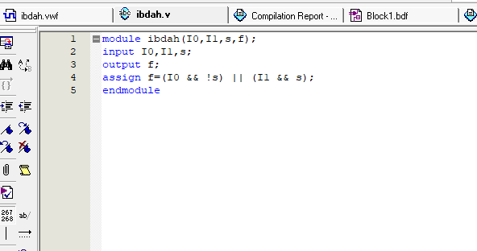

The waveform of 2x1 mux :

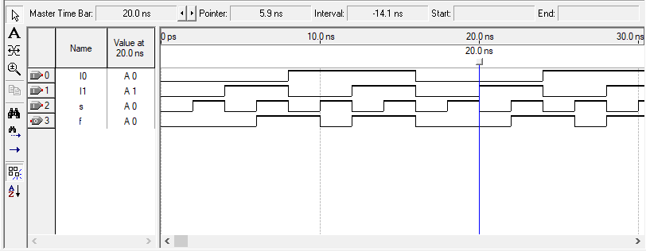

The Block diagram of 2x1 mux :

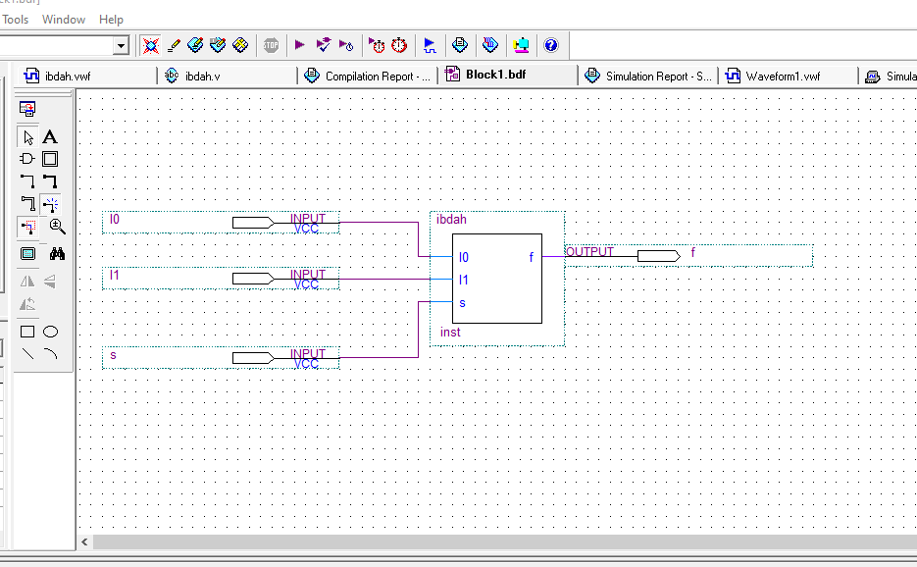

1. 2X4Decoder code :

module shereen(w0,w1,En,y);

input w0,w1;

input En;

output [3:0] y;

reg [3:0] y;

always

begin

if(En==0)

y= 4'b0000;

else if (En == 1)

begin

if( w0 == 0 && w1 == 0)

y =4'b0001;

else if (w0==0 && w1 == 1)

y = 4'b0010;

else if (w0 == 1 && w1 == 0)

y = 4'b0100;

else

y = 4'b1000;

end

end

endmodule

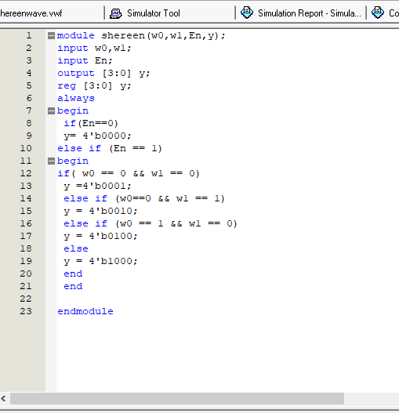

Decoder wave form :

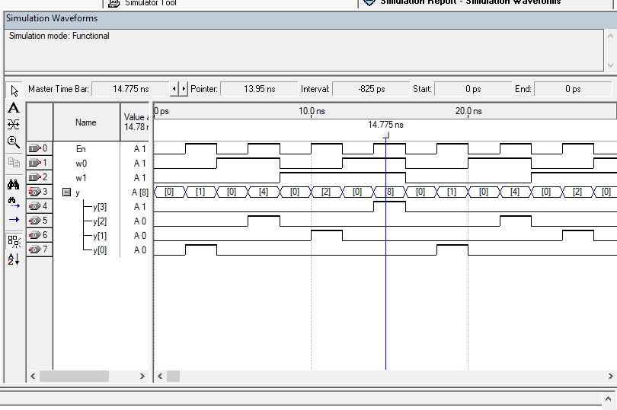

Decoder Block diagram :

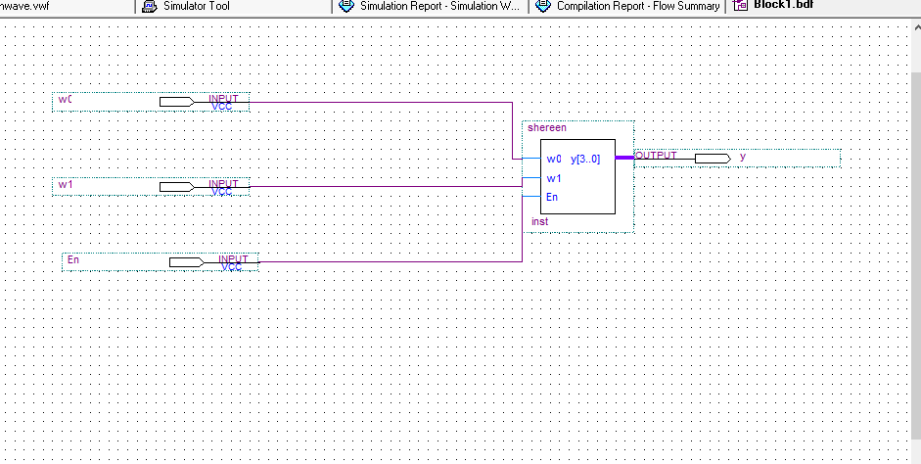

1. All system code :

module system (I,s,En,y);

input [1:0]I;

input s,En;

output [3:0] y;

wire w0,w1;

Ibdah G1(I[0],I[1],s,w0);

Ibdah G2(I[0],I[1],s,w1);

shereen G3(w0,w1,En,y);

endmodule

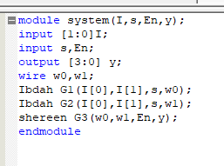

System wave :

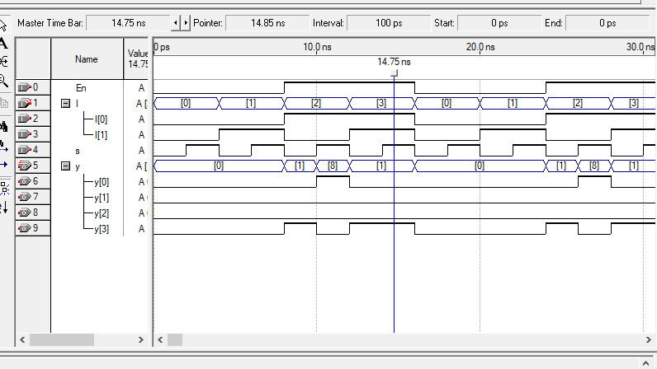

All system Block diagram :

