Shereen Ibdah 1200373

Q2: solution

1. Decoder code

module Ibdah(C,B,En,D0,D1,D2,D3);

input C,B,En;

output D0,D1,D2,D3;

wire w1,w2;

not G1(w1,C);

not G2(w2,B);

and G6(D0,En,w1,w2);

and G3(D1,En,w1,B);

and G4(D2,En,C,w2);

and G5(D3,En,C,B);

endmodule

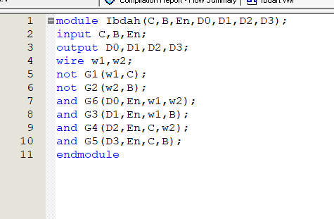

Decoder wave :

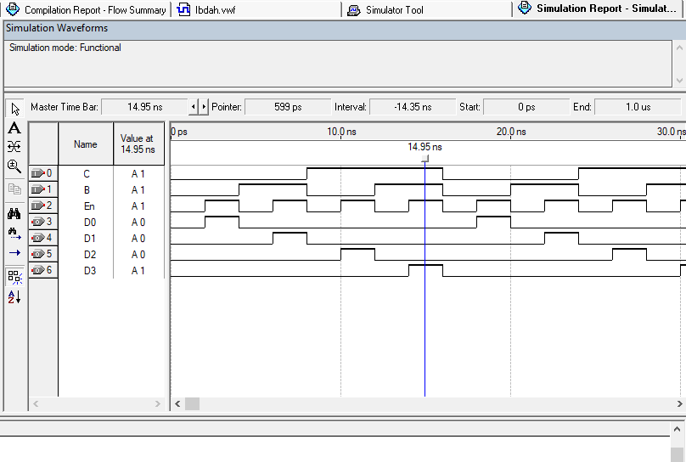

Decoder Block diagram :

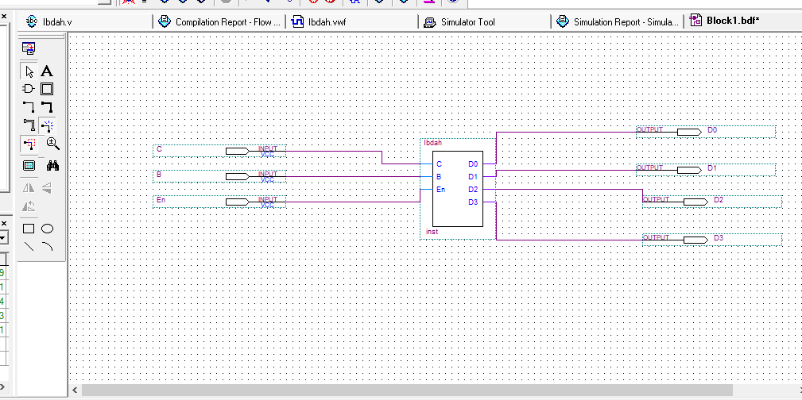



System Code:

module BIRZEIT (A,B,C,f,D0,D1,D3,C2,C3);

input A,B,C;

output f,D0,D1,D3;

output C2,C3;

wire w1,w2,w3,w4;

not(w1,A);

Ibdah(C,B,w1,D0,D1,w2,D3);

Ibdah(C,B,A,w3,w4,C2,C3);

nor (f,w2,w3,w4);

endmodule

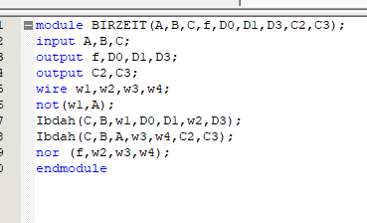

System wave : 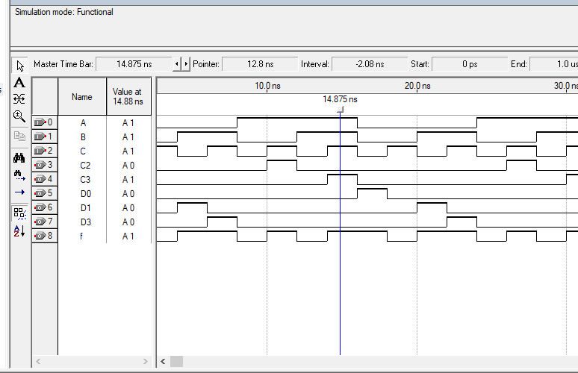

System Block diagram :

