**Name: Shereen Ibdah**

**1200373**

**Computer Organization and Microprocessors – ENCS2380**

**Assembly Assignment**

**My Code : you will the Code in the last page also**

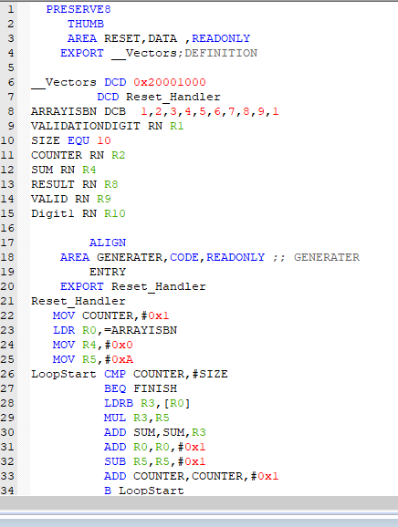

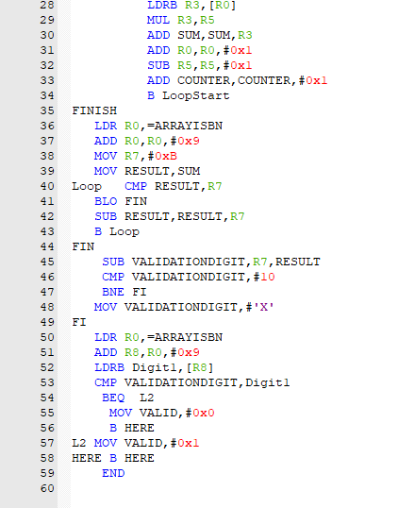

Testing for ISBN 5123487654 R9 is the Validation digit and this ISBN is Valid:

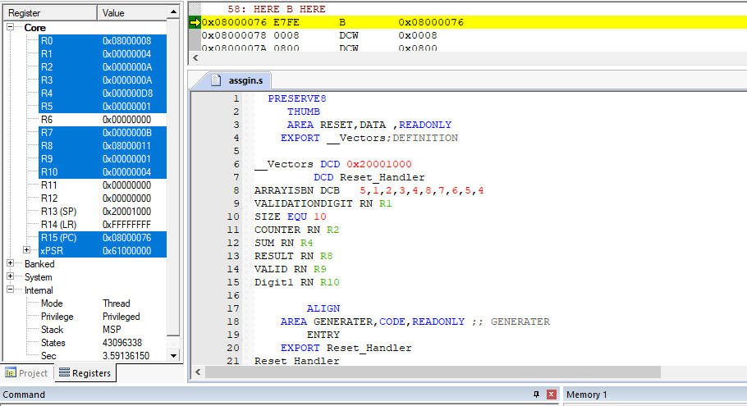

Testing for ISBN 5123487658, R9 is the Validation digit and this ISBN is not Valid:

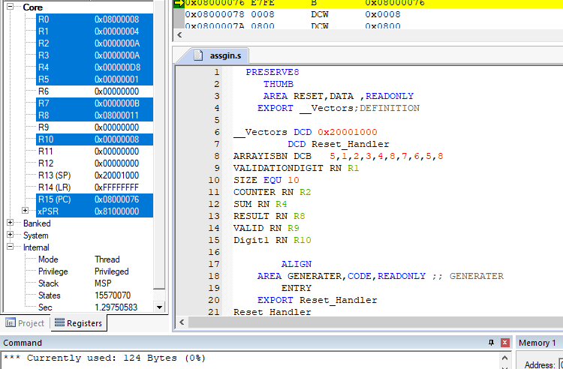

Testing for ISBN 7465159237, R9 is the Validation digit and this ISBN is Valid:

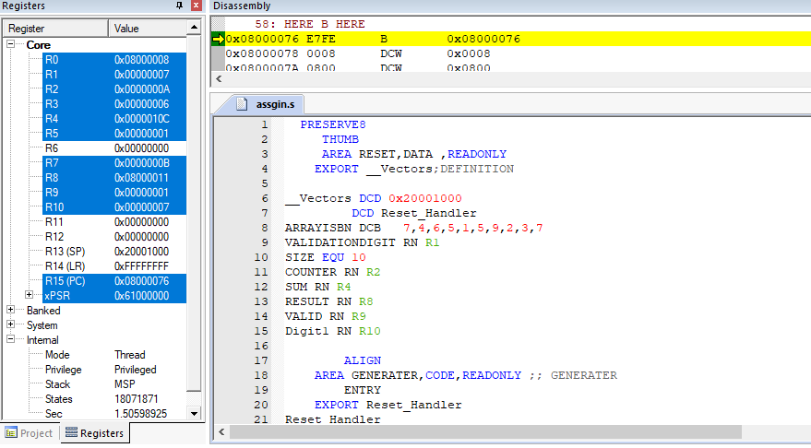

Testing for ISBN 7465159232, R9 is the Validation digit and this ISBN is not Valid

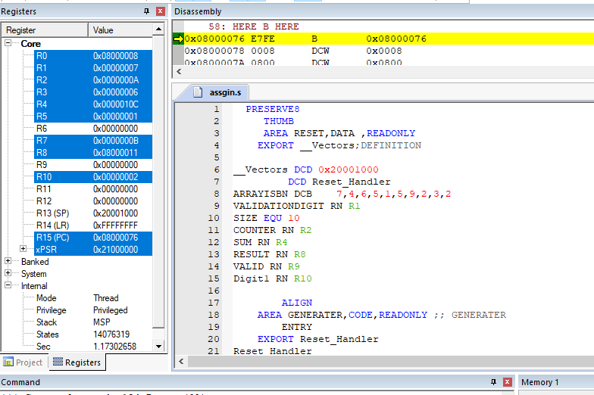

Testing for ISBN 123456789X , R9 is the Validation digit and this ISBN is Valid

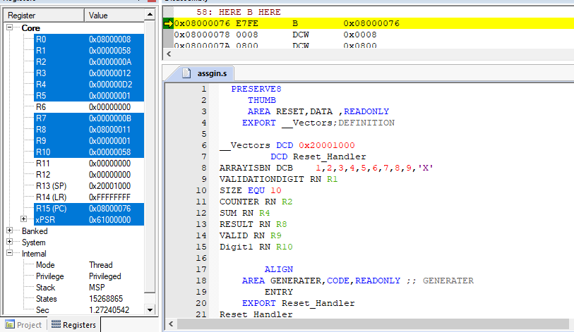

And it stored in memory like this :

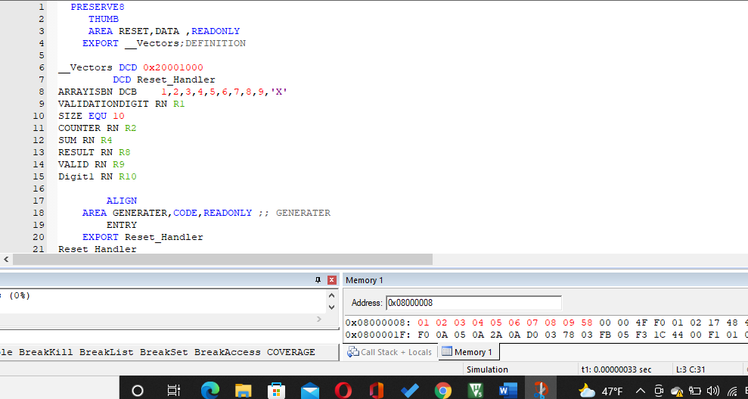

Testing for ISBN 1234567891, R9 is the Validation digit and this ISBN is not Valid

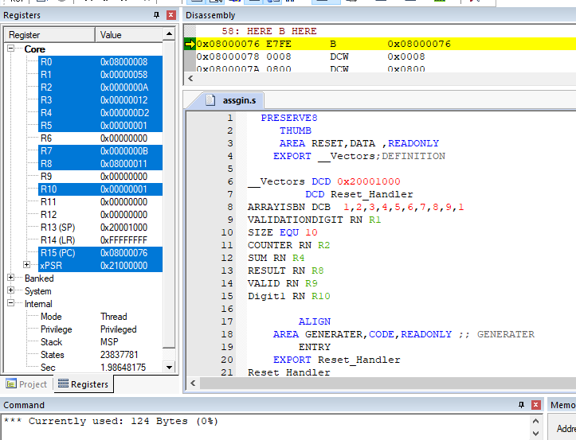

PRESERVE8

THUMB

AREA RESET,DATA ,READONLY

EXPORT __Vectors;DEFINITION

__Vectors DCD 0x20001000

DCD Reset_Handler

ARRAYISBN DCB 5,1,2,3,4,8,7,6,5,4

VALIDATIONDIGIT RN R1

SIZE EQU 10

COUNTER RN R2

SUM RN R4

RESULT RN R8

VALID RN R9

Digit1 RN R10

ALIGN

AREA GENERATER,CODE,READONLY ;; GENERATER

ENTRY

EXPORT Reset_Handler

Reset_Handler

MOV COUNTER,#0x1

LDR R0,=ARRAYISBN

MOV R4,#0x0

MOV R5,#0xA

LoopStart CMP COUNTER,#SIZE

BEQ FINISH

LDRB R3,[R0]

MUL R3,R5

ADD SUM,SUM,R3

ADD R0,R0,#0x1

SUB R5,R5,#0x1

ADD COUNTER,COUNTER,#0x1

B LoopStart

FINISH

LDR R0,=ARRAYISBN

ADD R0,R0,#0x9

MOV R7,#0xB

MOV RESULT,SUM

Loop CMP RESULT,R7

BLO FIN

SUB RESULT,RESULT,R7

B Loop

FIN

SUB VALIDATIONDIGIT,R7,RESULT

CMP VALIDATIONDIGIT,#10

BNE FI

MOV VALIDATIONDIGIT,#'X'

FI

LDR R0,=ARRAYISBN

ADD R8,R0,#0x9

LDRB Digit1,[R8]

CMP VALIDATIONDIGIT,Digit1

BEQ L2

MOV VALID,#0x0

B HERE

L2 MOV VALID,#0x1

HERE B HERE

END