- QUESTION A day in the life… connecting to the Internet

In the topology shown below, a client A (on the left side) joins a network and wants to download the webpage for http://example.net/ from the webserver H (on the right side). All wires/links are Ethernet segments. In this question, you will be asked what packets are on the wire (and the addresses in those packets’ headers) for this to occur. When asked to provide the addresses of machines, you can refer to them abstractly: IP-H is the IP address of the webserver H, MAC-H is the MAC address of H. If a packet is being sent to a broadcast address, use “BR” as the destination (e.g., IP-BR or MAC-BR).

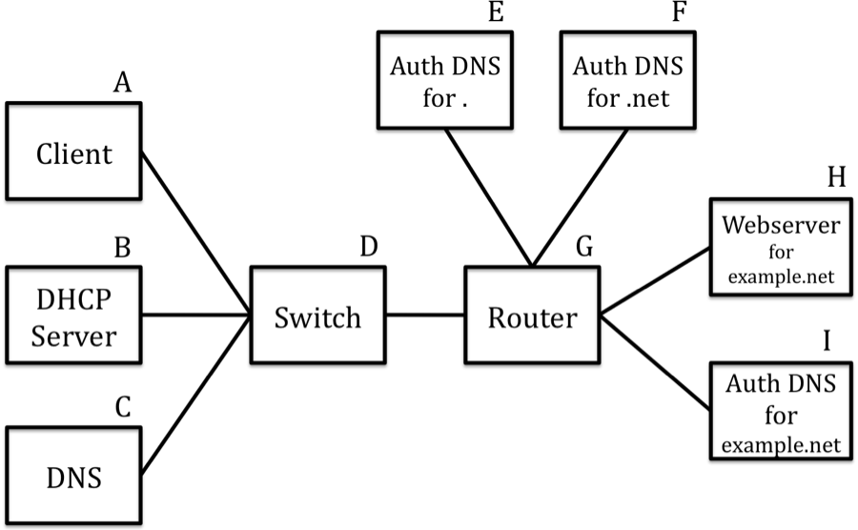

Assume the following:
- All the machines, except the client, already have their ARP caches full.
- DNS resolver C has an empty DNS cache.
- http://example.net/index.html ﬁts in a single packet.
- Client just joined the network and so all of its caches are empty (DNS, ARP, DHCP)

When you are asked to write a packet with its headers, you should include both network and link-layer addresses. So a DNS query from client A to server C and the response should look like the following. Note that other packets may be involved with a full DNS lookup that we are not showing in this example.

Order | Link Src | Link Dst | Network Src | Network Dst | Protocol  Description
1 | MAC-A | MAC-C | IP-A | IP-C | DNS query
2 | MAC-C | MAC-A | IP-C | IP-A | DNS resp.
In the following questions, you may not need to use all the lines we provide.

1. [4 points] As it just joined the network, the first thing the client needs to do is get an IP address and other related network state. In the next lines, write the packets on the network involved in that step, including their header information.

Order | Link Src | Link Dst | Network Src | Network Dst | Protocol  Description
1 | MAC-A | MAC-BR | -- | -- | DHCP Discover
2 | MAC-B | MAC-A | -- | -- | DHCP Offer
3 | MAC-A | MAC-BR | -- | -- | DHCP Request
4 | MAC-B | MAC-A | -- | -- | DHCP Acknowledgment
5
6

2. [10 points] Now that the client has an IP address for itself, it wants to resolve the IP address of example.com, which will be IP_H. Write down all the packets involved in this phase. Remember that the client just joined the network.

If a packet’s headers change during transmission (i.e., the IP or MAC address get changed), you should write the packet on two separate lines, corresponding to the two set of headers it sees during transmission. For the description, write the most specific protocol, i.e., “DNS query”, not “UDP”.

Order | Link Src | Link Dst | Network Src | Network Dst | Protocol  Description
1 | MAC-A | MAC-BR |  |  | ARP Request
2 | MAC-C | MAC-A |  |  | ARP Reply
3 | MAC-A | MAC-C | IP-A | IP-C | DNS Request
4 | MAC-C | MAC-G | IP-C | IP-E | DNS Request (to .)
5 | MAC-G | MAC-E | IP-C | IP-E | DNS Request
6 | MAC-E | MAC-G | IP-E | IP-C | DNS Reply
7 | MAC-G | MAC-C | IP-E | IP-C | DNS Reply
8 | MAC-C | MAC-G | IP- C | IP-F | DNS Request (to .net)
9 | MAC-G | MAC-F | IP-C | IP-F | DNS Request
10 | MAC-F | MAC-G | IP-F | IP-C | DNS Reply
11 | MAC-G | MAC-C | IP-F | IP-C | DNS Reply
12 | MAC-C | MAC-G | IP-C | IP-I | DNS Request (to example.net)
13 | MAC-G | MAC-I | IP-C | IP-I | DNS Request
14 | MAC-I | MAC-G | IP-I | IP-C | DNS Reply
15 | MAC-G | MAC-C | IP-I | IP-C | DNS Reply
16 | MAC-C | MAC-A | IP-C | IP-A | DNS Reply
17

3. [5 points] Now that the client has IP_H, it wants to download the web page http://example.net/index.html. (Recall that the webpage fits in one data packet.) Write down all network-layer packets that are sent on the wire in order to complete this process. Remember to clean up any transfers.

For the “protocol description”, if the packet is associated with transport layer, you should write something like “TCP SYN”. If it’s inherently an application-level message (i.e., data sent over a TCP connection), you should write something like “HTTP request”. In this example, you should assume that you are running a “basic” TCP implementation, so it’s not doing any fancier optimizations like delayed ACKs or piggybacking.

Order | Network Src | Network Dst | Description
1 | IP-A | IP-H | TCP SYN
2 | IP-H | IP-A | TCP SYN-ACK
3 | IP- A | IP-H | TCP-ACK
4 | IP-A | IP-H | HTTP Request
5 | IP-H | IP-A | TCP ACK
6 | IP-H | IP-A | HTTP Reply
7 | IP-A | IP-H | TCP ACK
8 | IP-H | IP-A | TCP FIN
9 | IP-A | IP-H | TCP FIN-ACK
10 | IP-H | IP-A | TCP ACK
11
12

** Note: We also accepted 8 as IP-A to IP-H (i.e., close initialized by client), and we also accepted a 4-way handshake of FIN, ACK, FIN, ACK.

