

Electrical and Computer Systems Engineering Department
ENCS333
Homework 1

Due October 3rd

- Define CMOS ? What are the two types of transistor? How do they work, show operation region of each device?

Complementary Metal Oxide Semiconductor “CMOS”.

Types of transistor : P channel and N channel semiconductor devices OR
PMOS or NMOS, NMOS is layed on p-type substrate while PMOS is layed on N-type substrate, PMOS majority carriers are holes, NMOS majority carries are electrons, and NMOS is faster but, not immune to NOISE as PMOS.
Working Region of PMOS is the same as NMOS, but with negative VGS

Working Region of NMOS:
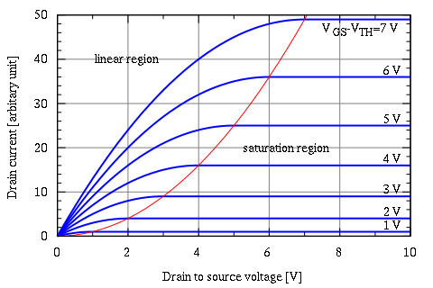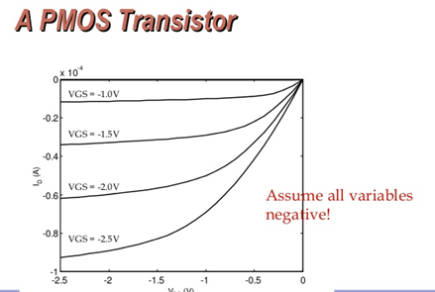

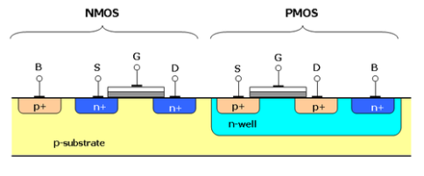

NMOS Works when a voltage is applied to the gate corresponds to the following

NMOS:
Vgs < Vt OFF
Vds < Vgs -Vt LINEAR
Vds > Vgs – Vt SATURATION
PMOS Works when a voltage is applied to the gate corresponds to the following

PMOS
Vsg < |Vt| OFF
Vsd < Vsg – |Vt| LINEAR
Vsd > Vsg – |Vt| SATURATION

- In parallel with the increase of IC operating frequencies, how do the roles of parasitic C and L change?

As frequencies increase, this will change
- the characteristics of the signals traveling in the IC
- The capacitance and inductance of devices
- X_{L}=2*pi*f*L as Frequency increases, X_{L} increases and same for X_{C}=1/(2*pi*f*C)

- What are the trends of power consumption related to IC evolution?

- We have three type of power:
  - Dynamic Power –Charging and discharging load capacitances
  - Short Circuit power –Occurs when PMOS and NMOS devices on simultaneously
  - Static Current –Bias circuitry in analog circuits
  - Leakage Current –Reverse-biased diode leakage –Subthreshold leakage –Tunneling through gate oxide

As the IC technologies get smaller, meaning more transistors per cm^2, will lead to more power consumption but will be less per devices .

- What are the basic steps for CMOS IC fabrication?

- Step One:
  - Wafer Production
  - Epitaxial growth
- Step Two:
Masking: To protect other parts of wafers when working on specific place or area of the wafer
- Etching
  - It removes material selectively from the surface of wafer to create patterns. The pattern is defined by etching mask. The parts of material are protected by this etching mask
- Step 4:
- Doping:
To alter the electrical character of silicon, atom with one less electron than silicon such as boron and atom with one electron greater then silicon such as phosphorous are introduced into the area.
- Atomic diffusion
In this method p and n regions are created by adding dopants into the wafer. The wafers are placed in an oven which is made up of quartz and it is surrounded with heating elements.
- Ion implantation
This is also a method used for adding dopants. In this method, dopant gas such as phosphine or boron trichloride will be ionized first. Then it provides a beam of high energy dopant ions to the specified regions of wafer
- Step 5
- Metalization
It is used to create contact with silicon and to make interconnections on chip. A thin layer of aluminum is deposited over the whole wafer. Aluminium is selected because it is a good conductor, has good mechanical bond with silicon, forms low resistance contact and it can be applied and patterned with single deposition and etching process.
- Assembly and packaging
Each of the wafers contains hundreds of chips. These chips are separated and packaged by a method called scribing and cleaving. The wafer is similar to a piece of glass.

- What are the main IC Characteristics?
Power , Area, speed, timing

- What are the main IC parasitic?

- Inductance 2. Capacitance 3. Resistance

- Explain What do we mean by process node? And how does that affect IC characteristics

  - The technology node (also process node, process technology or simply node) refers to a specific semiconductor manufacturing process and its design rules.
  - Different nodes often imply different circuit generations and architectures. Generally, the smaller the technology node means the smaller the feature size, producing smaller transistors which are both faster and more power-efficient. Historically, the process node name refered to a number of different features of a transistor including the gate length as well as M1 half-pitch

