* **Lab2_Solution:**
* ***Create layout CellView for Cell Nand.***
* 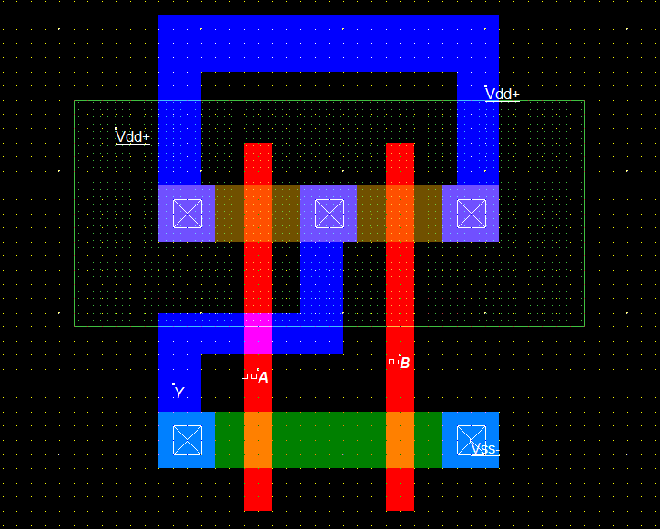Layout:
* 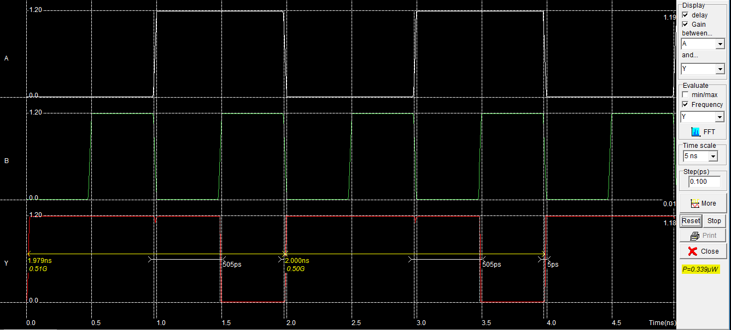Simulation & Power:
* Power = 0.339uW. since, time scale = 5ns and Step = 0.1 PS.
* 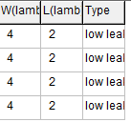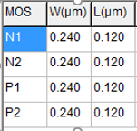At Lambda = 0.060 um.