**Maher Saleem 1130258  
IC Sec2**

**Homework #1**

**Q1**

When we apply a positive gate voltage above a *threshold* value induces a channel by creating a thin layer of negative charges in the substrate region adjacent to the SiO2 layer. The conductivity of the channel is enhanced by **increasing** the gate-to-source voltage and thus pulling more electrons into the channel area. For any gate voltage below the threshold value, there is no channel.

The current saturate at high VDS since the width of the channel area is limited (this depends of the geometry of the MosFet and **the value of Vgs**) . Also since the channel became thin in the drain , this will limit the current.

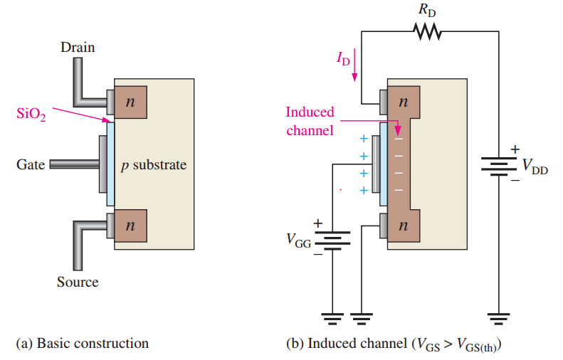

**Q2**

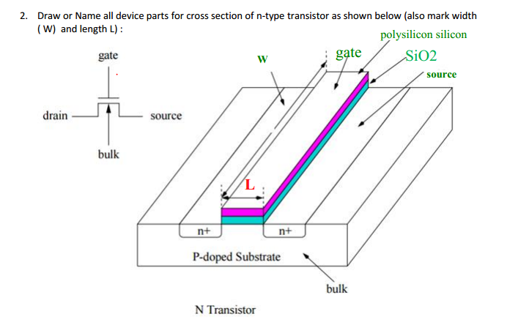

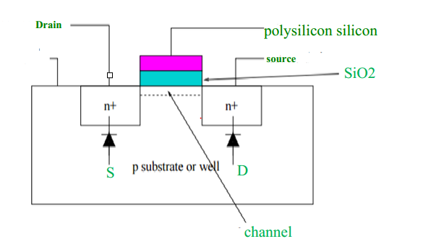

**Q3**.

The NMOSFET has three regions  
1)cut off region: when the (Vgs < Vt ) , this will make the current between drain and source is zero.

2linear region : when (Vgs - Vt > Vds > 0V) ,it’s the region when we increase Vds , the Ids increases (as a linear function).

3) Saturation region : when ( Vds > Vgs – Vt) , this will lead to the max current by the applied Vgs

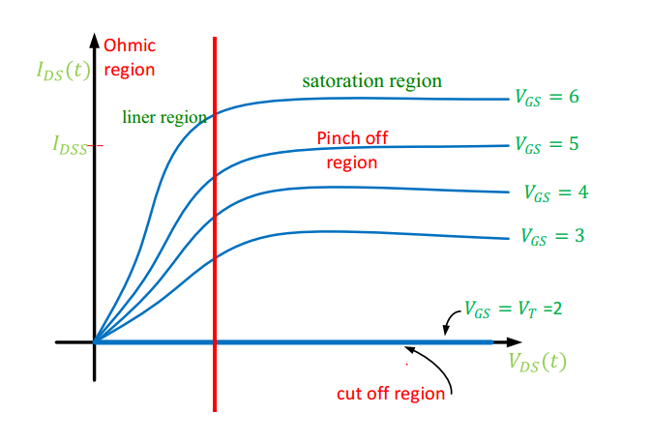

**Q4.**

This is the formula of the current across Ids .

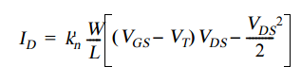

We notice that its depends on the width and the length of the Mosfet. and this is obvious since if the width is larger , this will allow more electrons to pass from the drain to source . Also if the Length is larger , this implies that electrons need more energy to go from the drain to source.

**Q5.**

VT is a function of several components, most of which are material constants such as the difference in work-function between gate and substrate material, the oxide thickness, the Fermi voltage, the charge of impurities trapped at the surface between channel and gate oxide, and the dosage of ions implanted for threshold adjustment. Also the source-bulk voltage VSB has an impact on the threshold. The parameter g (gamma) is called the body-effect coefficient, and expresses the impact of changes in VSB.



References :

* **Electronic Devices - Floyd 9th Edition**
* **Digital Integrated Circuits a Design Perspective, Second Edition**