

Faculty of Engineering and Technology
Electrical and Computer Engineering Department
Digital Integrated Circuit
ENCS333

Quiz No. 3

- Prepared by: Ayham Hashesh 1161301

- Instructor: Dr. Khader Mohammad

- Section No.: 1

- Date: 28-4-2020

- List thee advantage of domino design (Dynamic Logic)?
- Full swing outputs (VOL = GND and VOH = VDD).
- Non-ratioed sizing of the devices does not affect the logic levels.
- Faster switching speed.
- What are the issues of domino design (Dynamic Logic)?
- Overall power dissipation usually higher than static CMOS.
- Pull down network starts to work as soon as the input signals exceeds VTN, so VM, VIH and VIL equal to VTN. (Low noise margin)
- Needs a precharge/evaluate clock.
- List three CMOS Logic advantage?
- Full rail-to-rail swing: High Noise Margin.
- No direct path steady state between power and ground: No static power dissipation.
- Always a path to V_{DD} or Ground in steady state: Low output impedance.
- Define Charge Sharing? Do we have charge sharing problem in the attached figure? if yes how do we solve it
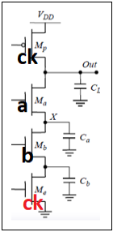
- Charge sharing: Charge stored originally in C_{L} is redistributed (shared) over C_{L} and other capacitors leading to reduce roubstness.
- Yes we have charge sharing problem.
- To solve: Precharge internal nodes using a clock driven transistor (at the cost of increased area and power).

- What is the function of the attached layout? Is this an optimal design? Explain
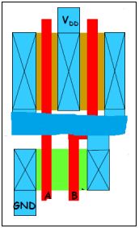
- Nand Gate.
- No, It’s not the optimal design as there exists many capacitance which can be reduced if we shred the diffusion

