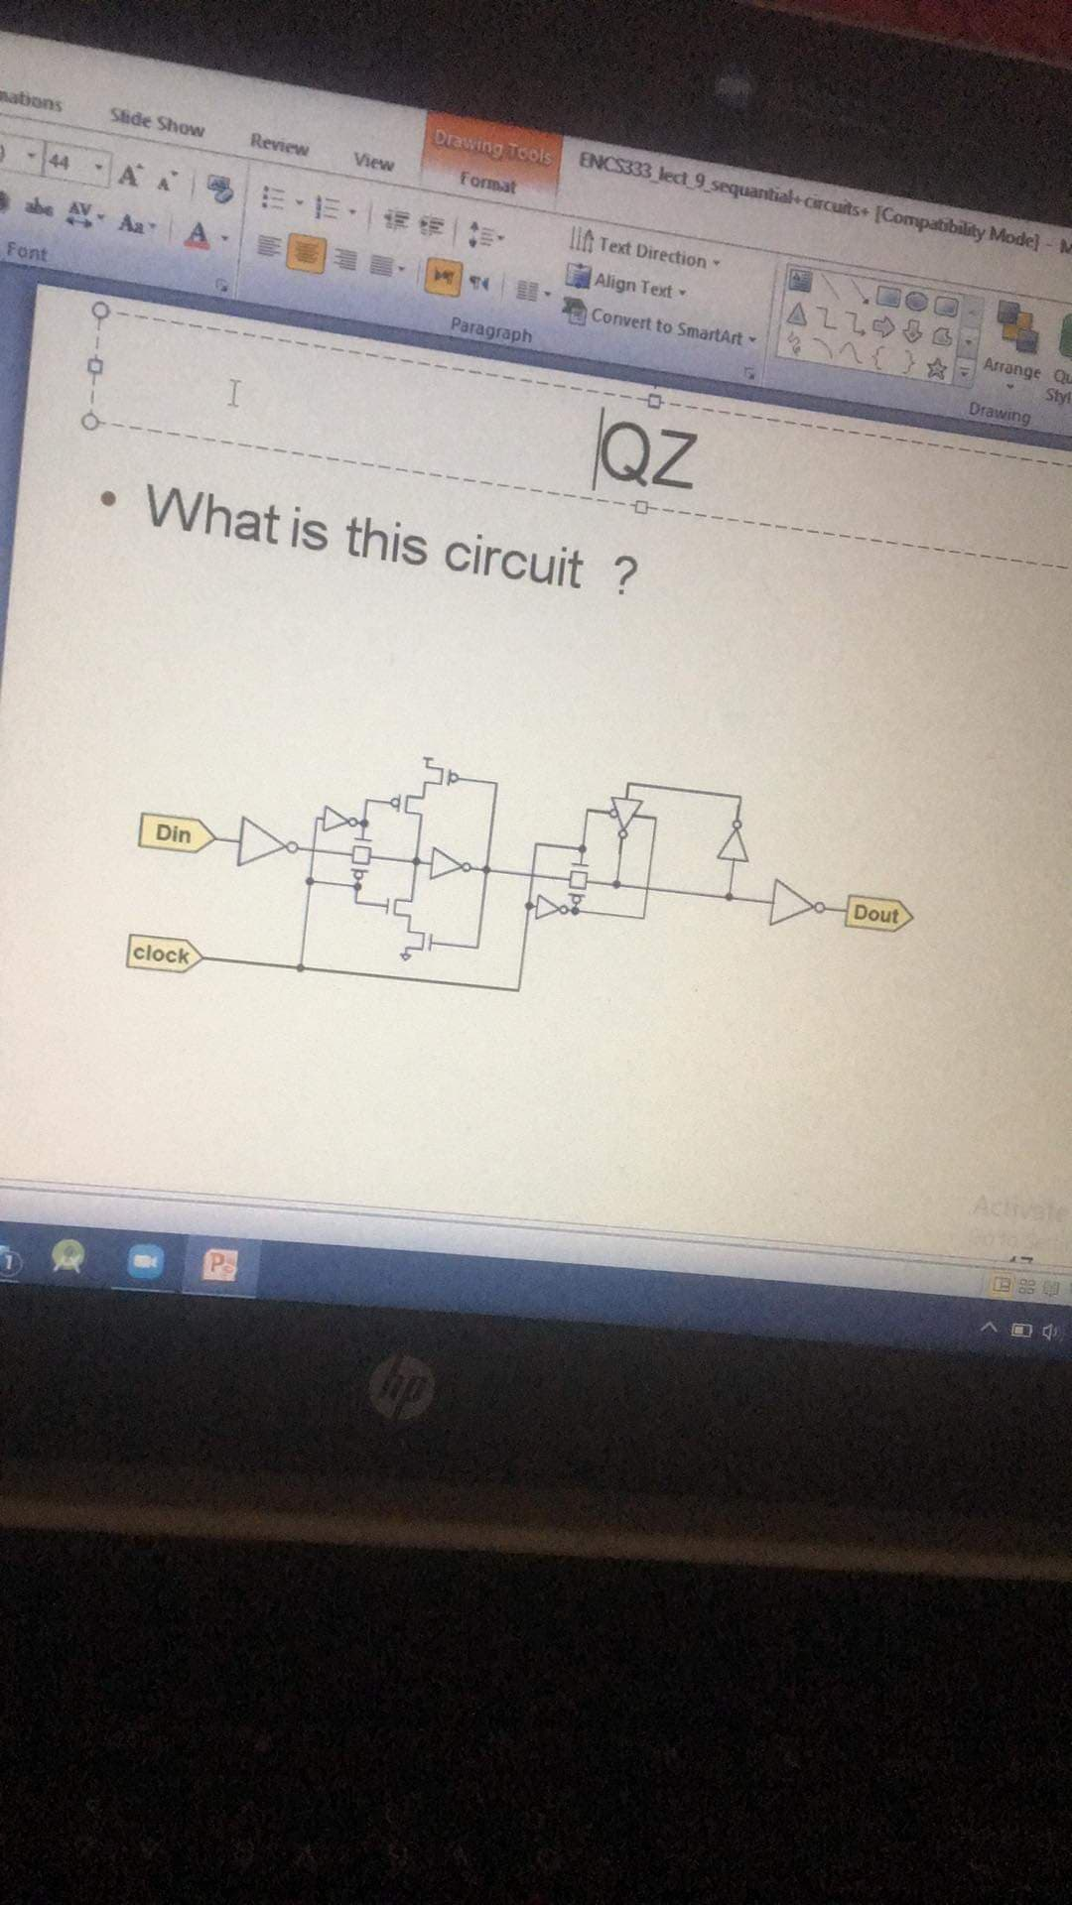

*Note 1 that this quiz was a surprise exam*

***Answer***

Rising edge flip flop

*Note 2 he could ask you to invert his type*

* *All you need is to invert the clock*