

**Faculty of Engineering**

**Electrical and Computer Engineering Department**

**Integrated Circuits**

IC Homework #1

Student name:

Mohammad Mouadi

Student ID:

1162246

Instructor name:

D. Khader Mohammad

Q1: Cmos: known as Complementary metal–oxide–semiconductor, is a technology of constructing integrated circuits.

CMOS transistors work usually as switches that goes on and off which gives us the ability to construct many logic gates.

PMOS:

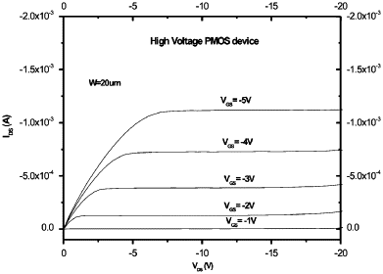

NMOS: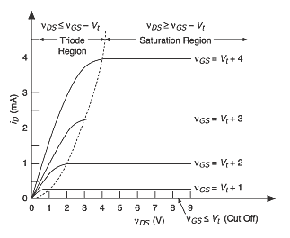

Q2: In high frequencies, Capacitance parasitic appears clearly, and we need to deal with it once it causes problems.

Inductance appears as Capacitance in high frequencies.

Q3: IC technology is getting smaller (Length in CMOS transistors is getting smaller) which leads to faster devices. However, it consumes more power (The power actually becomes 3 times more every 10 years).

Q4: IC fabrication steps:

1. Wafer production
2. Masking
3. Etching
4. Doping
5. Metallization
6. Assembly and packaging

Q5: Power is discussed in question 2. Area is getting smaller and smaller over time. ICs are getting faster because of shrinking the the process. Timing.

Q6: Inductance, capacitance and resistance parasitic

Q7: To define the process node, a process must be defined. A process is: set of steps to make an integrated circuit with transistors that meet a certain range of performance and size characteristics.

The process node is: is a standardized process used across a wide range of products.  Standardizing the process for multiple products makes yield and process improvement much easier, since the same resources can solve complex problems