

**Faculty of Engineering**

**Electrical and Computer Engineering Department**

**Integrated Circuits design**

IC homework#3

Student name:

Mohammad Mouadi

Student ID:

1162246

Instructor name:

D. Khader Mohammad

Part1:

Schematic:

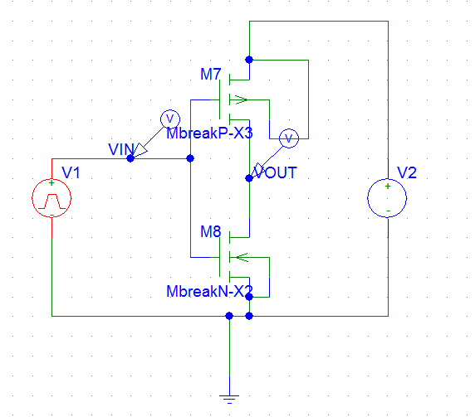

NMOS specifications:

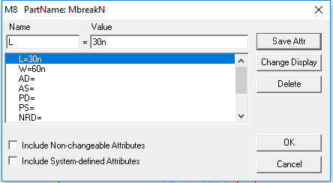

PMOS specifications:

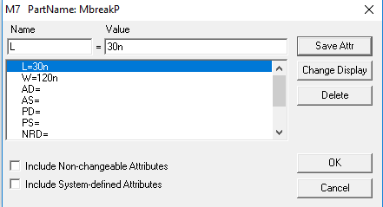

Simulation:

Fall time (2 ps):

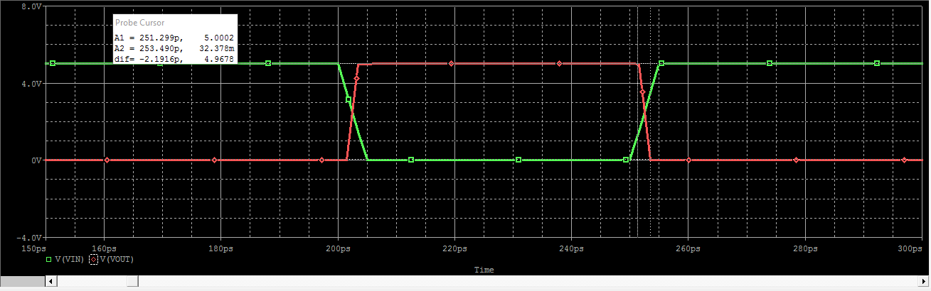

Rise time (2 ps):

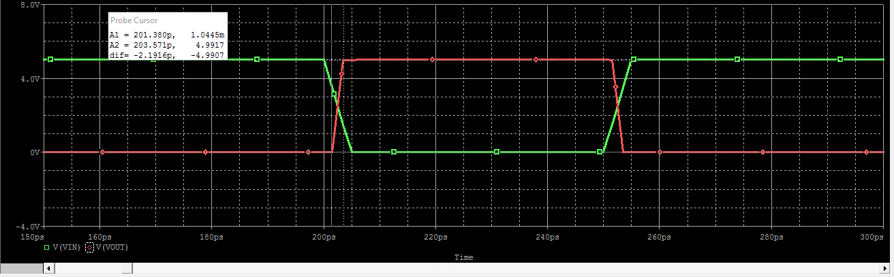

Part2:

Layout:

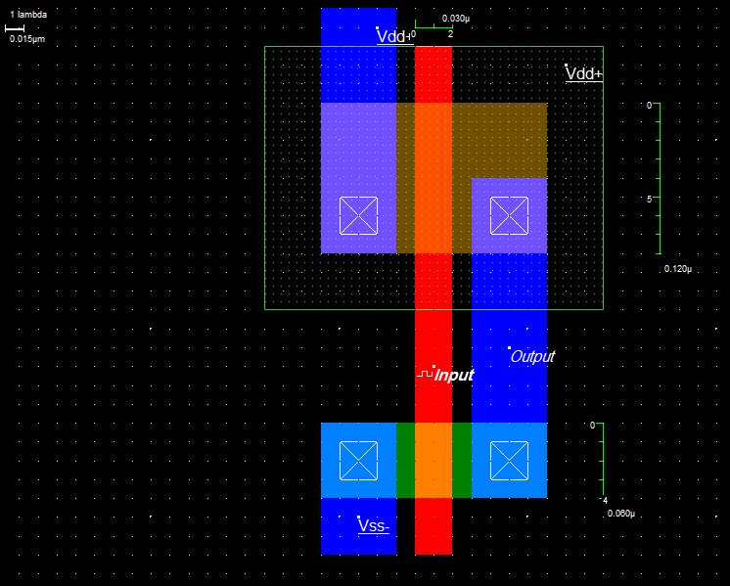

Simulation(Fall and rise time almost 2 ps):

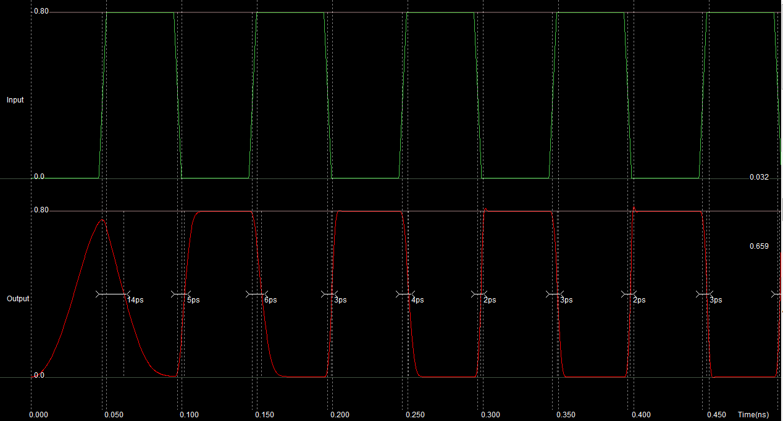

Part3:

Layout:

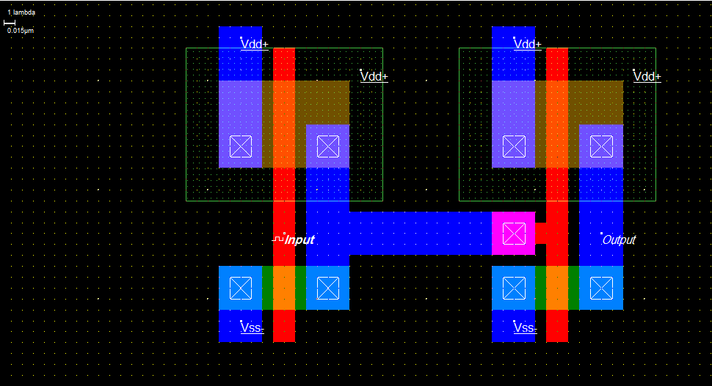

Simulation:

