

Electrical and Computer Systems Engineering Department
ENCS333
Homework 5

Due December 6th
Question 1 :
- Draw the schematic corresponding to the layout below
- What logic function does the circuit implement? To which logic family does the circuit belong?
- Does the circuit have any advantages over fully complementary CMOS?
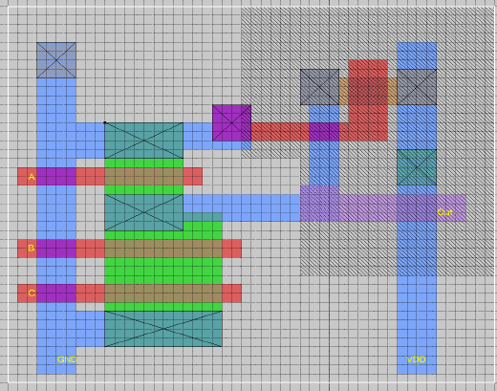

Question 2:
Design, lay out, and simulate a CMOS four-input XOR gate in the standard 0.25 micron CMOS process. You can choose any logic circuit style, and you are free to choose how many stages of logic to use: you could use one large logic gate or a combination of smaller logic gates.
The supply voltage is set at 2.5 V! Your circuit must drive an external 20 fF load in addition to whatever internal parasitic are present in your circuit.
The primary design objective is to minimize the propagation delay
of the worst-case transition for your circuit. The secondary objective is
to minimize the area of the layout. At the very worst, your design must
have a propagation delay of no more than 0.5 ns and occupy an area of
no more than 500 square microns, but the faster and smaller your circuit,
the better. Be aware that, when using dynamic logic, the precharge time
should be made part of the delay.
The design will be graded on the magnitude of A × tp2, the product of the area of your design and the square of the delay for the worst-case transition.

