

Electrical and Computer Systems Engineering Department
ENCS333
Homework 2

Due October 11th

- If a designer wants a perfectly balanced rise time and fall time for a CMOS inverter driving a capacitive load, what should the ratio of NMOSFET to PMOSFET transistor widths be?
- Since the mobility of electron is normally twice of the mobility of holes, we need to make the width of PMOS twice as large as the width of NMOS.
- In the context of digital integrated circuits, what are holes? Use three or fewer sentences.

- Majority carrier in the PMOS carries positive charge.
- List three advantages of CMOS over NMOS, and one advantage of NMOS over CMOS.

  - adv. of CMOS :
    - Less power consumption
    - High noise immunity
    - Faster
  - Adv. of NMOS
  - Smaller gate
- Delay depends on the input patterns. Consider Figure 1.
- In input pattern P, inputs A and B are each low for a long time,then input B transitions instantly to VDD.
- In input pattern Q, inputs A and B are each low for a long time, then both transition to VDD simultaneously and instantly. Which input pattern results in more delay? Explain why

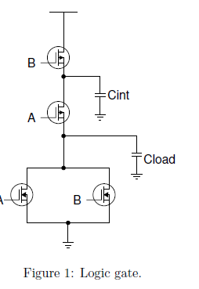

P results more delay
- Show the circuit diagram for the function below using pass gate with output buffer or inverter.

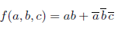
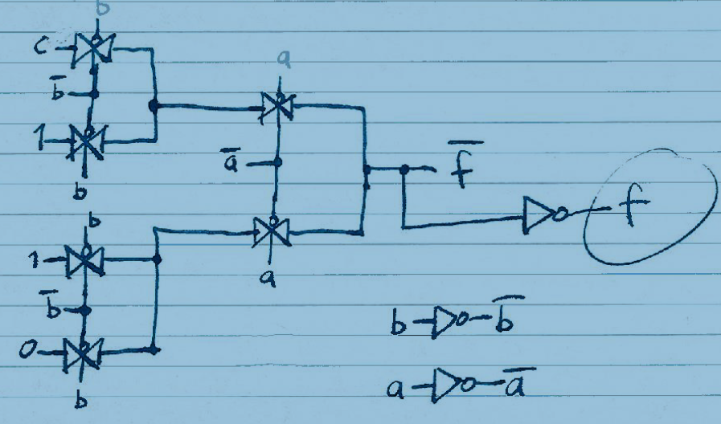

- Use default parameters unless alternate values are given. Write a logic equation for this complex gate.
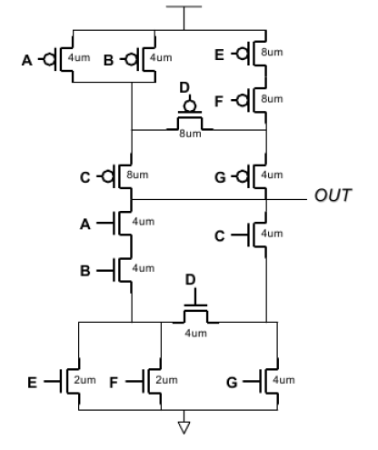
- Determine the bias state (Region of operation) for the three circuit conditions if Vtn = 0.4 V. The source voltage is always lower than the drain voltage in an nMOS transistor. First identify the correct terminals.

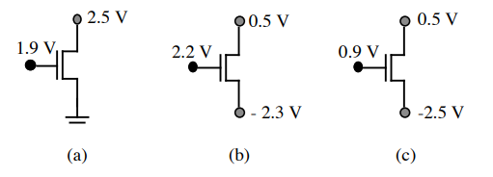
- VGS = 1.9 V, VDS = 2.5 V, Vtn = 0.4 V, therefore VGS = 1.9 V < 2.5 V + 0.4 V = 2.9 V
is satisfied, and the transistor is in the saturated state
- VGS = VG – VS = 2.2 V – (– 2.3 V) = 4.5 V. VDS = VD – VS = 0.5 V – ( –2.3) = 2.8 V. Therefore, VGS = 4.5 V > 2.8 V + 0.4 V = 3.2 V the transistor is in non-saturation.
- ) VGS = VG – VS = 0.9 V – (– 2.5 V) = 3.4 V. VDS = VD – VS = 0.5 V – (– 2.5 V) = 3 V. Therefore, VGS = 3.4 V = VDS + Vtn = 3 V + 0.4 V = 3.4 V, and the transistor is at the boundary of the saturated and non-saturated regions.

- Calculate ID and VDS if Kn = 100 µA/V2 , Vtn = 0.6 V, and W/L = 3 for transistor M1.
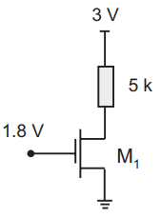
Current in saturated state :
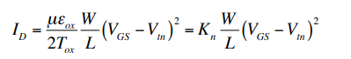

The bias state of M1 is not known so we must initially assume one of the two states, then solve for bias voltages and check for consistency against that transistor bias condition. Initially, assume that the transistor is in the saturated state so that
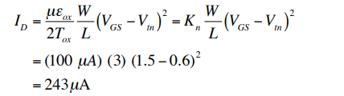
Using Kirchhoff’s Voltage Law (KVL)
VDS = VDD − IDR = 5 − (243 mA)(15 kΩ) =1.355V
We assumed that the transistor was in saturation, so we must check the result to see if that is true. For saturation
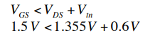
so the transistor is in saturation, and our assumption and answers are correct.

- Repeat Q8 above finding ID and VDS if VG = 1.8 V

Assume a transistor saturated state and

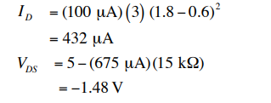
This value for VDS is clearly not reasonable since there are no negative potentials in the circuit. Also the bias check gives
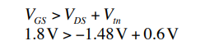
The initial saturated state assumption was wrong, so we repeat the analysis using the non-saturated state assumption
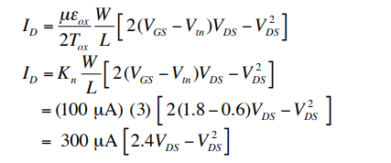
This equation has two unknowns, so another equation must be found. We will use the KVL
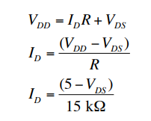
The two equations can be equated to their ID solution giving
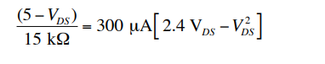

The solutions are VDS = 0.531 V, 2.09 V
The valid solution is VDS = 0.531 V, since this satisfies the non-saturation condition that was used in its solution.
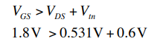
AND
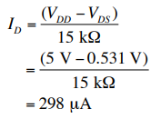

- Determine the bias state for the pMOS transistors where Vtp = -0.4 V. It is helpful with pMOS transistors to first identify and label the source and drain terminals. The source terminal in a pMOS transistor has a higher voltage than the drain terminal.

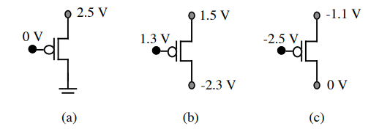
- VGS = – 2.5 V, VDS = – 2.5 V, therefore VGS > VDS + Vtp, or – 2.5 V > – 2.5 + (– 0.4) V, so the transistor is in saturation.
- (b) The gate voltage is not sufficiently more negative than either drain or source terminal to invert holes at the oxide interface, so that the transistor is in the offstate.
- (c) VGS = – 2.5 – (– 1.1) = – 1.4 V, VDS = 0 – ( – 1.1) = 1.1 V. What is wrong? The gate voltage is sufficiently negative to turn on the transistor, but the source to drain voltage is negative. Holes must leave the source and flow to the drain, but they can’t under this conclusion. The answer is that the drain terminal with a lower voltage is on the top and the source on the bottom so that VGS = – 2.5 – 0 = – 2.5 V, VDS = – 1.1 – 0 = – 1.1 V. Therefore VGS > VDS + Vtp, or – 2.5 V < – 1.1 + (– 0.4) V, so the transistor is in non-saturation. The pMOS source terminal always has a higher voltage than the drain terminal.

- Calculate ID and VDS for Vtp = –1.0 V, Kp = 100 µA/ V2 , and W/L = 4




