

Electrical and Computer Systems Engineering Department
ENCS333
Qz1

- Define CMOS ?
Complementary Metal Oxide Semiconductor “CMOS

- Below is cross section of CMOS
  - Mark Types of transistor
  - Label Gate, Drain source and bulk for each device

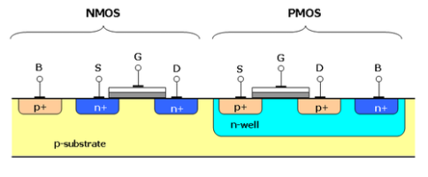
- What do we mean by technology node ?

Process technology/Length of devices

- The main IC Characteristics are Power , Area, speed (timing) , how does technology node affect :
chip size
speed
Power
Complexity
efficient. Historically, the process node name refered to a number of different features of a transistor including the gate length as well as M1 half-pitch

technology node means the smaller the feature size, producing smaller transistors which are both faster and more power-efficient. Historically, the process node name refered to a number of different features of a transistor including the gate length as well as M1 half-pitch

