

Electrical and Computer Systems Engineering Department
ENCS333
Qz1

- Below is cross section of CMOS
  - Mark Types of transistor
  - Label Gate Drain source and bulk for each device
  - Draw symbol view for each device

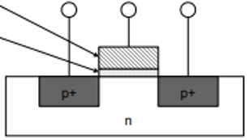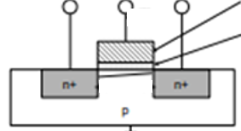

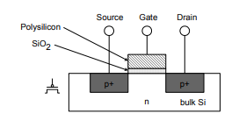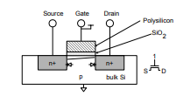

- show operation region of each device? Draw the ID vs VDs curve

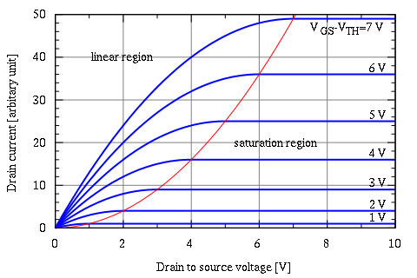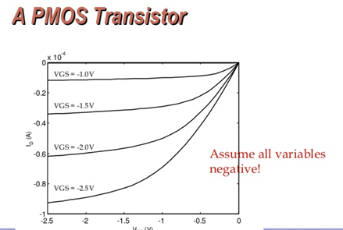

- Which one of these IC Characteristics Power, Area, speed (timing ) got affected by changing the process node ?
Area
speed
Power
Complexity
efficient. Historically, the process node name referred to a number of different features of a transistor including the gate length as well as M1 half-pitch

technology node means the smaller the feature size, producing smaller transistors which are both faster and more power-efficient. Historically, the process node name referred to a number of different features of a transistor including the gate length as well as M1 half-pitch

