

**Electrical and Computer Systems Engineering Department**

**ENCS333**

**Qz2**

Determine the bias state (Region of operation) for the three circuit conditions if **Vtn = 0.4** V. The source voltage is always lower than the drain voltage in an nMOS transistor. First identify the correct terminals.

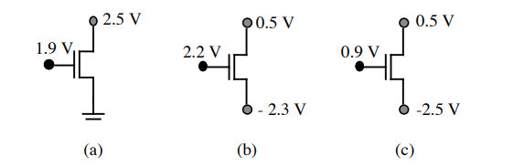

Solution:

