

**Electrical and Computer Systems Engineering Department**

**ENCS333**

**Qz3**

**What the type of failure in the following:**

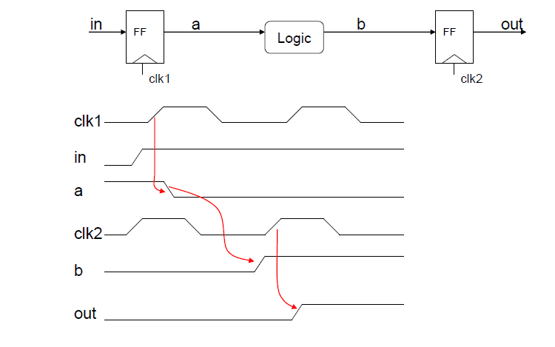

Solution:

