Dear Students,

Each student is required to submit a report about Static and Dynamic Routing.

It should include:

1. Cover Page
2. Abstract
3. Table of Contents
4. Introduction (Theoretical Background)
5. Procedure (Topology and the commands you used to build it)
6. Discussion
7. Conclusion
8. References

In the introduction you should include all the relevant details (Theory) that we discussed during the lab in regards to static routing as well as dynamic routing (Distance vector and Link state) and RIP.

In the Procedure you should create this topology (you don’t need to use the same router type):

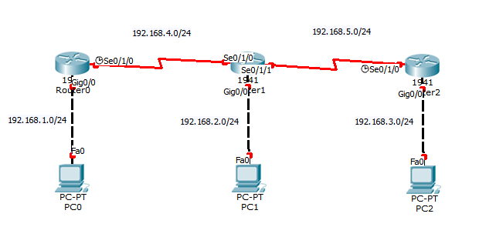

Figure – Topology

You should establish routing using RIPv1 as well as static routing. However, it is sufficient that you explain the commands entered on one of the routers and PCs; since the other routers will have the same commands.

In the discussion, you should include your results as well any discussion about the different routing techniques and/or algorithms.

In the references, you should include all the references you have used, written in the scientific method of citing!

Do not copy and paste from the internet, use your own words (paraphrase). If you need to take something, cite it in the references, but this should be done moderately and should not be done to a full paragraph.

Make sure that your report is neat and easily read, always put captions under your figures, tables and equations.