

COMPUTER SYSTEMSENGINEERING DEPARTMENT

COMPUTER NETWORKS LABARATORY

**(ENCS 413)**

***Report On:***

***{Internet Protocol Version 6 (IPv6)}***

**Student name:**Amjad majed Albalawi **Student ID:**1102083

**Instructor Name:** DR. Bayan Nimer.

**Teacher Assistant:** MR. Elias Hazboun.

Contents

Subject page

Abstract 2

Introduction 2

Procedure 4

Comparison and Discussion 10

Conclusion 10

References 10

**Abstract:**

Every computer system and device connected to the Internet is located by an IP address. The current system of distributing IP addresses is called IPv4. This system assigns each computer a 32-bit numeric address, such as 120.121.123.124. However, with the growth of computers connected to the Internet, the number of available IP addresses are predicted to run out in only a few years. This is why IPv6 was introduced.

**1. Introduction**

IPv6 (***I***nternet ***P***rotocol ***V***ersion ***6***) is also called IPng (***I***nternet ***P***rotocol ***n***ext ***g***eneration) and it is the newest version of the Internet Protocol (IP) reviewed in the IETF standards committees to replace the current version of IPv4 (***I***nternet ***P***rotocol ***V***ersion ***4***).[1]

Compared to IPv4,IPv6 offers better addressing, security and other features to support large worldwide networks.

In IPv6, IP addresses change from the current 32-bit standard and dotted decimal notation to a new 128-bit address system. IPv6 addresses remain backward compatible with IPv4 addresses. For example, the IPv4 address "192.168.100.32" may appear in IPv6 notation as "0000:0000:0000:0000:0000:0000:C0A8:6420" or "::C0A8:6420".   
  
The most obvious benefit of IPv6 is the exponentially greater number of IP addresses it can support compared to IPv4. Many countries outside the U.S. suffer from a shortage of IP addresses today. Because IPv6 and IPv4 protocols coexist, those locales with an address shortage can easily deploy new IPv6 networks that work with the rest of the Internet. Experts believe it will take many more years before all networks fully change over to IPv6.   
  
Other benefits of IPv6 are less obvious but equally important. The internals of the IPv6 protocol have been designed with scalability and extensibility in mind. This will allow many different kinds of devices besides PCs, like cell phones and home appliances, to more easily join the Internet in future.[2]

There are many ways in order to use an existing **IPv4** routing infrastructure to carry **IPv6** traffic.

**1)** **IPv6 tunneling**: Tunneling techniques are usually classified according to the mechanism by which the encapsulating node determines the address of the node at the end of the tunnel. In router-to-router or host-to-router methods, the IPv6 packet is being tunneled to a router. In host-to-host or router-to-host methods, the IPv6 packet is tunneled all the way to its final destination.

The entry node of the tunnel (the encapsulating node) creates an encapsulating IPv4 header and transmits the encapsulated packet. The exit node of the tunnel (the decapsulating node) receives the encapsulated packet, removes the IPv4 header, updates the IPv6 header, and processes the received IPv6 packet. However, the encapsulating node needs to maintain soft state information for each tunnel, such as the maximum transmission unit (MTU) of the tunnel, to process IPv6 packets forwarded into the tunnel.

2)**Dual stack**: When a device has dual stack capabilities then it has access to both IPv4 and IPv6 technology available. It can use both of these technologies to connect to remote servers and destinations in parallel.

When a client wants to connect to a server (e.g.,www.example.com), the client issues two DNS requests in parallel: one request for IPv4 addresses, and one request for IPv6 addresses. After receiving the responses, the client generally follows the process described in IETF standard RFC3484 ”Default Address Selection for IPv6” which leans towards an assumption that dual stack is a state of transitioning towards and IPv6-only network, and hence prefers IPv6 above IPv4 by design. When a client receives a response including both an IPv4 and IPv6 address then based upon RFC3484 the IPv6 address is the preferred address. If, for whatever reason, the usage of that address was non-successful, an alternate address will be used, potentially a valid IPv4 address to connect to the remote location.[3]

3) **IPv6 transition mechanisms:** are technologies that facilitate the [transitioning](http://en.wikipedia.org/wiki/IPv6_deployment) of the [Internet](http://en.wikipedia.org/wiki/Internet) from its initial (and current) [IPv4](http://en.wikipedia.org/wiki/IPv4) infrastructure to the successor addressing and routing system of [Internet Protocol Version 6](http://en.wikipedia.org/wiki/IPv6) (IPv6). As IPv4 and IPv6 networks are not directly interoperable, these technologies are designed to permit hosts on either network to participate in networking with the other network.

To meet its technical criteria, IPv6 must have a straightforward transition plan from the current IPv4.[[1]](http://en.wikipedia.org/wiki/IPv6_transition_mechanisms#cite_note-RFC1726-1) The [Internet Engineering Task Force](http://en.wikipedia.org/wiki/Internet_Engineering_Task_Force) (IETF) conducts working groups and discussions through the IETF [Internet Drafts](http://en.wikipedia.org/wiki/Internet_Draft) and [Requests for Comments](http://en.wikipedia.org/wiki/Requests_for_Comments) processes to develop these transition technologies towards that goal. Some basic IPv6 transition mechanisms are defined in [RFC 4213](http://tools.ietf.org/html/rfc4213).[4]

IPv6 Address Types:

* **Unicast addresses.** A packet is delivered to one interface.
* **Multicast addresses.** A packet is delivered to multiple interfaces.
* **Anycast addresses.** A packet is delivered to the nearest of multiple interfaces (in terms of routing distance).

IPv6 does not use broadcast messages.

Unicast and anycast addresses in IPv6 have the following scopes (for multicast addresses, the scope is built into the address structure):

* **Link-local.** The scope is the local link (nodes on the same subnet).
* **Site-local.** The scope is the organization (private site addressing).
* **Global.** The scope is global (IPv6 Internet addresses).

In addition, IPv6 has special addresses such as the loopback address. The scope of a special address depends on the type of special address.

Much of the IPv6 address space is unassigned.

Table 1.1 summarizes the special IPv6 addresses

|  |  |
| --- | --- |
| 0:0:0:0:0:0:0:1 (::1) | Local host |
| 2001::/3 | Global Unicast |
| FE80::/10 | Local Unicast |

Table 1.1: Special IPv6 Addresses.

**2.** Procedure

In this experiment we will use Cisco Packet Tracer to build and configure the topology in following Figure using IPV6 static and dynamic routing.

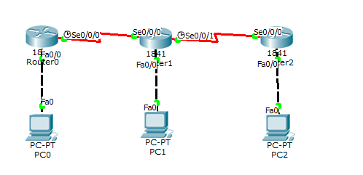

1)static routing:

First of all we set the ip configuration of pc's as the following:

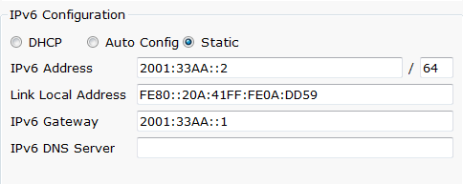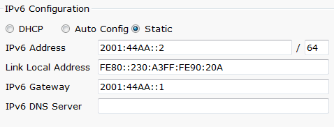

Pc0 Pc1

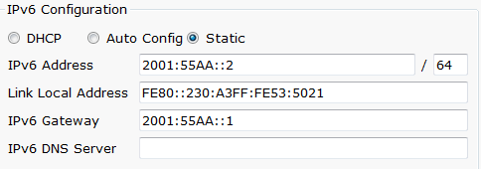

Pc2

Then we configure the routers as the following:

Router0

ipv6 unicast-routing *//Enable IPV6 routing*

interface FastEthernet0/0

ipv6 address 2001:33AA::1/64 *//assign IPV6 address for this interface*

interface Serial0/0/0

ipv6 address 2001:22AA::1/64 *//assign IPV6 address for this interface*

clock rate 64000

ipv6 route 2001:44AA::/64 2001:22AA::2 *// Enable Static routing on Router0*

ipv6 route 2001:55AA::/64 2001:22AA::2 *// Enable Static routing on Router0*

Router1

ipv6 unicast-routing *//Enable IPV6 routing*

interface FastEthernet0/0

ipv6 address 2001:44AA::1/64 *//assign IPV6 address for this interface*

interface Serial0/0/0

ipv6 address 2001:22AA::2/64 *//assign IPV6 address for this interface*

interface Serial0/0/1

ipv6 address 2001:11AA::1/64 *//assign IPV6 address for this interface*

ipv6 route 2001:33AA::/64 2001:22AA::1 *// Enable Static routing on Router1*

ipv6 route 2001:55AA::/64 2001:11AA::2 *// Enable Static routing on Router1*

Router2

ipv6 unicast-routing *//Enable IPV6 routing*

interface FastEthernet0/0

ipv6 address 2001:55AA::1/64 *//assign IPV6 address for this interface*

interface Serial0/0/0

ipv6 address 2001:11AA::2/64 *//assign IPV6 address for this interface*

ipv6 route 2001:44AA::/64 2001:11AA::1 *// Enable Static routing on Router2*

ipv6 route 2001:33AA::/64 2001:11AA::1 *// Enable Static routing on Router2*

After these configurations we expect that PC0 can reach PC1 and pc2 and vice versa, so we tried to send ICMPv6 packets between them and got the following results:

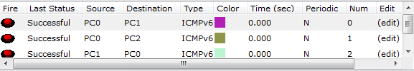



The test has been done successfully as expected.

1)dynamic routing:

Dynamic routing in IPv6 can be done by just enabling RIP on every interface of each router in the network; **Routers** has been configured as the following:

Router0

ipv6 unicast-routing *//Enable IPV6 routing*

interface FastEthernet0/0

ipv6 address 2001:33AA::1/64 *//assign IPV6 address for this interface*

ipv6 rip 1 enable *// enable dynamic routing algorithm (RIP)*

interface Serial0/0/0

ipv6 address 2001:22AA::1/64 *//assign IPV6 address for this interface*

ipv6 rip 1 enable *// enable dynamic routing algorithm (RIP)*

clock rate 64000

Router1

ipv6 unicast-routing *//Enable IPV6 routing*

interface FastEthernet0/0

ipv6 address 2001:44AA::1/64 *//assign IPV6 address for this interface*

ipv6 rip 1 enable *// enable dynamic routing algorithm (RIP)*

interface Serial0/0/0

ipv6 address 2001:22AA::2/64 *//assign IPV6 address for this interface*

ipv6 rip 1 enable *// enable dynamic routing algorithm (RIP)*

interface Serial0/0/1

ipv6 address 2001:11AA::1/64 *//assign IPV6 address for this interface*

ipv6 rip 1 enable *// enable dynamic routing algorithm (RIP)*

Router2

ipv6 unicast-routing *//Enable IPV6 routing*

interface FastEthernet0/0

ipv6 address 2001:55AA::1/64 *//assign IPV6 address for this interface*

ipv6 rip 1 enable *// enable dynamic routing algorithm (RIP)*

interface Serial0/0/0

ipv6 address 2001:11AA::2/64 *//assign IPV6 address for this interface*

ipv6 rip 1 enable *// enable dynamic routing algorithm (RIP)*

in order to test our work we do traceroute from Router0 to PC2

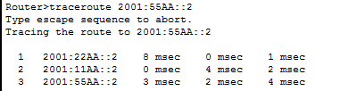

Also we use ping command from pc0 to pc1&pc2.

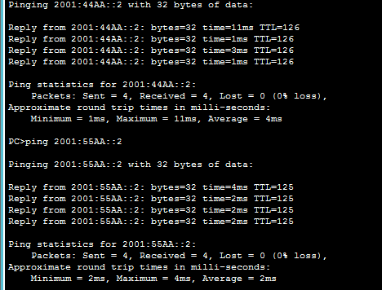

**3. Comparison and Discussion**

IPv6 is often referred to as the ["next generation" Internet standard](http://www.enterprisenetworkingplanet.com/reports/article.php/1347761/IPv6:+What+You+Need+to+Know.htm) and has been under development now since the mid-1990s. IPv6 was born out of concern that the demand for IP addresses would exceed the available supply.

While increasing the pool of addresses is one of the most often-talked about benefit of IPv6, there are other important technological changes in IPv6 that will improve the IP protocol:

**-** No more NAT (Network Address Translation)  
**-** Auto-configuration  
**-** No more private address collisions  
- Better multicast routing  
- Simpler header format  
- Simplified, more efficient routing  
- True quality of service (QoS), also called "flow labeling"  
- Built-in authentication and privacy support  
- Flexible options and extensions  
- Easier administration (say good-bye to DHCP)

**4. Conclusions**

In this experiment we learned how we can assign IPv6 addresses to the computers, and how we can configure it in Cisco Routers .we also learn how to use static and dynamic protocols in IPv6, which they give the routers the ability to connect with the other networks that not connected directly.

IPv6 provide huge pool of addresses , however we still use IPv4, The reason why the IPv4 is still being used is because the address pool supports the continual demands and extends its usefulness. Another reason is that IPv4 and IPv6 are not compatible and as a result it will take a huge financial toll in the transition which is considered an impediment, it also due to the IPv6 uses visual IPs which caused a problem called NAT .

**5.** **references**

1. IPv6, http://www.webopedia.com/TERM/I/IPng.html,13/5/2014
2. IPv6, http://compnetworking.about.com/od/networkprotocolsip/g/bldef_ipv6.htm;13/5/2014
3. Dual stack in ipv6; http://www.cisco.com/c/dam/en/us/products/collateral/ios-nx-os-software/enterprise-ipv6-solution/aag_c45-625513.pdf;13/5/2014.
4. IPv6 transition; http://en.wikipedia.org/wiki/IPv6_transition_mechanisms;13/5/2014;