

**Birzeit University**

**Computer Systems Engineering Department**

**ENCS413-Computer Networks Lab**

**IPv6**

**Prepared By:**

Mohammad Ismail 1091228

**Instructor:**

Dr. Imad Tartier

**Teaching Assistant:**

Mr. Rami Naji

**Abstract**

As the demand on the domains increases every day and the range of IPv4 is $2^{32}$, and the rest of IP's that the world have will not be enough to meet such demand, so we need to increase the range of IP's that we could use, the Internet Engineering Task Force (IETF) who developed the IPv6, and the new amount is $2^{128}$, it's a huge amount that will save us from lacking IP's in the next future, and in this experiment we will study the address in IPv6 and how we can design a topology that run IPv6.

1. **Introduction**

**IPv6** (**Internet Protocol version 6**) is the latest revision of the Internet Protocol (IP), the primary communications protocol upon which the entire Internet is built. It is intended to replace the older IPv4, which is still employed for the vast majority of Internet traffic as of 2012. IPv6 was developed by the Internet Engineering Task Force (IETF) to deal with the long-anticipated problem of IPv4 running out of addresses.

The address in IPv6 is consisting of eight groups of 4 hexadecimal digits, each group separated by colon instead of dot.

* **Unicast address:** which Packets sent to a single interface.
* **Global Unicast address:** it’s like the public address in IPv4, starts with 2000::/3.
* **Link-Local address:** like the private addresses in IPv4 in that they’re not meant to be routed and they start with FE80::/10.
* **Multicast:** same as in IPv4, packets addressed to a multicast address are delivered to all interfaces tuned into the multicast address.
* **Anycast:** in this address packet is delivered to only one device—actually, to the closest one it finds defined in terms of routing distance.

We can use the static routing and the dynamic routing to let the routers talks to each others, and these protocols is the same as in IPV4.

in the new version of dynamic protocol which is called RIPng protocol, the main difference with last version is that the protocol is configured from the interface that will use it, not from the router.

1. **Procedure**

In our experiment we will design the next topology using IPv6, as in figure 1

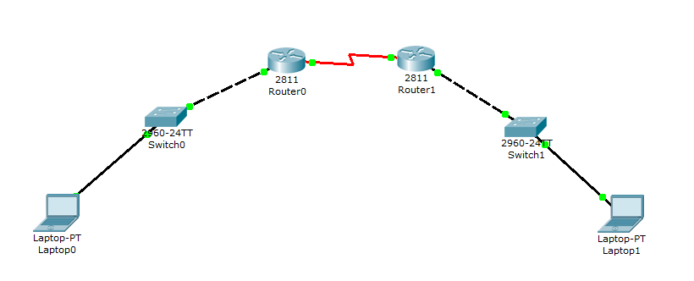

Figure 1

And our topology will have the next configuration as in table 1 and 2.

|  |  |  |
| --- | --- | --- |
| Interface | R1 | R2 |
| Fast Ethernet | 2001:11AA::1/64 | 2001:33AA::1/64 |
| Serial | 2001:22AA::1/64 | 2001:22AA::2/64 |

Table 1

|  |  |  |
| --- | --- | --- |
|  |  |  |
| Interface | NIC | NIC |
| IPV6 Address | 2001:11AA::2/64 | 2001:33AA::2/64 |
| Gateway | 2001:11AA::1 | 2001:33AA::1 |

Table 2

**Static Routing**

For example, we will take the first router to configure its interfaces, for static routing we need the networks Id's that not connected directly.

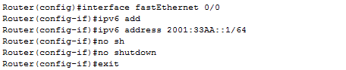

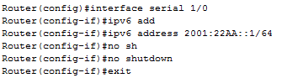



As we can see from the last configuration that the IPv6 has the same commands of IPv4.

And we did these configurations for all routers.

**Dynamic routing**

We will use the same configuration from static routing just we need to change the way the routers talks which here using RIPng protocol and this protocol is the same as RIP protocol in IPv4.

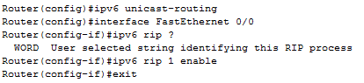

Se we need to enter each interface and define the RIPng protocol and enable it. After the configuration completed we did the ping and trace route commands from PC1 to PC2 as in figure 2.

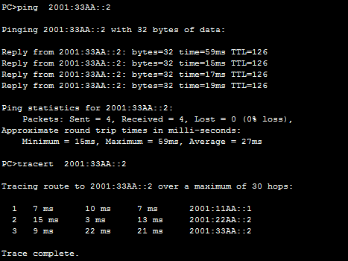

Figure 2

1. **Conclusion**

In this experiment we learned a lot of things about IPv6, how we can assign IPv6 addresses, how we can configure it in Cisco Routers. The IPv6 uses the same protocols like IPv4, static and dynamic protocols, which they give the routers the ability to connect with the other networks that not connected directly.

Still IPv6 not spread and the internet still use IPv4, because some politics reasons, but any way, IPv6 will be used in the future, since the lack of addresses will be huge, the problem on IPv6 is known as the NAT and this because IPv6 uses visual IPs.

1. **References**
2. <http://en.wikipedia.org/wiki/IPv6>
3. <http://www.worldipv6launch.org/>
4. <http://www.google.com/intl/en/ipv6/>