

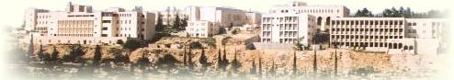

**Birzeit University**

**Computer Systems Engineering Department**

**ENCS413-Computer Networks Lab**

**OSPF**

**Prepared By:**

Yousef Madia 1100211

**Instructor:**

Dr. Bian Nymer

**Teaching Assistant:**

Mr. Elias Hazboon

**28/4/2014**

**Abstract**

In this report we are going to introduce the OSPF protocol, configure the OSPF protocol and observe its advantages and disadvantages, and then recognize the different types of routers in this protocol and learn the messages than are transfer between those routers.

**Table of contents**

**Abstract**…………………………………………………………………2

1. **Introduction**……………………………………………………...4

2.**Prosecure** …………………………………………………………..7

3.**Discussion**………………………………………………………..10

4.**Conclusion**……………………………………………………….14

5.**References**………………………………………………….……15

1. **Introduction**

**Open shortest path first (OSPF)** Stands for "Open Shortest Path First." OSPF is a method of finding the shortest path from one [router](http://www.techterms.com/definition/router) to another in a local area network ([LAN](http://www.techterms.com/definition/lan)). As long as a network is [IP-based](http://www.techterms.com/definition/ip), the OSPF algorithm will calculate the most efficient way for data to be transmitted.

If there are several routers on a network, OSPF builds a table (or topography) of the router connections. When data is sent from one location to another, the OSPF algorithm compares the available options and chooses the most efficient way for the data to be sent. This limits unnecessary delays in data transmission and prevents infinite loops.

OSPF routing is an open protocol, and uses SPF algorithm (Dijkstra algorithm). OSPF is the routing protocol of choice when:

1) There are routers from vendors other that Cisco in the network.

2) The network requires segmentation into areas or zones.

OSPF is a link-state routing protocol. That calls for sending of link-state advertisements (LSAs) to all other routers within the same area. As OSPF routers accumulate link-state information, they use the SPF algorithm to calculate the shortest path to each node.

**Dijkstra's algorithm** is called the single-source shortest path. It is also known as the single source shortest path problem. It computes length of the shortest path from the source to each of the remaining vertices.

Based on the network type, OSPF router can elect one router to be a Designated Router (DR) and one router to be a Backup Designated Router (BDR). For example, on multi-access broadcast networks (such as LANs) routers defaults to elect a DR and BDR. DR and BDR serve as the central point for exchanging OSPF routing information. Each non-DR or non-BDR router will exchange routing information only with the DR and BDR, instead of exchanging updates with every router on the network segment. DR will then distribute topology information to every other router inside the same area. This greatly reduces OSPF traffic.

To send routing information to a DR or BDR the multicast address of 224.0.0.6 is used. DR sends routing updates to the multicast address of 224.0.0.5. If DR fails, BDR takes over its role of redistributing routing information.

Every router on a network segment establish a full neighbor relationship with the DR and BDR. Non-DR and non-BDR routers establish a two way neighbor relationship between themselves.

NOTE – on point-to-point links a DR and BDR are not elected since only two routers are directly connected.

On LANs, DR and BDR have to be elected. Two rules are used to elect a DR and BDR:

1.    router with the highest OSPF priority will become a DR. By default, all routers have a priority of 1  
2.    if there is a tie, a router with the highest router ID wins the election

The router with the second highest OSPF priority or router ID will become a BDR.

**Types of Routers**

1. ABR : Area Border Router, used in area 0 and has at least one interface in area 0 and another interface with other areas.
2. IR : Internal Router, is the router that is used at the same area (internally).
3. ASBR : Autonyms System Border Router, used to connect two different autonyms systems.
4. BR : Backbone Router, is a router used in area 0 just like ABR, but it is not necessary to have interface with other areas.

**Advantages of OSPF**

1. Improves bandwidth consumption.
2. Open standard.
3. Hierarchal.
4. Authentication.
5. Supports VLSM.
6. No hop count

**Disadvantages of OSPF**

1. Complex.
2. Processor and Ram consumption.

**Tables Maintained by OSPF**

1. Routing table.
2. Topology table.
3. Neighbor table

**OSPF neighbor relationships**

1. Router ID.
2. Hello, Dead Timer.
3. Network mask.
4. Area ID.
5. Neighbors.
6. Router priority.
7. DR, BDR, IP address.
8. Authentication password.
9. **Procedure**

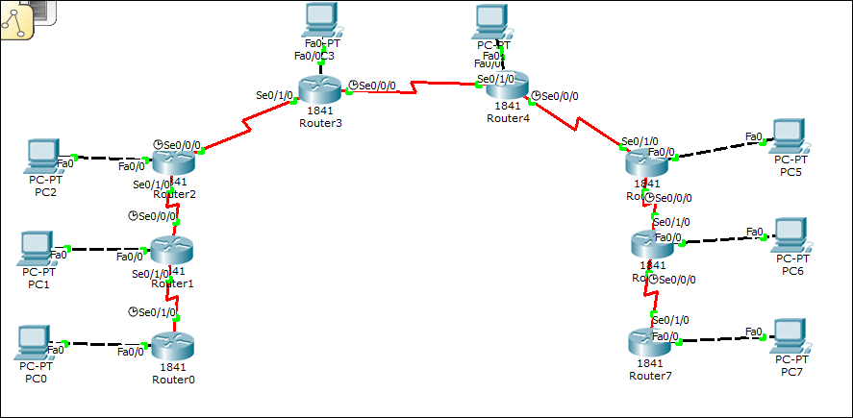

Note: explanations were made on Router 2 and PC2.

1. Router of type 1841 was chosen.
2. A Copper Cross over was used to connect between Routers.
3. A Copper Straight throw was used to connect between each router witch and the end user (PCs).
4. For configuring the PC (end user), by clicking twice on the pc, then Desktop ->IP Configuration as shown in Fig1.

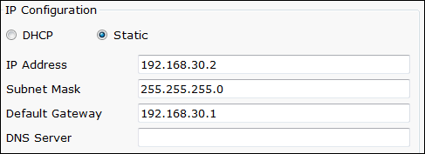

Fig1

1. For configuring the Fa0/0 of the Router, by clicking twice on the Router2, then enable -> configure -> interface Fa 0/0 as shown in Fig2.

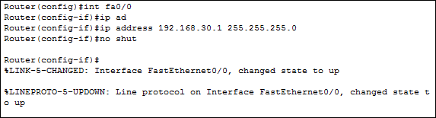

Fig2

1. For configuring the serial of the Router, by clicking twice on the Router2, then enable -> configure -> interface serial 0/0/0 and serial 0/1/0 as shown in Fig3 and Fig 4.

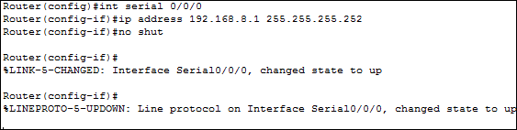

Fig3

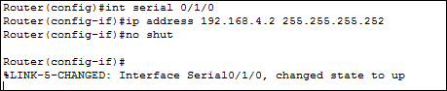

Fig4

1. For configuring the OSPF protocol on the Router , by clicking twice on the Router2, then enable -> configure ->router OSFF 1 ->network 192.168.0.4 0.0.0.3 area 2 as shown in Fig 5.

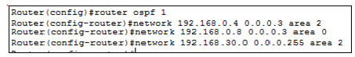

Fig5

1. For testing that topology was configured correctly, show IP route command was used, as shown in Fig 6.

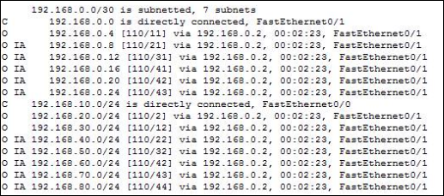

Fig 6

1. For verifying the connectivity between the PCs (PC0->PC1, PC0->PC2) the command ping was used as shown in Fig 7.

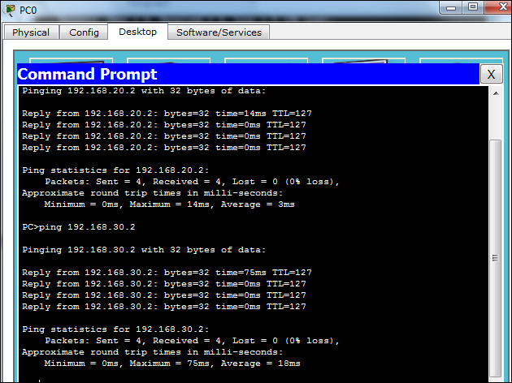

Fig 7

1. **Discussion**

1. Part 1



By talking router R1 as the first node so its distance = zero, the shortest path is R1,R2,R4,R5,R7 as calculated in the steps shown is Table1 with minimum cost =10 .

|  |  |  |  |  |  |  |  |
| --- | --- | --- | --- | --- | --- | --- | --- |
| Step | N’ | D(R2),P(R2) | D(R3),P(R3) | D(R4),P(R4) | D(R5),P(R5) | D(R6),P(R6) | D(R7),P(R7) |
| 0 | R1 | 2,R2 | 4,R3 | ∞ | ∞ | ∞ | ∞ |
| 1 | R1,R2 |  | 4,R1 | 4,R2 | 12,R2 | ∞ | ∞ |
| 2 | R1,R2,  R3 |  |  | 4,R2 | 12,R2 | ∞ | ∞ |
| 3 | R1,R2,  R3,R4 |  |  |  | 8,R4 | 8,R4 | 24,R4 |
| 4 | R1,R2,  R3,R4,  R6 |  |  |  | 8,R4 |  | 12,R6 |
| 4 | R1,R2,  R3,R4,  R6,R5 |  |  |  |  |  | 10,R5 |
| 5 | R1,R2,  R3,R4,  R6,R5,  R7 |  |  |  |  |  |  |

Table1

1. Part2

The addresses of each router is shown in Table 2.

|  |  |
| --- | --- |
| 192.5.79.0 | 192.5.79.3 |
| 192.5.79.4 | 192.5.79.7 |
| 192.5.79.8 | 192.5.79.11 |
| 192.5.79.12 | 192.5.79.15 |
| 192.5.79.16 | 192.5.79.19 |
| 192.5.79.20 | 192.5.79.23 |
| 192.5.79.24 | 192.5.79.27 |
| 192.5.79.28 | 192.5.79.31 |
| 192.5.79.32 | 192.5.79.35 |
| 192.5.79.36 | 192.5.79.39 |

Table 2

We want to now to enable OSPF protocol for each router and as we know the OSPF protocol exactly the same RIP protocol when we need to define the neighbors networks for example, we will show the command used in Router 1.

R1(config)#router ospf 1

R1(config-router)#network 192.5.79.0 0.0.0.3 area 0

R1(config-router)#network 192.5.79.4 0.0.0.3 area 0

We need to define loopback on R7 and advertize it for area 0 as shown in Fig 8.

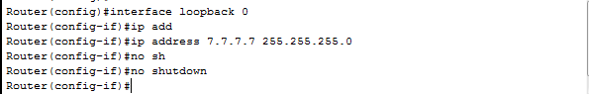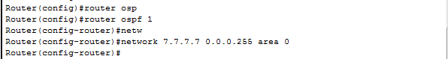

Fig8

And now we need to define the cost on each link, for example we will take the router one, and see how we can put the cost for its interfaces.

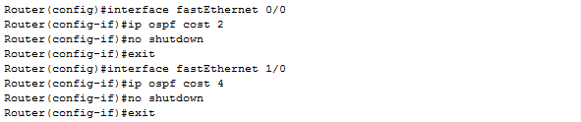

Now we use traceroute command on router 1 to send packets to loopback 7.7.7.7 as shown in Fig 9.

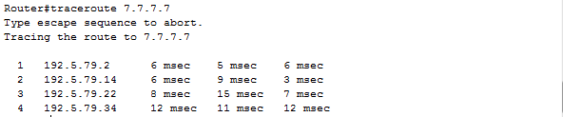

Fig 9

If we use show ip route in router one, we will have

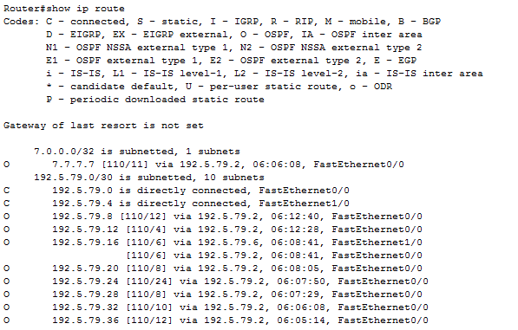

Fig10

If we need the router ID, we can use "show ip ospf" command on each router as shown in Fig 11.

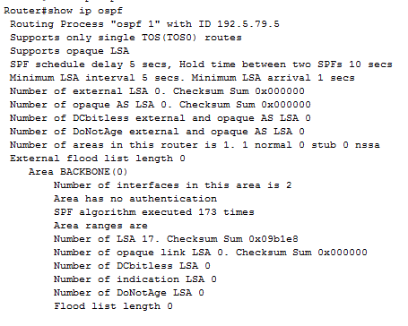

Fig11

We found that R1 has the ID of 192.5.79.5.

1. **Conclusion**

By the end if this experiment, many objectives were achieved. First of all OSPF protocol was covered successfully, by getting more information about its advantages, types and OSPF neighbor relationships.

OSPF was then simulated (using the packet tracer) on two different topology as practical examples and one topology was configured in the lab and so we become more familiar with the OSPF protocol.

1. **References**

OSPF definition,<http://www.techterms.com/definition/ospf>,25/4/2014.

OSPF definition, <http://en.wikipedia.org/wiki/Open_Shortest_Path_First,25/4/2014>.

Designated backup and designated router, http://study-ccna.com/designated-backup-designated-router,25/4/2014

Dijkstra's algorithm,http://www.cs.nyu.edu,25/4/2014