Static routing: a router that is manually configured its routing table by the administrator, and it's suitable for small not for large networks since the administrator will configure it manually.

Static routers are not fault tolerant. The lifetime of a manually configured static route is infinite and, therefore, static routers do not sense and recover from downed routers or downed links.

Dynamic routing: a router that are supported by software applications running on the router which dynamically learn network destinations and how to get them, built tables and also advertise those destinations to other routers.

Dynamic routes learned from other routers have a finite lifetime. If a router or link goes down, the routers sense the change in the internetwork topology through the expiration of the lifetime of the learned route in the routing table.

1. Organize resources within a network.
2. Ability to secure resources by placing them into separate   
   sub networks so every sub network has its privileges.
3. Speedup network since the broadcast domain" will be much smaller.

Pc0 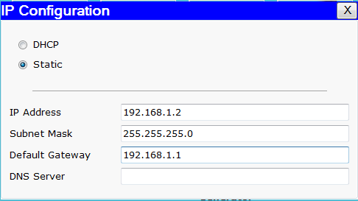

Pc1 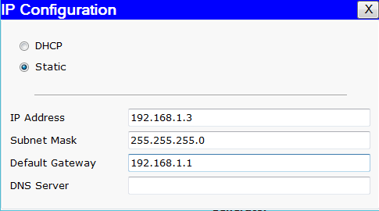

Pc2 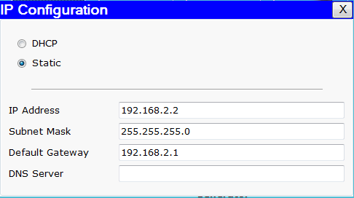

Pc3 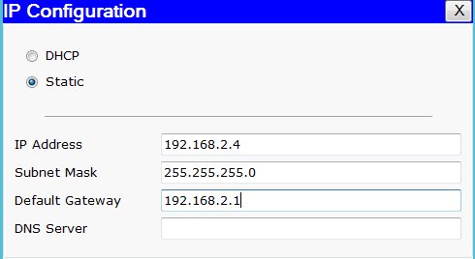

* Sending packets from pc0 to pc1

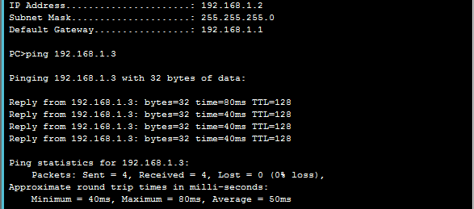

* There is no connection from pc0 to pc2

