Mohammad Ismail prelab#3 1091228

---------------------------------------------------------------------------------

1. Configure the right network

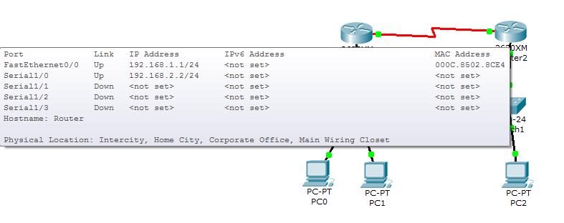

Fig(1)

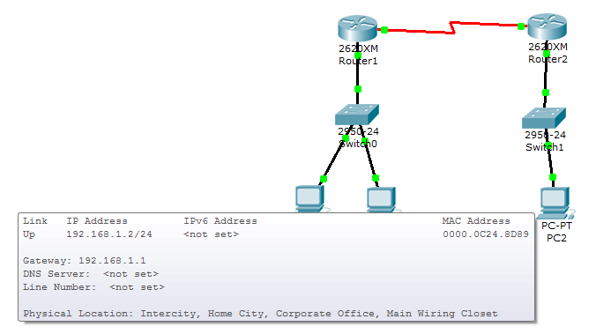

Fig(2)

1. Configure the left network.

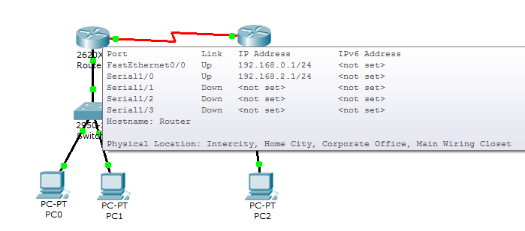

Fig(3)

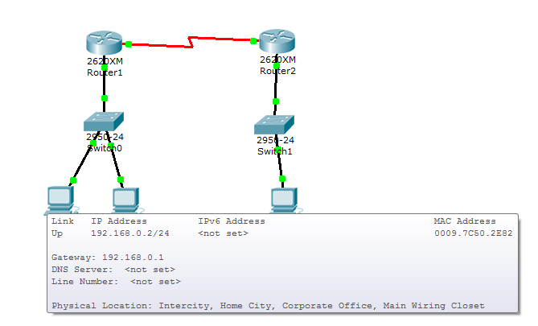

Fig(4)

1. Test the connectivity.

