

**Birzeit University**

**Computer Systems Engineering Department**

**ENCS413-Computer Networks Lab**

**Static and Dynamic Routing**

**Prepared By:**

Mohammad Jaradat 1080579

**Instructor:**

Dr. Mohammad Hussein

**Teaching Assistant:**

Mr. Rami Naji

**28/9/2012**

**Abstract**

Routing is used for taking a packet (data) from one device and sending it through the network to another device on a different network. If your network has no routers then you are not routing. Routers route traffic to all the networks in your internetwork.

1. **Introduction**

A routing protocol is a standardized process by which routers learn and communicate connectivity information, called routes, each of which describes how to reach a destination host and network. Routers that wish to exchange routing information must use the same routing protocol to communicate [routing](http://www.inetdaemon.com/tutorials/internet/ip/routing/routing.shtml) information.

*Routing* is the process of learning all the paths through the [network](http://www.inetdaemon.com/tutorials/networking/lan/index.shtml) (routes) and using routes to forward data from one network to another. A *protocol* is a standardized way to perform a task. So, a *routing protocol* would be a standardized way of learning routes and moving data from one network to another.

Routing protocols are used by routers to dynamically learn all paths through a set of networks and forward data between the networks. Routers are specialized computer devices designed to perform routing.

The rest of this report is structured as follows. In section 2, the proposed work in the experiments will be introduced. Section 3 provides a discussion and comparison between static and dynamic routing. Section 4 concludes the report.

1. **Proposed Work in the Experiments**

In this experiment we implement two routing protocols, the first one in the static routing and here we define every network that the router can reach, and if we notice if we have huge number of networks we will face a problems of entering each network ID, and this is not efficient, the second one is the RIP protocol, and in this we just define the neighbors networks, and this what makes it more efficient than static protocol.

We used the packet tracer as our tool to simulate the topology, in RIP protocol and in static protocol, and we used the Cisco routers to test the same situation but in reality.

1. **Comparison and Discussion**

As we can see there are differences between static protocol and dynamic protocol, the static used for small networks and especially in local networks since we can control them easily, for example, in companies as internetworks, and for sure any change in the networks IDs we have to change again the routing table, but in the dynamic protocol as the RIP, we can use it for large networks since we define the router neighbors networks, so here any new networks will defined automatically.

**3.1- Static routing**

A router with manually configured routing tables is known as a static router. A network administrator, with knowledge of the internetwork topology, manually builds and updates the routing table, programming all routes in the routing table. Static routers can work well for small internetworks but do not scale well to large or dynamically changing internetworks due to their manual administration.

Static routers are not fault tolerant. The lifetime of a manually configured static route is infinite and, therefore, static routers do not sense and recover from downed routers or downed links.

**3.2 - Dynamic routing**

A router with dynamically configured routing tables is known as a dynamic router. Dynamic routing consists of routing tables that are built and maintained automatically through an ongoing communication between routers. This communication is facilitated by a routing protocol, a series of periodic or on-demand messages containing routing information that is exchanged between routers. Except for their initial configuration, dynamic routers require little ongoing maintenance, and therefore can scale to larger internetworks.

Dynamic routing is fault tolerant. Dynamic routes learned from other routers have a finite lifetime. If a router or link goes down, the routers sense the change in the internetwork topology through the expiration of the lifetime of the learned route in the routing table. This change can then be propagated to other routers so that all the routers on the internetwork become aware of the new internetwork topology.

The ability to scale and recover from internetwork faults makes dynamic routing the better choice for medium, large, and very large internetworks.

**3.3- The main differences between the two protocols**

Static routing: a router that is manually configured its routing table by the administrator, and it's suitable for small not for large networks since the administrator will configure it manually.

Static routers are not fault tolerant. The lifetime of a manually configured static route is infinite and, therefore, static routers do not sense and recover from downed routers or downed links.

Dynamic routing: a router that are supported by software applications running on the router which dynamically learn network destinations and how to get them, built tables and also advertise those destinations to other routers.

Dynamic routes learned from other routers have a finite lifetime. If a router or link goes down, the routers sense the change in the internetwork topology through the expiration of the lifetime of the learned route in the routing table.

**3.4- Static routing Procedure**

1. First of all our topology was

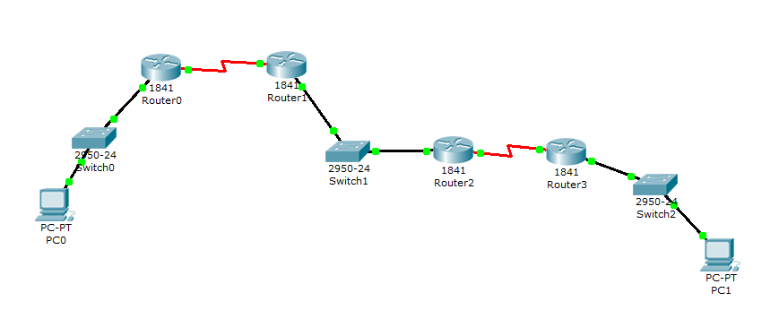

Fig 1

1. We start configuring the routers, and all routers have the same configuration so I will describe one of them as an example, I will use Router0 in the left corner in fig 1.
2. If we clicked the router0 twice then window will appear, we choose the CLI tap, to enter CLI command window.
3. Now we need to assign the IP for each interface we used in the router, if we start with fast Ethernet interface 0/0, so enter to the config mode, then enter

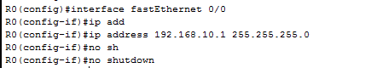PIC 1

1. Now we want to configure the serial port

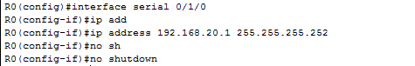

PIC 2

1. Now we give the PC0 its IP address to connect with its router.

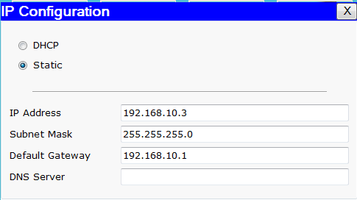

PIC 3

1. After that our left network is configured correctly and all devices can reached each others, but still the left network can't reach the other network so we need here the static routing protocol to reach other networks and tell the router to not drop any packets needs to go to other subnet network.

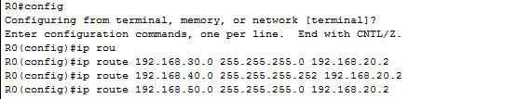PIC 4

As we can see from PIC 4 that we need to define each route and tell the router which interface port connects to these networks, and register the network ID with the a proper port, so now when the packets came to the router from a defined network id, it will not drop it and re route it to the suitable path.

1. To change the router name we used



1. To change the current time in the route



1. if we need to put a password to the telnet port we used the command



11– We did this configuration for each router, and finally we assign the IP address for each PC in this topology, and as there was two PC's then the second computer will have the next IP.

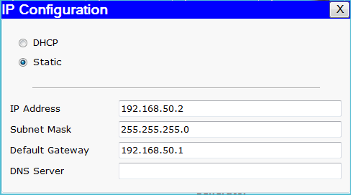

**3.5- Dynamic routing Procedure**

1. We did the same topology so the same configuration will take it's places, but when we reach step 7, the dynamic protocol used other way to represent it's self, and it detect each networks without typing them as static route protocol.
2. As we used the same we need to delete the static router so we used the command no router for each assignment that we assign.
3. Finally we used the dynamic route

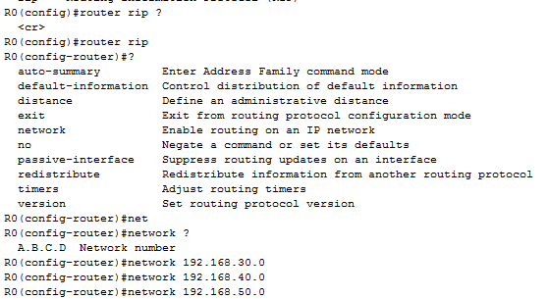

PIC 5

As we can see from PIC 5 that we used the RIP protocol which is one of the dynamic protocols that we can use, and we just define the networks neighbors to the routers that we want to use and the RIP protocol updated its routing table every 30 seconds with the new routes that are available.

1. We did step 3 for each router in this topology to be able to use the RIP protocol which is one of the dynamic protocols and has an administrative distance of 120 and it is used to rate the trustworthiness of routing information received on a router from a neighbor router.
2. **Conclusion**

In our last two experiments we used the static and dynamic routing methodology to connect networks with each others, and finally we designed two networks the first one used the static routing protocol and this could used for small networks, the second one used the dynamic routing protocol that can be used to for large scale networks.

There are a lot of things that we learned from these experiments, such as how we can use the CLI command, using the packet tracer, static and dynamic routing.

We see how the static and dynamic route works and what is the differences between them and when we can used them and this depend on the network size, privacy and load.

1. **References**

<http://www.firewall.cx/networking-topics/routing.html>

<http://technet.microsoft.com/en-us/library/cc940013.aspx>

<http://www.inetdaemon.com/tutorials/internet/ip/routing/index.shtml>

<http://www.cisco.com/en/US/products/hw/routers/index.html>