**Prelab Exp 1**

**Yousef Madia**

**1100211**

**Question#1:**

1. What are the advantages, disadvantages, bandwidth, and applications of each type of the network cables?

1-Unshielded twisted pair:

* Advantages : inexpensive
* Disadvantages : cant transmit for long distance
* Bandwidth : 100 Mbps
* Applications : Telephone and modem lines

2-Shielded twisted pair:

* Advantages : pair wire can carry data at a faster speed
* Disadvantages : physically larger and expensive
* Bandwidth : Category 5: 100 Mbps, 1 Gpbs Ethernet ,Category 6: 10Gbps
* Applications : Telephone , modems and TV

3- Coaxial cable:

* Advantages : good bandwith , great channel capacity , noise immunity due to low error rate , bidirectional
* Disadvantages : congestion, noise, and security risks
* Bandwidth : 100 Gbps
* Applications : CATV , video distribution

3- Fiber-optic cable:

* Advantages : high-speed operation , low error rate
* Disadvantages : very expensive
* Bandwidth : 300 Gbps
* Applications : CATV , modems

1. Draw the layout of each type.

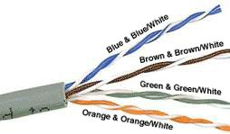

Unshielded twisted pair

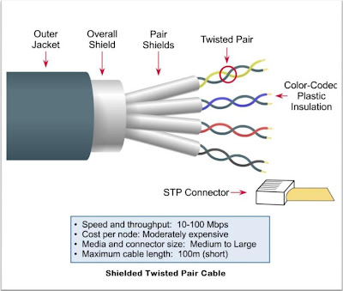

Shielded twisted pair

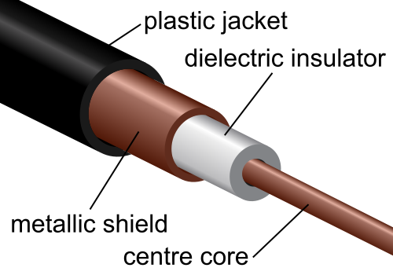

Coxial cable

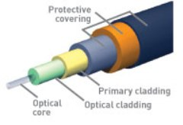

Fiber-optic cable

**Question#2:**

Figure 1.1 shows the most common Network Devices; explain the function of each device and the difference between them? In which layer each device operates?

**1-Router :** The main function of a router is to enable the movement of data by a device from one network to another. A router is actually a specialised computer connected to one or more networks, operates in Network Layer .

**2-Swich:** The main function of a switch is to forward a message to a specific host. When any host on the network or a switch sends a message to another host on the same network or same switch, the switch receives and decodes the frames to read the physical (MAC) address portion of the message, operates in data link layer .

**3-Hub :** The function of a hub is to allow communications between devices so that data can be transmitted from one computer to another. It is a piece of hardware and is most often used in a small LAN (Local Area Network) setting, where there is little likelihood of traffic conflicts. A hub is usually the easiest and cheapest way of connecting a few computers so that they can share communication resources like the Internet, it operates in physical layer .

**4-Bridge :** used to create a connection between two separate computer networks or to divide one network into two. Both networks usually use the same protocol; [Ethernet](http://www.wisegeek.com/what-is-ethernet.htm) is an example of a protocol. Network devices include, but are not limited to, Personal Computers (PCs), printers, routers, switches and hubs. Devices connected to a network via an Ethernet adapter card have what is known as a Media Access Control (MAC) address, also called a physical or hardware address. It is this address that uniquely identifies a device to a bridge that can then determine to which network the device is connected, operates in network layer .

**5-ATM Switch :** ATM switches are high-speed packet switches designed to process and forward ATM cells. ATM switches require capabilities for connection admission control, traffic

control, and OAM (operations and maintenance), operates in data link layer .

**Question#3:**

1. Compare Mac address with IP address with respect to address format, functions, OSI layer that operate on, and who assign it?

IPv4 : 32 bit , OSI 3 , DHCP .

Mac : 48 bit , OSI 4 , unique assigned by producer .

1. Define the following terms: Subnet Mask and Default Gateway**.**

* A subnet mask separates the IP address into the network and host addresses .Subnetting further divides the host part of an IP address into a subnet and host address (<network><subnet><host>). It is called a subnet mask because it is used to identify network address of an IP address by perfoming bitwise AND operation on the netmask.
* A default gateway is the device that passes traffic from the local subnet to devices on other subnets. The default gateway often connects a local network to the Internet, although internal gateways for local networks also exist.

1. Fill the following table:

|  |  |  |  |
| --- | --- | --- | --- |
| **Address Class** | **IP Range** | **Bits for Subnet Mask** | **Subnet Mask** |
| **Class A** | **1-126** | 11111111 00000000 00000000 00000000 | 255.0.0.0 |
| **Class B** | **128-191** | 11111111 11111111 00000000 00000000 | 255.255.0.0 |
| **Class C** | **192-223** | 11111111 11111111 11111111 00000000 | 255.255.255.0 |

**Question#4:**

What is the different between workgroup LAN and domain LAN.

**In a workgroup:**

* All computers are peers; no computer has control over another computer.
* Each computer has a set of user accounts. To use any computer in the workgroup, you must have an account on that computer.
* There are typically no more than ten to twenty computers.
* All computers must be on the same local network or subnet.

**In a domain:**

* One or more computers are servers. Network administrators use servers to control the security and permissions for all computers on the domain. This makes it easy to make changes because the changes are automatically made to all computers.
* If you have a user account on the domain, you can log on to any computer on the domain without needing an account on that computer.
* There can be hundreds or thousands of computers.
* The computers can be on different local networks.

**Question#5:**

What are the functions of the following commands: AT Command, NET Command.

AT Command : is a [Command Prompt command](http://pcsupport.about.com/od/commandlinereference/tp/command-prompt-commands-p1.htm) that can be used to schedule other commands and programs to run at specific dates and times.

Net [Command](http://pcsupport.about.com/od/termsc/g/commands.htm):  is a [Command Prompt command](http://pcsupport.about.com/od/commandlinereference/tp/command-prompt-commands-p1.htm) that can be used to manage almost every aspect of a network and its settings including managing network shares, network print jobs, network users, and much more.