

**Birzeit University**

**Computer Systems Engineering Department**

**ENCS413-Computer Networks Lab**

**IPv6**

**Prepared By:**

Yousef Madia 1100211

**Instructor:**

Dr. Bayan Nymer

**Teaching Assistant:**

Mr. Elias Hazboun

**Abstract**

IPv6 (**I***nternet* **P***rotocol* **V***ersion* **6**) is the newest version of the [Internet Protocol (IP)](http://www.webopedia.com/TERM/I/IP.html) reviewed in the [IETF](http://www.webopedia.com/TERM/I/IETF.html) standards committees to replace the current version of IPv4 (**I***nternet* **P***rotocol* **V***ersion* **4**).It was designed as an evolutionary upgrade to the Internet Protocol and will, in fact, coexist with the older IPv4 for some time. IPv6 is designed to allow the Internet to grow steadily, both in terms of the number of hosts connected and the total amount of data traffic transmitted.

**Table of contents**

**Abstract**…………………………………………………………………2

1. **Introduction**……………………………………………………...4

2.**Prosecure** …………………………………………………………..6

3.**Discussion** …………………………………………………………..9

4.**Conclusion**…………………....………………………………….11

5.**References**……………….………………………………….……11

1. **Introduction**

**IPv6 (Internet Protocol version 6)**, also called IPng (or IP Next Generation), is the next planned version of the IP address system. (IPv5 was an experimental version used primarily for [streaming](http://www.techterms.com/definition/streaming) data.) While IPv4 uses 32-bit addresses, IPv6 uses 128-bit addresses, which increases the number of possible addresses by an exponential amount. For example, IPv4 allows 4,294,967,296 addresses to be used (2^32). IPv6 allows for over 340,000,000,000,000,000,000,000,000,000,000,000,000 IP addresses. That should be enough to last awhile.

Because IPv6 allows for substantially more IP addresses than IPv4, the addresses themselves are more complex. They are typically written in this format:

**hhhh:hhhh:hhhh:hhhh:hhhh:hhhh:hhhh:hhhh**

Each "hhhh" section consists of a four-digit [hexadecimal](http://www.techterms.com/definition/hexadecimal) number, which means each digit can be from 0 to 9 and from A to F.

**IPv6 improvements compared with IPv4:**

1. 128-bit and so (2^32) addresses.
2. No nat.
3. Auto configuration.
4. Simpler header format.
5. Simpler and efficient routing (no check sum).
6. Better quality QOS.
7. Built in security measures.

**Converting from IPv6 to IPv4 ways:**

1. Tunneling.
2. Dual Stack.
3. Translation.

**Addresses Types :**

1. **Unicast address**: which Packets sent to a single interface.
2. **Global Unicast address**: it’s like the public address in IPv4,starts with 2000::/3.
3. **Link-Local address:** like the private addresses in IPv4 in that they’re not meant to be routed and they start with FE80::/10.
4. **Multicast:** same as in IPv4, packets addressed to a multicast address are delivered to all interfaces tuned into the multicast address.
5. **Anycast:** in this address packet is delivered to only one device—actually, to the closest one it finds defined in terms of routing distance.

We can use the static routing and the dynamic routing to let the routers talks to each others, and these protocols is the same as in IPV4.

In the new version of dynamic protocol which is called RIPng protocol, the main difference with last version is that the protocol is configured from the interface that will use it, not from the router.

1. **Procedure**

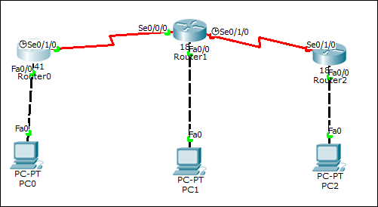

Note: explanations were made o ,Router 0 and PC0.

2.1 Static routing:

1. Router of type 1841 was chosen.
2. A Copper Cross over was used to connect between Routers.
3. A Copper Straight throw was used to connect between each router and the end user (PCs).
4. For configuring the PC (end user), by clicking twice on the pc, then Desktop ->IPv6 Configuration as shown in Fig1.

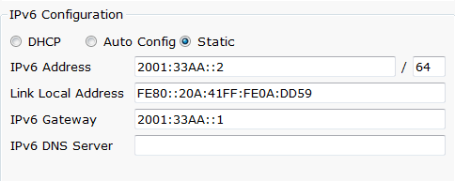

Fig1

1. Router0 was configured as shown in Fig2.







Fig2

1. Ping from PC0 -> PC2is shown in Fig3.

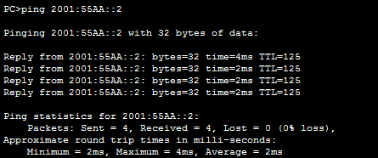

Fig3

2.2 Dynamic routing:

1. Router0 was configured as shown in Fig4.

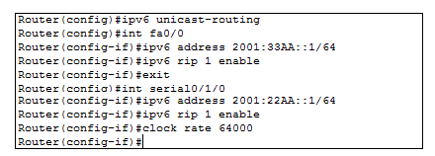

Fig4

1. Ping from PC0 -> PC1,PC0->PC2 is shown in Fig5.

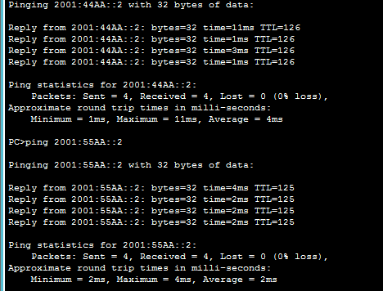

Fig5

1. **Discussion**

With IPv6, everything from appliances to automobiles can be interconnected. But an increased number of IT addresses isn't the only advantage of IPv6 over IPv4. In honor of World IPv6 Day, **here are six more good reasons** to make sure your hardware, software, and services support IPv6.

1. **More Efficient Routing**  
   IPv6 reduces the size of routing tables and makes routing more efficient and hierarchical. IPv6 allows ISPs to aggregate the prefixes of their customers' networks into a single prefix and announce this one prefix to the IPv6 Internet. In addition, in IPv6 networks, fragmentation is handled by the source device, rather than the router, using a protocol for discovery of the path's maximum transmission unit (MTU).
2. **More Efficient Packet Processing**  
   IPv6's simplified packet header makes packet processing more efficient. Compared with IPv4, IPv6 contains no IP-level checksum, so the checksum does not need to be recalculated at every router hop. Getting rid of the IP-level checksum was possible because most link-layer technologies already contain checksum and error-control capabilities. In addition, most transport layers, which handle end-to-end connectivity, have a checksum that enables error detection.
3. **Directed Data Flows**  
   IPv6 supports multicast rather than broadcast. Multicast allows bandwidth-intensive packet flows (like multimedia streams) to be sent to multiple destinations simultaneously, saving network bandwidth. Disinterested hosts no longer must process broadcast packets. In addition, the IPv6 header has a new field, named Flow Label, that can identify packets belonging to the same flow.
4. **Simplified Network Configuration**  
   Address auto-configuration (address assignment) is built in to IPv6. A router will send the prefix of the local link in its router advertisements. A host can generate its own IP address by appending its link-layer (MAC) address, converted into Extended Universal Identifier (EUI) 64-bit format, to the 64 bits of the local link prefix.
5. **Support For New Services**  
   By eliminating Network Address Translation (NAT), true end-to-end connectivity at the IP layer is restored, enabling new and valuable services. Peer-to-peer networks are easier to create and maintain, and services such as VoIP and Quality of Service (QoS) become more robust.
6. **Security**  
   IPSec, which provides confidentiality, authentication and data integrity, is baked into in IPv6. Because of their potential to carry malware, IPv4 ICMP packets are often blocked by corporate firewalls, but ICMPv6, the implementation of the Internet Control Message Protocol for IPv6, may be permitted because IPSec can be applied to the ICMPv6 packets.
7. **Conclusion**

In this experiment we learned a lot of things about IPv6, how we can assign IPv6 addresses, how we can configure it in Cisco Routers.The IPv6 uses the same protocols like IPv4, static and dynamic protocols, which they give the routers the ability to connect with the other networks that not connected directly.

Still IPv6 not spread and the internet still use IPv4, because some politics reasons, but any way, IPv6 will be used in the future, since the lack of addresses will be huge, the problem on IPv6 is known as the NAT and this because IPv6 uses visual IPs.

1. **References**
2. IPv6,<http://www.techterms.com/definition/ipv6>,5/4/2014
3. IPv6, <http://www.webopedia.com/TERM/I/IPng.html> ,5/4/2014
4. IPV6 benifts,http://www.networkcomputing.com/networking/six-benefits-of-ipv6/d/d-id/1232791?, 5/4/2014