

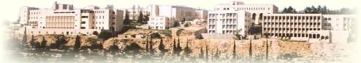

**Birzeit University**

**Computer Systems Engineering Department**

**ENCS413-Computer Networks Lab**

**OSPF**

**Prepared By:**

Yousef Madia 1100211

**Instructor:**

Dr. Bian Nymer

**Teaching Assistant:**

Mr. Elias Hazboon

**28/4/2014**

**Abstract**

In this report we are going to introduce the OSPF protocol, configure the OSPF protocol and observe its advantages and disadvantages, and then recognize the different types of routers in this protocol and learn the messages than are transfer between those routers.

**Table of contents**

**Abstract**…………………………………………………………………3

1. **Introduction**……………………………………………………...4

2.**Prosecure** …………………………………………………………..6

2.1Vlamconfiguration….…………………………………….7

2.2 Sub-interface configratio……………………………11

3.**Discussion**………………………………………………………..14

4.**Conclusion**……………………………………………………….14

5.**References**………………………………………………….……15

1. **Introduction**

**Open shortest path first (OSPF)** Stands for "Open Shortest Path First." OSPF is a method of finding the shortest path from one [router](http://www.techterms.com/definition/router) to another in a local area network ([LAN](http://www.techterms.com/definition/lan)). As long as a network is [IP-based](http://www.techterms.com/definition/ip), the OSPF algorithm will calculate the most efficient way for data to be transmitted.

If there are several routers on a network, OSPF builds a table (or topography) of the router connections. When data is sent from one location to another, the OSPF algorithm compares the available options and chooses the most efficient way for the data to be sent. This limits unnecessary delays in data transmission and prevents infinite loops.

OSPF routing is an open protocol, and uses SPF algorithm (*Dijkstra* algorithm). OSPF is the routing protocol of choice when:

1) There are routers from vendors other that Cisco in the network.

2) The network requires segmentation into areas or zones.

OSPF is a link-state routing protocol. That calls for sending of *link-state advertisements* (LSAs) to all other routers within the same area. As OSPF routers accumulate link-state information, they use the SPF algorithm to calculate the shortest path to each node.

**Dijkstra's algorithm** is called the single-source shortest path. It is also known as the single source shortest path problem. It computes length of the shortest path from the source to each of the remaining vertices.

1. **Procedure**
2. Part 1

We need here to find the shortest path in figure 1, by using the Dijekstra algorithm that used by the OSPF protocol.



Figure 1

We consider R1 as the first node that had distance zero, then we calculate the distance for each node that connected with R1, so here we have R2 with distance equal to two plus zero, and R3 with distance equal to four, then we choose the minimum distance, and here we choose the R2, then we calculate again for every node that is validated, R1, R2, so we will found that cost to go from R2 to R5 is twelve and the cost to go from R2 to R4 is four, and the cost to go from R1 to R3 is four, so we choose the minimum one, we will take the R4 to be candidate, then we repeat the procedure again to obtain the shortest path, and the final path is from R1 to R2 to R4 to R5 to R7 and the cost is 10.

1. Part2

From class C and as we need every network to have two host so the next table is the addresses that our routers will use.

|  |  |
| --- | --- |
| 192.5.79.0 | 192.5.79.3 |
| 192.5.79.4 | 192.5.79.7 |
| 192.5.79.8 | 192.5.79.11 |
| 192.5.79.12 | 192.5.79.15 |
| 192.5.79.16 | 192.5.79.19 |
| 192.5.79.20 | 192.5.79.23 |
| 192.5.79.24 | 192.5.79.27 |
| 192.5.79.28 | 192.5.79.31 |
| 192.5.79.32 | 192.5.79.35 |
| 192.5.79.36 | 192.5.79.39 |

Table 1

We want to now to enable OSPF protocol for each router and as we know the OSPF protocol exactly the same RIP protocol when we need to define the neighbors networks for example, we will show the command used in Router 1.

R1(config)#router ospf 1

R1(config-router)#network 192.5.79.0 0.0.0.3 area 0

R1(config-router)#network 192.5.79.4 0.0.0.3 area 0

After we assign the addresses and enabling the OSPF protocol, then next figure is what we reached.

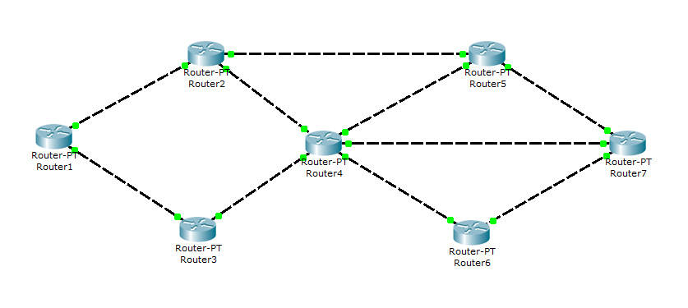

Figure 2

We need to define loopback on R7 and advertize it for area 0.

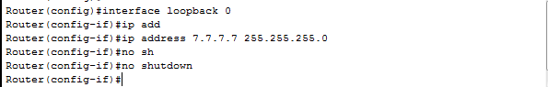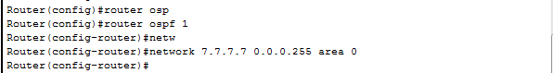

And now we need to define the cost on each link, for example we will take the router one, and see how we can put the cost for its interfaces.

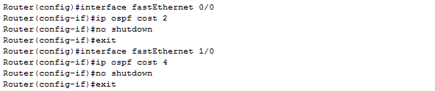

Now we use traceroute command on router 1 to send packets to loopback 7.7.7.7

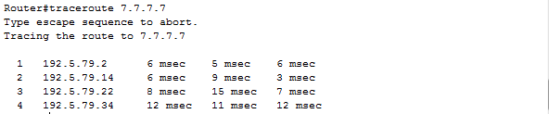

If we use show ip route in router one, we will have

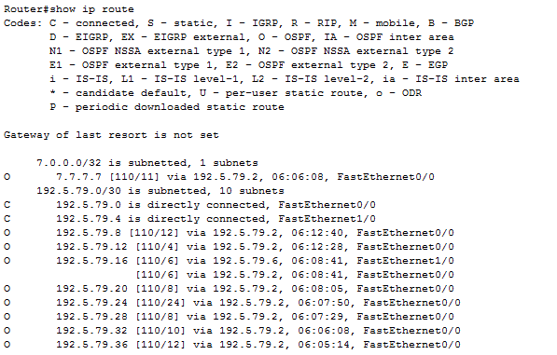

If we need the router ID, we can use "show ip ospf" command on each router for example we see in router one the next

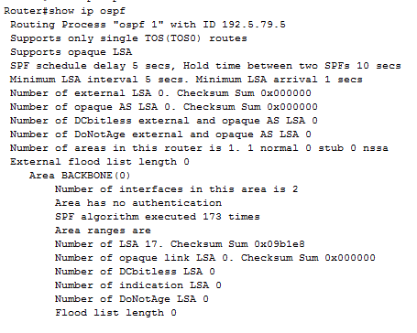

We found that R1 has the ID of 192.5.79.5.

1. **Conclusion**

As we can see from the last experiment that not the RIP protocol is the one we can use in the big networks as the load is so sensitive the Rip send advertisements every 30 seconds and as we have a lot of routers so it's not efficient to use RIP, but OSPF is more efficient and the advertisements sends when changes occurs, and one advertisement will send to define whole routers the whole networks, and this is the power that OSPF have.

1. **References**

OSPF definition,<http://www.techterms.com/definition/ospf>,25/4/2014.

Dijkstra's algorithm,http://www.cs.nyu.edu,25/4/2014

<http://searchenterprisewan.techtarget.com/definition/OSPF>

<http://en.wikipedia.org/wiki/Dijkstra's_algorithm>