



**Birzeit University**

**Computer Systems Engineering Department**

**ENCS413-Computer Networks Lab**

**Vlans**

**Prepared By:**

Yousef Madia 1100211

**Instructor:**

Dr. Bian Nymer

**Teaching Assistant:**

Mr. Elias Hazboon

**12/4/2014**

**Abstract**

In this report we are going to introduce the Vlans concept, observes the Vlans types and its advantages , and then differentiate between static and dynamic Vlans, after that we will configure two topology about the Vlans.

**Table of contents**

**Abstract**…………………………………………………………………3

1. **Introduction**……………………………………………………...4

2.**Prosecure** .. 6

2.1Vlamconfiguration….………………………………………….7

2.2 Sub-interface configration 11

3.**Discussion** 14

4.**Conclusion** 14

5.**References**………………………………………………….……15

1. **Introduction**

**A VLAN** (Virtual Local Area Network or Virtual LAN) is a local area network which groups together a collection of machines in a logical and non physical way.

In fact, communication between different machines on a local area network is governed by the physical architecture. Using virtual networks (VLANs) it is possible to be free of the limitations of the physical architecture (geographic constraints, addressing constraints ...) by defining logical segmentation.

**A trunk** port is a port that is assigned to carry traffic for all the VLANs that are accessible by a specific switch, a process known as trunking. Trunk ports mark frames with unique identifying tags - either 802.1Q tags or Interswitch Link (ISL) tags - as they move between switches. Therefore, every single frame can be directed to its designated VLAN.

An Ethernet interface can either function as a trunk port or as an access port, but not both at the same time. A trunk port is capable of having more than one VLAN set up on the interface. As a result, it is able to carry traffic for numerous VLANs at the same time.

**Types of Vlans**

1. Default: is the default vlans on all switches in their default state.
2. Native: is used when we want to send a packet without tagging it by the Trunk port, we can use at most one native vlan in a single network, the native vlans are used because some devices can not translate the tags made by the trunk port.
3. Data: is used only for exchanging data only such as printers and Pcs.
4. Voice: is used only for exchanging voice only such as voice over IP.
5. Management: is used only by the administrator of the Vlan for managing ports and switches.

**Advantages of the VLAN**

The VLAN makes it possible to define a new network above the physical network and therefore offers the following advantages:

* Reduction in the broadcasting of traffic on the network and so limiting the size of bandwidth.
* Increase in security because information is encapsulated in an additional level (tagged by the trunk) and also by limiting the access of each user.
* More flexibility in administration and changes to the network because all the architecture can be changed by simple parameters of the switches.
* Reduce cost by minimizing equipments (cables, switches…).
* Better performance especially when connecting two networks in different areas.

1. **Procedure :**

The first task was to configure a Vlan as shown in the topology fig1 and the second topology is shown in Fig2.

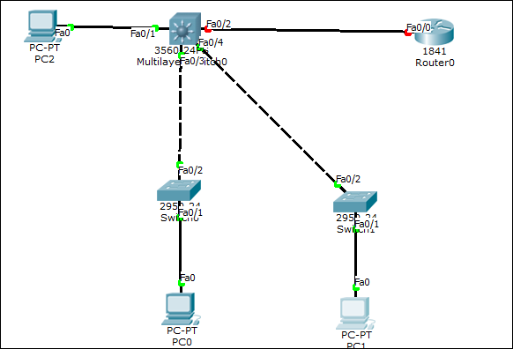

Fig 1

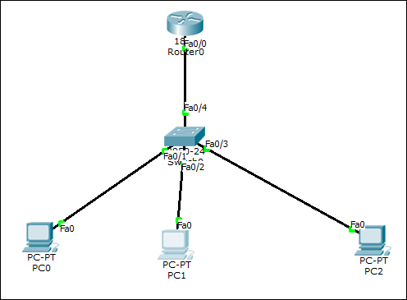

Fig 2

2.1 Vlan configuration:

Note: explanations were made on Swich0 ,Multi Layer Switch 0,Router 0 and PC0.

1. Multi Layer Switch of type 3560 , Router of type 1841, and switch of type 2950 were chosen.
2. A Copper Cross over was used to connect between switches and the Multi Layer Switch.
3. A Copper Straight throw was used to connect between each switch and the end user (PCs).
4. For configuring the PC (end user), by clicking twice on the pc, then Desktop ->IP Configuration as shown in Fig3.

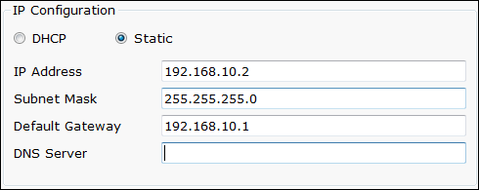

Fig3

1. For configuring the Vlan, by clicking twice on the switch0, then enable -> configure -> interface 0/1: switchport access Vlan 10, as shown in Fig4.



Fig4

1. For configuring the Trunk port, Switch0 was selected, then enable -> configure -> interface 0/2: switchport mode trunk, as shown in Fig5.

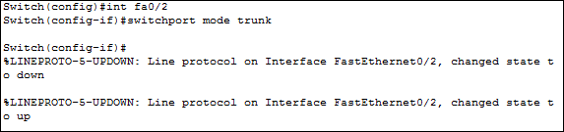

Fig5

1. For defining the trunk from Layer 3 device side, Multi Layer Switch0 was selected then enable -> configure -> interface 0/3: switchport trunk encapsulation dot1q, switchport mode trunk, as shown in Fi5 6.



Fig 6

1. To Enable routing on Multi Layer Switch 0 the IP routing command was entered as shown in Fig 7.



Fig 7

1. An IP address should be assigned for each of the VLAN subnets, as shown in Fig8.

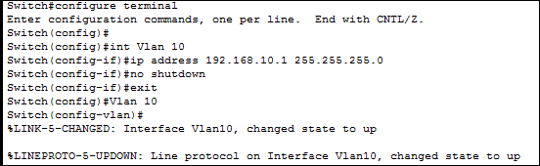

Fig 8

1. Steps 1-9 was repeated to the other networks.
2. For Configuring the interface of Multi Layer Switch 0 was connected to the default router (Router 0), as shown in Fig9.



Fig 9

1. To Configure a static default route on Multi Layer Switch 0 the inside IP address of Router0 was used, as shown in Fig10 .



Fig 10

1. Router0 was configured as shown in Fig11.



Fig11

1. For testing that Multi Layer Switch 0 was configured correctly, show IP route command was used, as shown in Fig12.

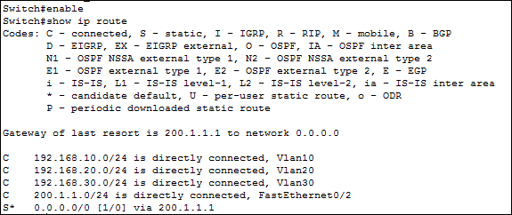

Fig 12

1. For verifying the connectivity between the PCs, the command ping was used as shown in Fig 13(ping from PC0 -> PC1 , ping from PC0 -> Server).

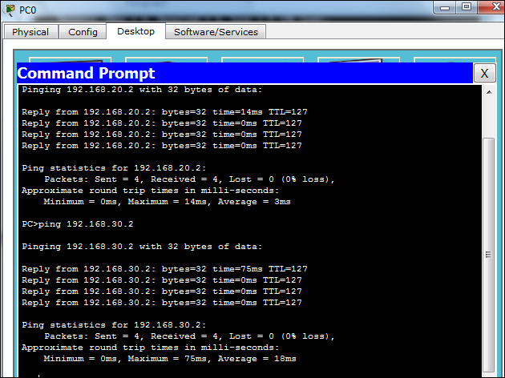

Fig 13

1. Pinging PC1 -> Server is shown in Fig 14.

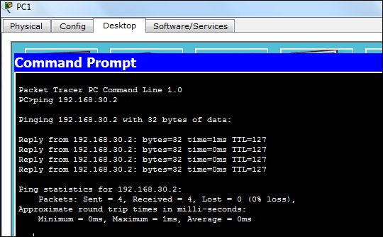

Fig 14

2.2 Sub-interface configuration

1. Router of type 1841 and switch of type 2950 were chosen.
2. A Copper Straight throw was used to connect between the switch and the end user (PCs), and between the switch and the router.
3. For configuration of Router0 , by clicking twice on the Router0, then enable -> configure -> interface 0/0.10 : encapsulation dot1Q 10 , ip address 192.168.10.1 255.255.255.0, as shown in Fig15.

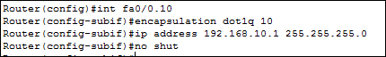

Fig 15

1. For configuration of Switch0, by clicking twice on the Switch0, then enable -> configure -> interface 0/4: switchport mode trunk, and hence interface 0/4 was the trunk port, as shown in Fig16.



Fig 16

1. For configuring the Vlans in switch0, command switchport access vlan 10 was used, see Fig 17.



Fig 17

1. For configuring the PC (end user), by clicking twice on the pc, then Desktop ->IP Configuration as shown in Fig18.



Fig18

1. Steps 1-6 was repeated to PC1 and PC2 (the server).
2. For testing that Router 0 was configured correctly, show IP route command was used, as shown in Fig19.

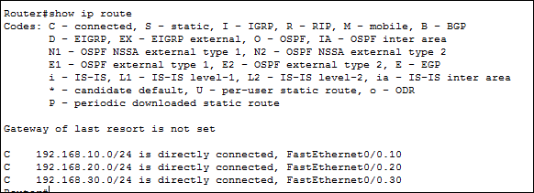

Fig 19

1. For verifying the connectivity between the PCs, the command ping was used as shown in Fig 20(ping from PC1 -> PC0 , ping from PC1 -> PC2(Server)).

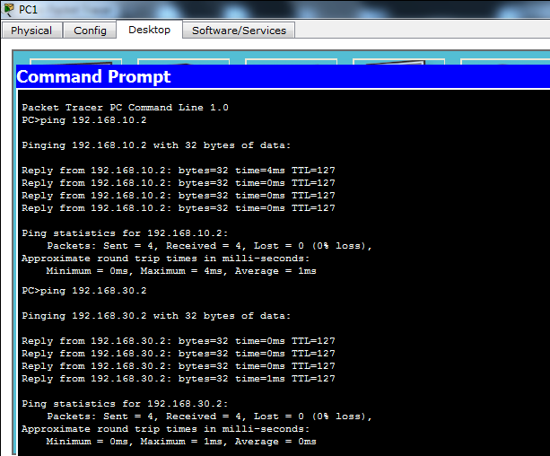

Fig 20

**4. Discussion:**

Static VLANs

Static VLANs offer port-based membership, where switch ports are assigned to speciﬁc VLANs. End user devices become members in a VLAN based on which physical switch port they are connected to. No handshaking or unique VLAN membership protocol is needed for the end devices; they automatically assume VLAN connectivity when they connect to a port. Normally, the end device is not even aware that the VLAN exists. The switch port and its VLAN are simply viewed and used as any other network segment, with other “locally attached” members on the wire.

Dynamic VLANs

Dynamic VLANs are used to provide membership based on the MAC address of an end user device. When a device is connected to a switch port, the switch must query a database to establish VLAN membership. A network administrator must assign the user’s MAC address to a VLAN in the database of a VLAN Membership Policy Server (VMPS).

**5.Conclusion:**

By the end if these experiments, many objectives were achieved. First of all Vlan concept was covered successfully, by getting more information about its advantages, types and ways to assign it (static of dynamic).

Vlan was then simulated (using the packet tracer) on two different topology as practical examples which made use more familiar with this kind of Lans.

**6.References:**

* Vlan,<http://www.level5software.net/documents/Introduction%20to%20VLANs.pdf> , accessed date 7/4/2014
* VLAN,<http://computernetworkingnotes.com/switching-vlan-stp-vtp-dtp-ether-channels/vlan.html>,7/4/2015
* Trunk , <http://www.techopedia.com/definition/27008/trunk-port> , accessed date 7/4/2014
* Subinterface_Configuration,<http://networkworld.com/ns/books/ciscopress/samples/1587200007.pdf>, 7/4/2014