**1. Abstract:**

Routers need to have entries in their routing table so they know where to send IP packets and that we can fill this routing table with static routes or with routing protocols.

In this report the two techniques will discussed the static routing and one kind of dynamic routing protocols called RIPv1.

**2. Introduction:**

Two basic method used to build routing table:

1. Static routing.
2. Dynamic routing protocols.

A **Static** routing table is created and updated by a network administrator, *manually*.it must be configured on *every* router for full connectivity. This method suitable for small network, but quickly becomes complex on large networks. Also static routing will not automatically adapted if there is a change in topology. Static routes have an Administrative Distance equal 1, and thus are always preferred over dynamic routes, unless the default AD is changed.

A **dynamic** routing table is created and updated by a *routing protocol* running on the router. Examples of routing protocols include **RIP**, **EIGRP, BGP, IS-IS** and **OSPF**. Routersshare dynamic routing information with each other, which increases CPU, RAM, and bandwidth usage. However some of the dynamic routing protocols are capable of choose the best path when there is a change in the routing infrastructure.

There are two categories in dynamic routing protocols:

* **Distance-vector protocols.**

* **Link-state protocols.**

Examples on a distance vector protocols include **RIP** and **IGRP**. Examples on link-state protocols include **OSPF** and **IS-IS**.

**What does the name of distance vector mean?**

**Distance**: how much the distance between source and destination, in RIP the distance (metric) defined by a hop count and in EIGRP there is a set of parameters enter in metric determination including **bandwidth**.

**Vector**: Which direction, which interface and the IP address of the next router to send it to.

**Distance vector** routing protocols have common characteristics:

* **Periodic** updates of the **full** routing table are sent to routing

Neighbors.

* Distance vector protocols suffer from slow convergence, and are highly susceptible to loops.

* The **Bellman-Ford algorithm** is used to determine the shortest path.

In the link state routing protocols each router has a knowledge about the whole network topology .however in distance vector routing protocols each router knows only its neighbors and sends messages only for them. Link-state protocols utilize some form of **cost**, usually based on bandwidth**,** to calculate a route’s metric. The **Dijkstra formula** is used to determine the shortest path.

In this report we will discuss RIP routing protocol, which is kind of distance vector routing protocols. RIP uses a hop count (the number of routers on a path between source and destination) to define its metric. It sends updates every 30 sec for its neighbors **only** and its **updates** contain the **full** routing table. RIP is a class full routing protocol which mean it doesn’t send the networks subnet masks in its routing updates but instead it is usually uses the first octet in its IP address to determine subnet mask.

**3. Procedure:**

The topology in figure (1) was implemented using cisco packet tracer.

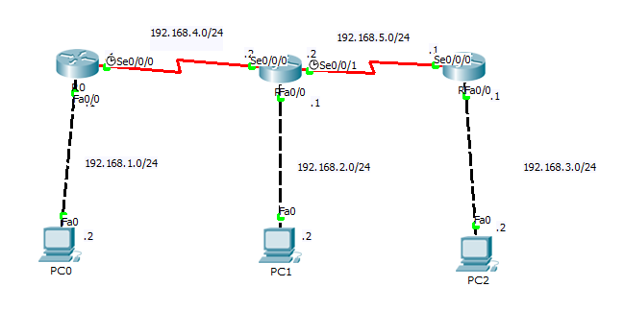

**Figure (1): main topology.**

**3.1 physical connections:**

A cross over cable used to connect routers with PC’s where the two devices operate in the same layer (network layer). A serial cable used to connect routers with each other through there serial interfaces.

**3.2 basic routers configurations:**

1. The interfaces on different routers are configured using the following commands:

The interface configuration mode was accessed using the following commands **enable** (from user mode to privileged mode) , **configuration terminal** (from privileged mode to configuration mode) ,and **interface [interface Name]** . See figure (2)

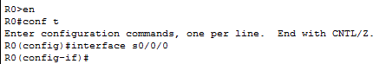

**Figure (2): access different modes**

**Note**: all our discussion below will be on R0,

**R0:**

The command **ip address** used to put an ip address with its subnet mask on a specific interface.

The command **no shutdown** used to activate the interface. Interfaces by default will be down, this command must be used for the activation process.

Since a serial interface used between routers, one of its ends (DCE) requires a clock rate that used for a synchronization process .so the command **clock rate** was used with a specific value for this purpose. As shown in figure (3) and figure (4).

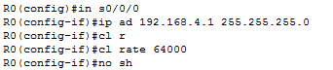

**Figure (3): Serial configurations**

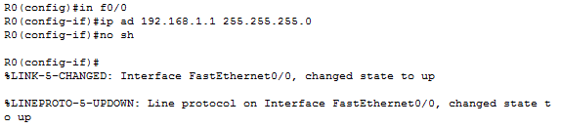**Figure (4): fast Ethernet configurations**

**3.3 PCs configurations:**

An ip address, subnet mask, and default-gateway were defined for each pc on a network, as shown in figure (5).

**Note:** the default-gateway must equal the ip address of the router interface that share the same network subnet.

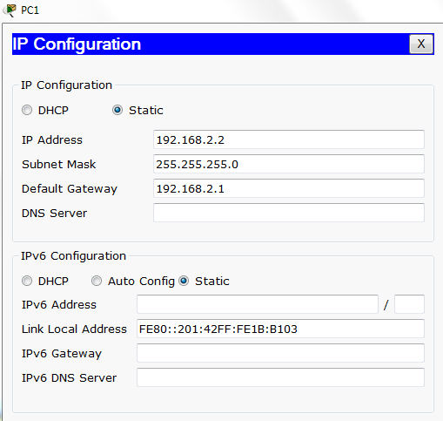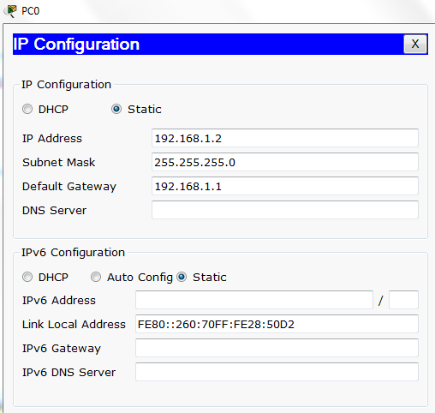

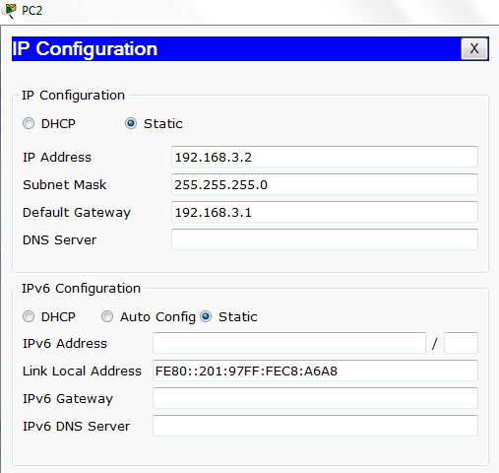

**Figure (5): PCs configurations.**

After that the command **show ip interface brief** used to verify that all configured interfaces in all routers in UP state.

**Note**: if we don’t use the no shutdown command, the interface will be an administratively down. See figure (6)

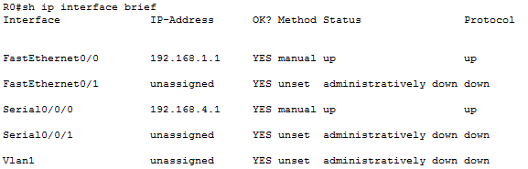

**Figure (6): verifying interfaces status.**

**3.4 static routing:**

To provide a connectivity between PCs on different network static routing was used. For the configuration process, the command **ip route** used , it required to put ip addresses of **NOT** directly connected network with their subnet masks and the address of the **next hop** or the name of **exit interface,** it is preferred to put the address of the next hop over an interface name, because interface name will cause a problem in networks that contains switches !. see figure (7)

Static routing configurations:







**Figure (7): static configuration.**

After that the command **ping** was used to verify the connectivity between all PCs on a network, and everything is work good! As shown in figure (8).

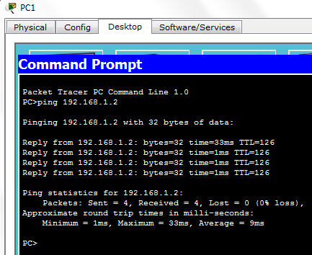

**Figure (8): ping from PC1 to PC0**

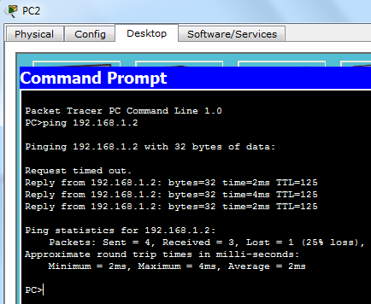

**Figure (9): ping from PC2 to PC0**

* 1. **RIP configurations:**
* In RIP which is a dynamic distance vector routing protocol, the networkcommand used to: Enter the classfull network address for each directly connected network. Enables RIP on all interfaces that belong to a specific network. Associated interfaces will now both send and receive RIP updates. Advertises the specified network in RIP routing updates sent to other routers every 30 seconds. See figure(10)

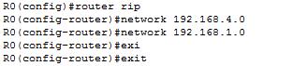

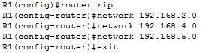

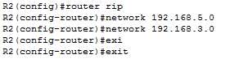

**Figure (10): RIP configuration.**

To verify our RIP configurations we use the command (**show ip route**):

R0:

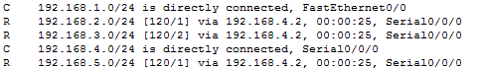

R1:

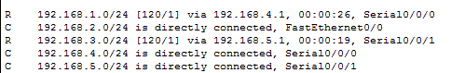

R2:

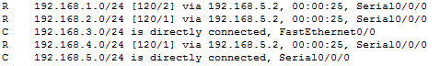

**Figure (11): RIP routing tables**

**Note:** each RIP route contains the RIP AD which equals 120, and the metric value that vary between one and two which represent an indication for number of hop counts.

To verify the connectivity between PCs after using RIP, again we use the command **ping.**

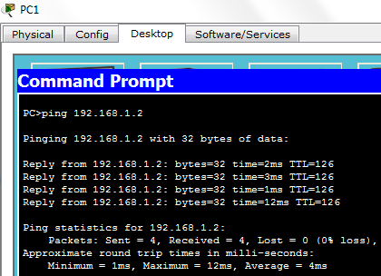

**Figure (12): From PC1 to PC0**

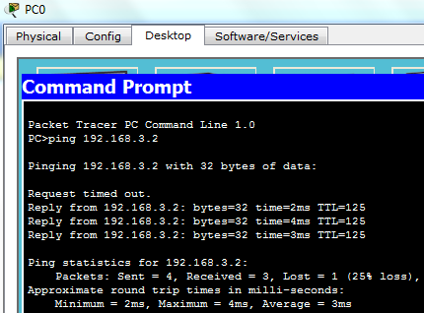

**Figure (13): From PC0 to PC2**

**4. Discussion:**

On one hand, static routing has several advantages over dynamic routing it has no bandwidth overhead (updates are not shared between routers), Minimal CPU/Memory overhead, and more secure! However, it is unsuitable for large networks, and if the Infrastructure changed the administrator must manually adjust the changes.

Dynamic routing Simpler to configure on larger networks, also it will dynamically choose a different or better route if a link goes down, and as in RIP, they have the Ability to load balance between multiple links with equal metrics. RIP sends its **full** routing table for their neighbors **every 30 sec**, and this put additional load on router CPU/RAM, also the choice of the “best route” is in the hands of the routing protocol, and not by the network administrator.

As we note that the administrative distance was created for routing evolution, in static routing the AD equal 1, but in RIP 120, so if there is two routes for a specific network in routing table the one with least AD will be chosen.

**5. Conclusions:**

In those experiments the basic commands on a packet tracer were learned and this provided us the ability to make simulations for different networks. Started by securing different access ports, different interfaces configuration, and finally by learned different routing techniques configurations. That enabled us to establish a connectivity between different devices on a network.

We discussed different routing techniques, include static routing and RIP routing protocol (as an example on dynamic routing ) ,we made different comparisons between them depended on different criteria’s include bandwidth and memory and CPU usage , topology size, administrator skills ,and security requirements .It was noted that every routing technique is suitable in a specific environment.

**6. References:**

1. HOW TO MASTER CCNA BY René Molenaar.
2. CCNA _Exploration2_CHAPTER 2,5 .



**BERZEIT UNIVERSITY**

**FACULTY OF INFORMATION TECHNOLOGY**

**COMPUTER SYSTEMS ENGINEERING DEPARTMENT**

**ENCS 413**

**Computer Networks Laboratory**

***Report* for Experiment No.2 & 3**

**Static and Dynamic Routing**

**Prepared by**

**Firas Shamasneh 1100218**

**Supervised by**

**Eng. Eleas Hazbon**

**Miss. bayan nimer**

**Table of Contents:**

1. Abstract.

2. Introduction.

3. Procedure:

3.1 physical connections:

3.2 basic routers configurations:

3.3 PCs configurations:

3.4 static routing:

3.5 RIP configurations:

4. Discussion.

5. Conclusions.

6. References.