**ENCS431 Assignment 2**

**Name: Hussein Dahir**

**ID: 1131138**

**Section: 2**

Q1)

a)

i)

z =

1.0500 + 1.9742i

1.0500 - 1.9742i

0.2000 + 0.9274i

0.2000 - 0.9274i

p =

-1.0000 + 2.0000i

-1.0000 - 2.0000i

0.1000 + 0.6245i

0.1000 - 0.6245i

k =

0.5000

sos =

0.5000 -1.0500 2.5000 1.0000 2.0000 5.0000

1.0000 -0.4000 0.9000 1.0000 -0.2000 0.4000

$$G\left(z\right)=\frac{(0.5-1.05z^{-1}-2.5z^{-2})(1-0.4z^{-1}+{0.9}^{-2})}{(1+2z^{-1}+5z^{-2})(1-0.2z^{-1}+0.4z^{-2})}$$

Z-Plane:

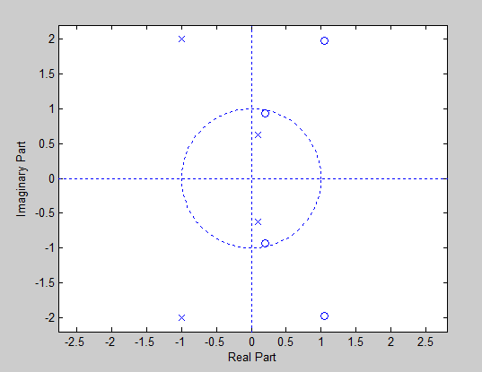

ROC:

|Z| < 0.632 (left sided)

0.632< |Z| < 2.24 (two sided)

|Z| > 2.24 (right sided)

ii)

z =

-0.5983 + 1.9119i

-0.5983 - 1.9119i

0.2483 + 0.9140i

0.2483 - 0.9140i

p =

-1.0500 + 1.7022i

-1.0500 - 1.7022i

-0.6000 + 0.0000i

-0.4000 + 0.0000i

k =

1

sos =

1.0000 -0.4967 0.8970 1.0000 1.0000 0.2400

1.0000 1.1967 4.0134 1.0000 2.1000 4.0000

$$G\left(z\right)=\frac{(1-0.4967z^{-1}-0.89z^{-2})(1-z^{-1}+{0.24}^{-2})}{(1+1.1967z^{-1}+4.0134z^{-2})(1-2.1z^{-1}+4z^{-2})}$$

Z-Plane:

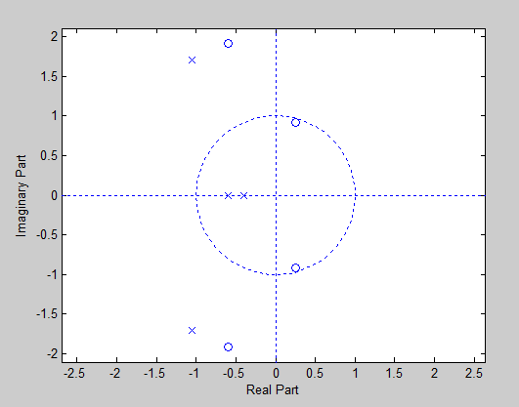

ROC:

|Z| < 0.4 (left sided)

0.4< |Z| < 0.6 (two sided)

0.6< |Z| < 1.999 (two sided)

|Z| > 1.999 (right sided)

Q1)

b)

i)

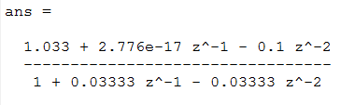

ii)

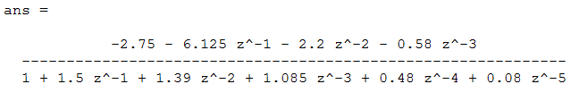

Q1)

c)

hn_inverse =

-sum(-(680*r3*r3^n - 240*r3^n + 920*r3^n*r3^2)/(869*r3^2 + 506*r3 - 396), r3 in RootOf(z1^3 + (79*z1^2)/110 + (23*z1)/110 - 6/55, z1))

Q2)

a)

y = x * h (convolution)

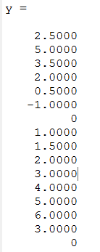

Signal (h) can be an impulse response for a moving averager filter, that can be used to smooth a signal.

Q2)

b)

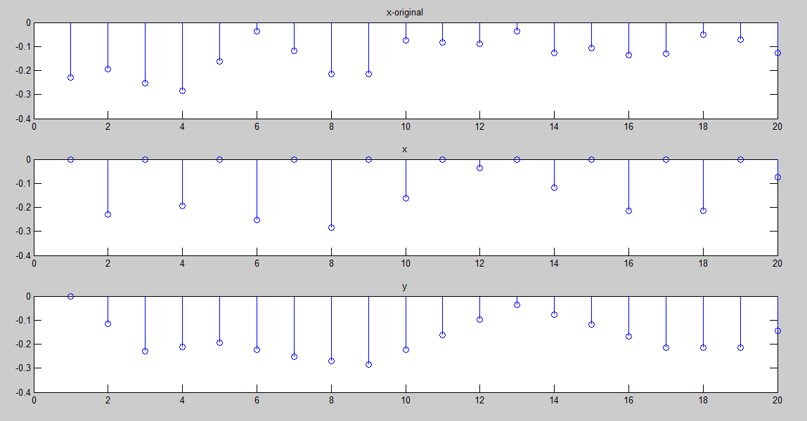

I noticed that the signal after being alternated with zeros (i.e. signal x) was slower than the original signal, and after convolving x with h, the signal got smoother, that is h was an impulse response for a smoothing (averaging) filter.

Q3)

1. Adding more coefficients will increase the number of times we hear the echo.
2. Varying more interval (i.e. delay) between echo’s, will increase the delay between times that we hear the echo in (longer time between an echo and another one).
3. Varying strength of echo’s, will change the volume and the strength on each heard echo.