Maher Saleem 1130258

i)

ans =

1.000000000000000 -2.100000000000002 5.000000000000004

1.000000000000000 -0.399999999999998 0.899999999999999

ans =

1.000000000000000 2.000000000000002 5.000000000000003

1.000000000000000 -0.200000000000002 0.400000000000001

k =

0.500000000000000

🡺

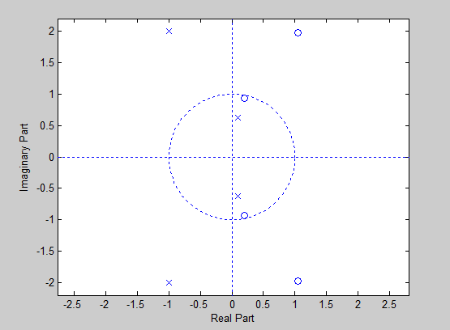

This has three possible ROC

1. 0 < |Z| < 0.63 🡺 left sided
2. 0.63 < |Z| < 2.3 🡺 double sided
3. |Z| > 2.3 🡺 right sided

ii)

ans =

1.000000000000000 1.196694247234408 4.013394953987231

1.000000000000000 -0.496694247234408 0.896996194312610

ans =

1.000000000000000 2.099999999999999 4.000000000000000

1.000000000000000 0.600000000000014 0

1.000000000000000 0.399999999999988 0

k =

1

🡺

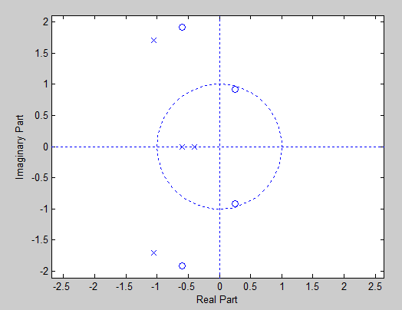

This has four possible ROC

1. 0 < |Z| < 0.4 🡺 left sided
2. 0.4 < |Z| < 0.6 🡺 double sided
3. 0.6 < |Z| < 1.99 🡺 double sided
4. |Z| > 1.99 🡺 right sided