

**Faculty of Information Technology**

**Computer Systems Engineering Department**

**Digital Signal Processing   
ENCS 331**

**(HW1)**

**“Introduction to Matlab “**

**Prepared by:**

**Nazeeh Rimawi -1170341**

**Instructor:**

**DR. Abualseoud Hanani**

**Section#2**

**2020**

# **Exercise 1.1**

## x1(n) = 2δ(n+2)-δ(n-4), -5≤ n ≤5

**Code:**

[a,n]=impseq(-2,-5,5);

[b,n]=impseq(4,-5,5);

x1=2*a-b

stem(n,x1)

axis([-6 6 -2 3])

xlabel('Time')

ylabel('Amplitude')

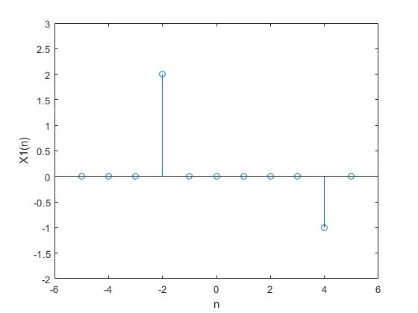**Graph:**

## b. x2(n) = n[u(n)-u(n-10)]+10exp(-0.3(n-10))*[u(n-10)-u(n-20)], 0≤ n ≤20

**Code:**

[a,n]=stepseq(0,0,20);

[b,n]=stepseq(10,0,20);

[c,n]=stepseq(20,0,20);

r1=n.*(a-b);

r2=10*exp(-0.3*(n-10));

r3=b-c;

x2=r1+r2.*r3;

stem(n,x2);

axis([0 21 -5 12])

xlabel('n')

ylabel('X2(n)')

**Graph:**

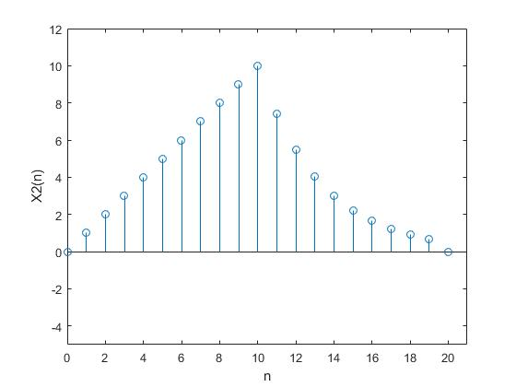

## c. x3(n) = cos(0.4πn)+0.2w(n), 0≤ n ≤50, where w(n) is a Guassian random sequence with 0 and variance 1.

**Code:**

n=[0:50];

r1=cos(0.4*pi*n);

r2=0.2*randn(1,51);

x3=r1+r2;

stem(n,x3);

axis([-1 51 -2 2])

xlabel('Time')

ylabel('Amplitude')

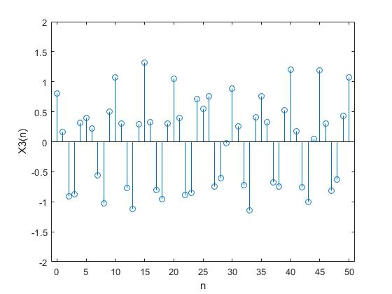**Graph:**

## d. x4(n) = exp(-0.1+j0.3)n, -10≤ n ≤10

**Code:**

n=[-10:10];

x4=exp(-0.1+0.3i).^n;

stem(n,x4)

axis([-11 12 -3 3])

xlabel('Time')

ylabel('Amplitude')

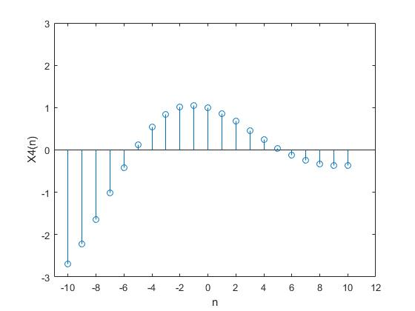**Graph:**

# **Exercise 1.2**

**Code:**

n=[-3,-2,-1,0,1,2,3]

x=[3 11 7 0 -1 4 2];

y=sigshift(x,n,2)+randn(1,7);

rxy=xcorr(x,y)

stem(rxy);

xlabel('n');

ylabel('rxy(n)');

**Graph:**

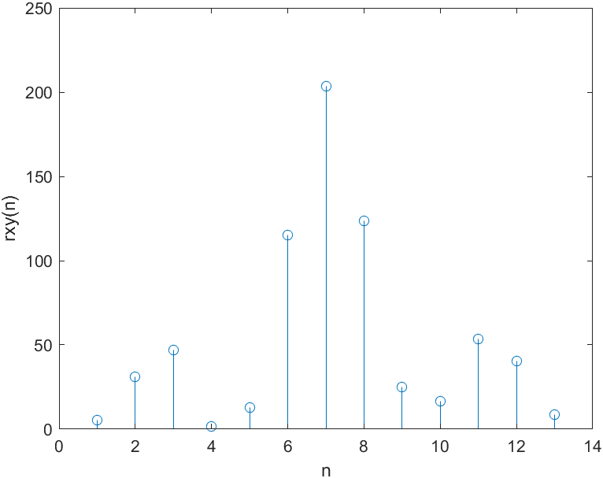

# **Exercise 1.3**

## Calculate and plot the impulse response h(n) at n=-20,.........120.

**Code:**

[x,n]=impseq(0,-20,120);

b=1;

a=[1 -1 0.9];

h=filter(1,a,x)

stem(n,h);

axis([-22 125 0 3]);

xlabel('n');

ylabel('h(n)');

**Graph:**

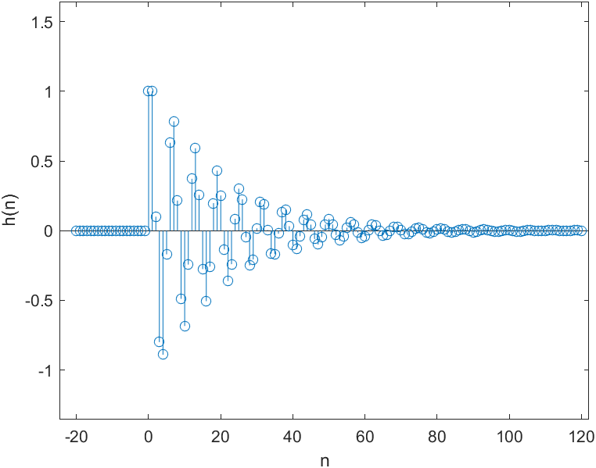

## b. Calculate and plot the unit step response s(n) at n=-20,.........120.

**Code:**

[x,n]=stepseq(0,-20,120);

b=1;

a=[1 -1 0.9];

s=filter(1,a,x)

stem(n,s);

axis([-22 125 0 3]);

xlabel('n');

ylabel('s(n)');

**Graph:**

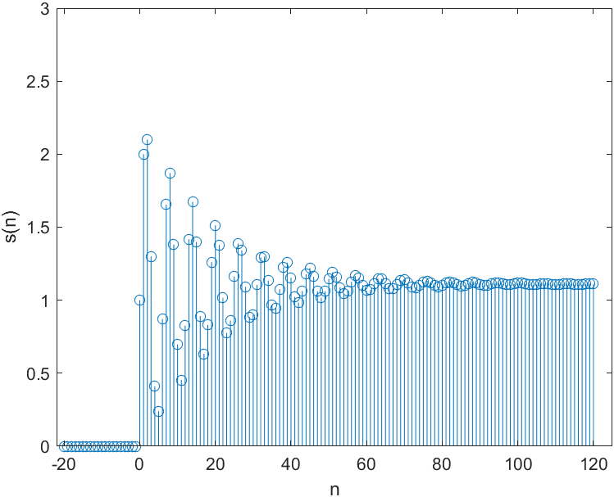

## c. Is the system specified by h(n) stable?

**Ans**:

*yes, and from the above graph , it has final value ≈0 as n goes to infinite*

# **Exercise 1.4**

Consider that we have an input x(n) of finite duration sequence: x(n)=u(n)-u(n-10) ,While the impulse response of infinite duration: h(n)=(0.9)^n u(n), Compute the output signal y(n)?

**Code:**

[a,n]=stepseq(0,0,500);

[b,n]=stepseq(10,0,500);

x=a-b;

h=(0.9).^n .*a;

y=conv(x,h)

stem(y)

**Graph:**

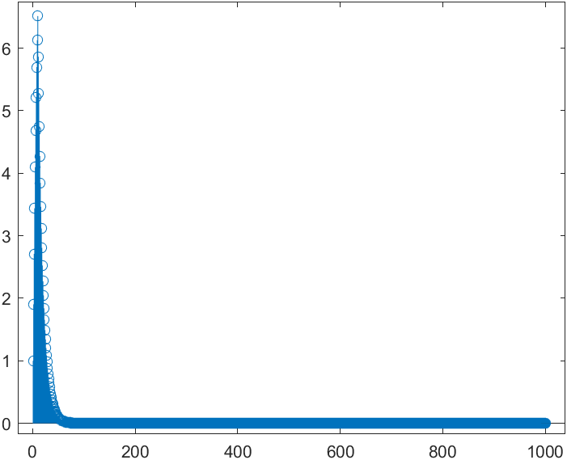

# **Exercise 1.5**

## Consider the first order system y(n) – ay(n-1) = x(n). i.e. y(n) = x(n) + ay(n-1)

### Use Matlab to generate a sinusoidal signal with unity amplitudes and the following frequencies: 1KHz, 2KHz, and 4KHz. Assume sampling frequency Fs = 10KHz.

**Code:**

%w1=2*pi*1khz/10khz=0.2*pi

%w2=2*pi*2khz/10khz=0.4*pi

%w3=2*pi*4khz/10khz=0.8*pi

n=[0:100]

x=cos(0.2*pi*n)+cos(0.4*pi*n)+cos(0.8*pi*n)

stem(x)

xlabel('n')

ylabel('x(n)')

**Graph:**

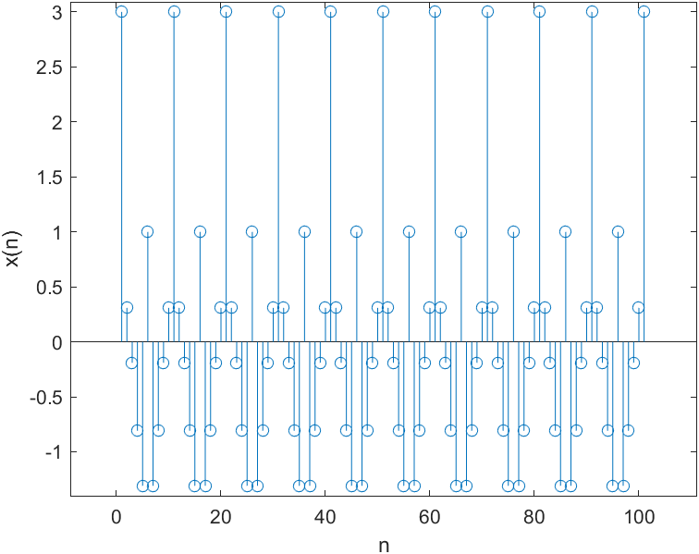

### Assume a=0.9 and use Matlab to implement the above system and compute the output signal y(n). Compare the frequencies of the input signal x(n) and y(n) output signal y(n)?

**Code:**

%y(n) – ay(n-1) = x(n) and a=-0.9

a=[1 -0.9] %output vectors

b=[1] %input vectors

n=[0:100]

x=cos(0.2*pi*n)+cos(0.4*pi*n)+cos(0.8*pi*n) %input

y=filter(b,a,x);

stem(n,y)

xlabel('n')

ylabel('Y(n)')

**Graph:**

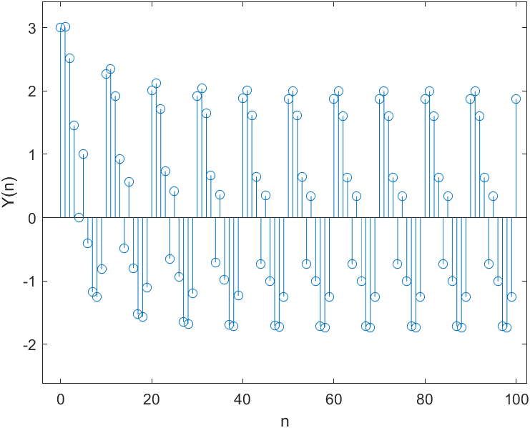

C- Change the value of the coefficient (a) such that the system passes frequencies 1KHz and 2KHz only. Record the value of (a) that you obtain and plot the input and the output signals.

***In this part we try to change the constant a to filter the high frequency (4khz)***

**Code:**

%y(n) – ay(n-1) = x(n) and a=-0.9

a1=[1 -0.9]

a2=[1 -0.85] %output vectors

b=[1] %input vectors

% n=[0:100]

x=cos(0.2*pi*n)+cos(0.4*pi*n)+cos(0.8*pi*n) %input

y1=filter(b,a1,x);

y2=filter(b,a2,x);

subplot(3,1,1)

stem(n,x,'g')

title('x(n)')

subplot(3,1,2)

stem(n,y1,'r')

title('y1(n) a=0.9')

subplot(3,1,3)

stem(n,y2)

title('y2(n) a=0.85')

xlabel('n')

ylabel('Y(n)')

**Graph**:

