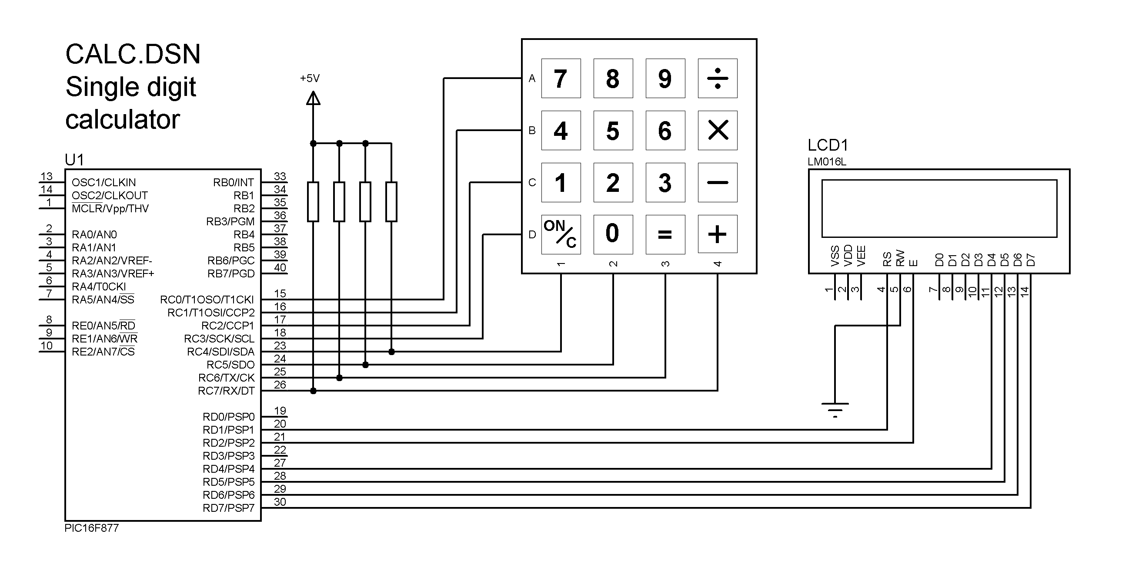

;;;;;;;;;;;;;;;;;;;;;;;;;;;;;;;;;;;;;;;;;;;;;;;;;;;;;;;;;;;
;
; CALC.ASM MPB Ver 1.0 28-8-05
;
; Simple calculator
; Single digit input, two digit results
; Integer handling only
;
;;;;;;;;;;;;;;;;;;;;;;;;;;;;;;;;;;;;;;;;;;;;;;;;;;;;;;;;;;;

PROCESSOR 16F877
; Clock = XT 4MHz, standard fuse settings
__CONFIG 0x3731

; LABEL EQUATES ;;;;;;;;;;;;;;;;;;;;;;;;;;;;;;;;;;;

INCLUDE "C:\BOOK2\APPS\P16F877A.INC"

Char EQU 30 ; Display character code
Num1 EQU 31 ; First number input
Num2 EQU 32 ; Second number input
Result EQU 33 ; Calculated result
Oper EQU 34 ; Operation code store
Temp EQU 35 ; Temporary register for subtract
Kcount EQU 36 ; Count of keys hit
Kcode EQU 37 ; ASCII code for key
Msd EQU 38 ; Most significant digit of result
Lsd EQU 39 ; Least significant digit of result
Kval EQU 40 ; Key numerical value

RS EQU 1 ; Register select output bit
E EQU 2 ; Display data strobe

; Program begins ;;;;;;;;;;;;;;;;;;;;;;;;;;;;;;;;;;;;;;;;;;

ORG 0 ; Default start address
NOP ; required for ICD mode

BANKSEL TRISC ; Select bank 1
MOVLW B'11110000' ; Keypad direction code
MOVWF TRISC ;
CLRF TRISD ; Display port is output

BANKSEL PORTC ; Select bank 0
MOVLW 0FF ;
MOVWF PORTC ; Set keypad outputs high
CLRF PORTD ; Clear display outputs
GOTO start ; Jump to main program

; MAIN LOOP ;;;;;;;;;;;;;;;;;;;;;;;;;;;;;;;;;;;;;;;;;;;;;;;

start CALL Init ; Initialise the display
MOVLW 0x80 ; position to home cursor
BCF Select,RS ; Select command mode
CALL Send ; and send code

CLRW Char ; ASCII = 0
CLRW Kval ; Key value = 0
CLRW DFlag ; Digit flags = 0

scan CALL keyin ; Scan keypad
MOVF Char,1 ; test character code
BTFSS STATUS,Z ; key pressed?
GOTO keyon ; yes - wait for release
GOTO scan ; no - scan again

keyon MOVF Char,W ; Copy..
MOVWF Kcode ; ..ASCIIcode
MOVLW D'50' ; delay for..
CALL Xms ; ..50ms debounce

wait CALL keyin ; scan keypad again
MOVF Char,1 ; test character code
BTFSS STATUS,Z ; key pressed?
GOTO wait ; no - rescan
CALL disout ; yes - show symbol

INCF Kcount ; inc count..
MOVF Kcount,W ; ..of keys pressed
ADDWF PCL ; jump into table
NOP
GOTO first ; process first key
GOTO scan ; get operation key
GOTO second ; process second symbol
GOTO calc ; calculate result
GOTO clear ; clear display

first MOVF Kval,W ; store..
MOVWF Num1 ; first num
GOTO scan ; and get op key

second MOVF Kval,W ; store..
MOVWF Num2 ; second number
GOTO scan ; and get equals key

; SUBROUTINES ;;;;;;;;;;;;;;;;;;;;;;;;;;;;;;;;;;;;;;;;;;;;;

; Include LCD driver routine

INCLUDE "C:\BOOK2\APPS\SUBS\LCD.INC"

; Scan keypad .............................................

keyin MOVLW 00F ; deselect..
MOVWF PORTC ; ..all rows
BCF PORTC,0 ; select row A
CALL Onems ; wait output stable

BTFSC PORTC,4 ; button 7?
GOTO b8 ; no
MOVLW '7' ; yes
MOVWF Char ; load key code
MOVLW 07 ; and
MOVWF Kval ; key value
RETURN

b8 BTFSC PORTC,5 ; button 8?
GOTO b9 ; no
MOVLW '8' ; yes
MOVWF Char
MOVLW 08
MOVWF Kval
RETURN

b9 BTFSC PORTC,6 ; button 9?
GOTO bd ; no
MOVLW '9' ; yes
MOVWF Char
MOVLW 09
MOVWF Kval
RETURN

bd BTFSC PORTC,7 ; button /?
GOTO rowb ; no
MOVLW '/' ; yes
MOVWF Char ; store key code
MOVWF Oper ; store operator symbol
RETURN

rowb BSF PORTC,0 ; select row B
BCF PORTC,1
CALL Onems

BTFSC PORTC,4 ; button 4?
GOTO b5 ; no
MOVLW '4' ; yes
MOVWF Char
MOVLW 04
MOVWF Kval
RETURN

b5 BTFSC PORTC,5 ; button 5?
GOTO b6 ; no
MOVLW '5' ; yes
MOVWF Char
MOVLW 05
MOVWF Kval
RETURN

b6 BTFSC PORTC,6 ; button 6?
GOTO bm ; no
MOVLW '6' ; yes
MOVWF Char
MOVLW 06
MOVWF Kval
RETURN

bm BTFSC PORTC,7 ; button x?
GOTO rowc ; no
MOVLW 'x' ; yes
MOVWF Char
MOVWF Oper
RETURN

rowc BSF PORTC,1 ; select row C
BCF PORTC,2
CALL Onems

BTFSC PORTC,4 ; button 1?
GOTO b2 ; no
MOVLW '1' ; yes
MOVWF Char
MOVLW 01
MOVWF Kval
RETURN

b2 BTFSC PORTC,5 ; button 2?
GOTO b3 ; no
MOVLW '2' ; yes
MOVWF Char
MOVLW 02
MOVWF Kval
RETURN

b3 BTFSC PORTC,6 ; button 3?
GOTO bs ; no
MOVLW '3' ; yes
MOVWF Char
MOVLW 03
MOVWF Kval
RETURN

bs BTFSC PORTC,7 ; button -?
GOTO rowd ; no
MOVLW '-' ; yes
MOVWF Char
MOVWF Oper
RETURN

rowd BSF PORTC,2 ; select row D
BCF PORTC,3
CALL Onems

BTFSC PORTC,4 ; button C?
GOTO b0 ; no
MOVLW 'c' ; yes
MOVWF Char
MOVWF Oper
RETURN

b0 BTFSC PORTC,5 ; button 0?
GOTO be ; no
MOVLW '0' ; yes
MOVWF Char
MOVLW 00
MOVWF Kval
RETURN

be BTFSC PORTC,6 ; button =?
GOTO bp ; no
MOVLW '=' ; yes
MOVWF Char
RETURN

bp BTFSC PORTC,7 ; button +?
GOTO done ; no
MOVLW '+' ; yes
MOVWF Char
MOVWF Oper
RETURN

done BSF PORTC,3 ; clear last row
CLRF Char ; character code = 0
RETURN

; Write display ...........................................

disout MOVF Kcode,W ; Load the code
BSF Select,RS ; Select data mode
CALL Send ; and send code
RETURN

; Process operations ......................................

calc MOVF Oper,W ; check for add
MOVWF Temp ; load input op code
MOVLW '+' ; load plus code
SUBWF Temp ; compare
BTFSC STATUS,Z ; and check if same
GOTO add ; yes, jump to op

MOVF Oper,W ; check for subtract
MOVWF Temp
MOVLW '-'
SUBWF Temp
BTFSC STATUS,Z
GOTO sub

MOVF Oper,W ; check for multiply
MOVWF Temp
MOVLW 'x'
SUBWF Temp
BTFSC STATUS,Z
GOTO mul

MOVF Oper,W ; check for divide
MOVWF Temp
MOVLW '/'
SUBWF Temp
BTFSC STATUS,Z
GOTO div
GOTO scan ; rescan if key invalid

; Calclate results from 2 input numbers ...................

add MOVF Num1,W ; get first number
ADDWF Num2,W ; add second
MOVWF Result ; and store result
GOTO outres ; display result

sub BSF STATUS,C ; Negative detect flag
MOVF Num2,W ; get first number
SUBWF Num1,W ; subtract second
MOVWF Result ; and store result

BTFSS STATUS,C ; answer negative?
GOTO minus ; yes, minus result
GOTO outres ; display result

minus MOVLW '-' ; load minus sign
BSF Select,RS ; Select data mode
CALL Send ; and send symbol

COMF Result ; invert all bits
INCF Result ; add 1
GOTO outres ; display result

mul MOVF Num1,W ; get first number
CLRF Result ; total to Z
add1 ADDWF Result ; add to total
DECFSZ Num2 ; num2 times and
GOTO add1 ; repeat if not done
GOTO outres ; done, display result

div CLRF Result ; total to Z
MOVF Num2,W ; get divisor
BCF STATUS,C ; set C flag
sub1 INCF Result ; count loop start
SUBWF Num1 ; subtract
BTFSS STATUS,Z ; exact answer?
GOTO neg ; no
GOTO outres ; yes, display answer
neg BTFSC STATUS,C ; gone negative?
GOTO sub1 ; no - repeat
DECF Result ; correct the result
MOVF Num2,W ; get divisor
ADDWF Num1 ; calc remainder

MOVF Result,W ; load result
ADDLW 030 ; convert to ASCII
BSF Select,RS ; Select data mode
CALL Send ; and send result

MOVLW 'r' ; indicate remainder
CALL Send
MOVF Num1,W
ADDLW 030 ; convert to ASCII
CALL Send
GOTO scan

; Convert binary to BCD ...................................

outres MOVF Result,W ; load result
MOVWF Lsd ; into low digit store
CLRF Msd ; high digit = 0
BSF STATUS,C ; set C flag
MOVLW D'10' ; load 10

again SUBWF Lsd ; sub 10 from result
INCF Msd ; inc high digit
BTFSC STATUS,C ; check if negative
GOTO again ; no, keep going
ADDWF Lsd ; yes, add 10 back
DECF Msd ; inc high digit

; display 2 digit BCD result ..............................

MOVF Msd,W ; load high digit result
BTFSC STATUS,Z ; check if Z
GOTO lowd ; yes, dont display Msd

ADDLW 030 ; convert to ASCII
BSF Select,RS ; Select data mode
CALL Send ; and send Msd

lowd MOVF Lsd,W ; load low digit result
ADDLW 030 ; convert to ASCII
BSF Select,RS ; Select data mode
CALL Send ; and send Msd

GOTO scan ; scan for clear key

; Restart ................................................

clear MOVLW 01 ; code to clear display
BCF Select,RS ; Select data mode
CALL Send ; and send code
CLRF Kcount ; reset count of keys
GOTO scan ; and rescan keypad

END ;;;;;;;;;;;;;;;;;;;;;;;;;;;;;;;;;;;;;;;;;;

