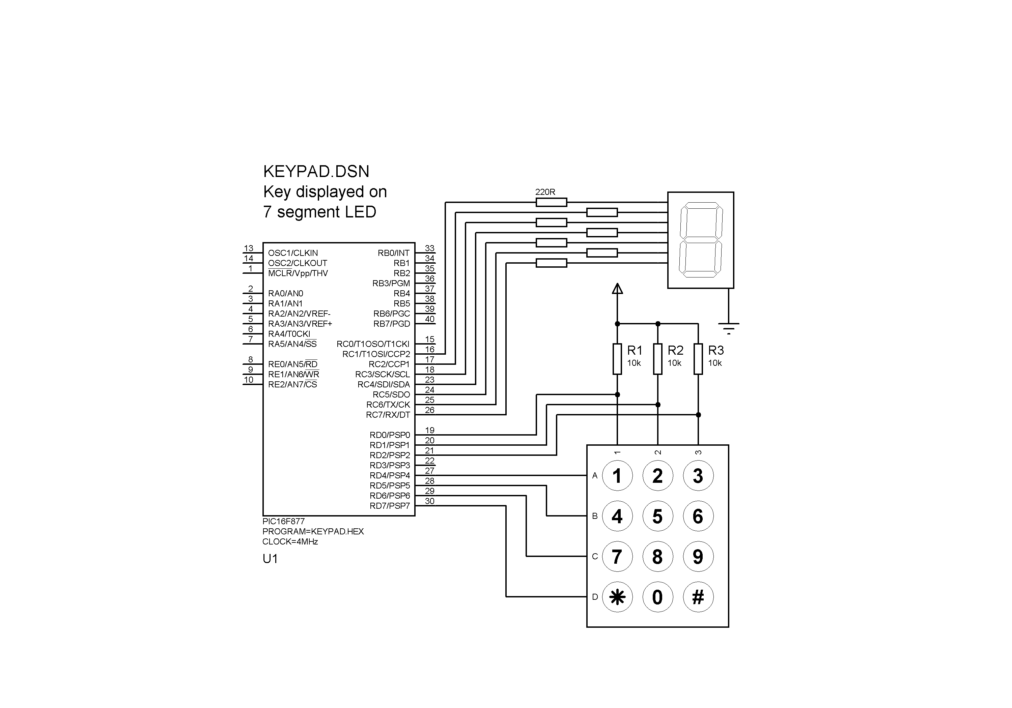

;;;;;;;;;;;;;;;;;;;;;;;;;;;;;;;;;;;;;;;;;;;;;;;;;;;;;;;;;;;
;
; KEYPAD.ASM MPB Ver 1.0 28-8-05
;
; Reads keypad and shows digit on display
; Design file KEYPAD.DSN
;
;;;;;;;;;;;;;;;;;;;;;;;;;;;;;;;;;;;;;;;;;;;;;;;;;;;;;;;;;;;

PROCESSOR 16F877

PCL EQU 002 ; Program Counter
PORTC EQU 007 ; 7-Segment display
PORTD EQU 008 ; 3x4 keypad

TRISC EQU 087 ; Data direction
TRISD EQU 088 ; registers

Key EQU 020 ; Count of keys

; Initialise ports.........................................

BANKSEL TRISC ; Display
CLRW ; all outputs
MOVWF TRISC ;
MOVLW B'00000111' ; Keypad
MOVWF TRISD ; bidirectional

BANKSEL PORTC ; Display off
CLRF PORTC ; initially
GOTO main ; jump to main

; Check a row of keys .....................................

row INCF Key ; Count first key
BTFSS PORTD,0 ; Check key
GOTO found ; and quit if on

INCF Key ; and repeat
BTFSS PORTD,1 ; for second
GOTO found ; key

INCF Key ; and repeat
BTFSS PORTD,2 ; for third
GOTO found ; key
GOTO next ; go for next row

; Scan the keypad..........................................

scan CLRF Key ; Zero key count
BSF 3,0 ; Set Carry Flag
BCF PORTD,4 ; Select first row
newrow GOTO row ; check row

next BSF PORTD,3 ; Set fill bit
RLF PORTD ; Select next row
BTFSC 3,0 ; 0 into carry flag?
GOTO newrow ; if not, next row
GOTO scan ; if so, start again

found RETURN ; quit with key count

; Display code table.......................................

table MOVF Key,W ; Get key count
ADDWF PCL ; and calculate jump
NOP ; into table
RETLW B'00001100' ; Code for '1'
RETLW B'10110110' ; Code for '2'
RETLW B'10011110' ; Code for '3'
RETLW B'11001100' ; Code for '4'
RETLW B'11011010' ; Code for '5'
RETLW B'11111000' ; Code for '6'
RETLW B'00001110' ; Code for '7'
RETLW B'11111110' ; Code for '8'
RETLW B'11001110' ; Code for '9'
RETLW B'10010010' ; Code for '*'
RETLW B'01111110' ; Code for '0'
RETLW B'11101100' ; Code for '#'

; Output display code......................................

show CALL table ; Get display code
MOVWF PORTC ; and show it
RETURN

;;;;;;;;;;;;;;;;;;;;;;;;;;;;;;;;;;;;;;;;;;;;;;;;;;;;;;;;;;;

; Read keypad & display....

main MOVLW 0FF ; Set all outputs
MOVWF PORTD ; to keypad high
CALL scan ; Get key number
CALL show ; and dsiplay it
GOTO main ; and repeat
END

;;;;;;;;;;;;;;;;;;;;;;;;;;;;;;;;;;;;;;;;;;;;;;;;;;;;;;;;;;;

