

Department of Electrical and Computer Engineering

ENCS438- Interfacing Techniques

**Final Exam**

Student Name: Student ID: Sec:

**Question 1: [15 points]**

1. A temperature sensor outputs a voltage varying as 100 mV/C and has a 2.5 kΩ output impedance. Develop signal conditioning to provide 0 to 2.5 V as the temperature varies from 30 to 130 C.
2. A high-pass filter is found to attenuate a 1-kHz signal by 25 dB. Find the critical frequency.

**Question 2: [10 points]**

A sensor output needs to feed an amplifier with a 10 kΩ input impedance. There is significant noise at 5 kHz. The data spectrum lies below 200 Hz. Design a low-pass filter for use between the sensor and the amplifier that reduces the data by not more than 1%. By how much is the noise reduced?

**Question 3: [20 points]**

Consider using an Arduino, a transistor and an optocoupler to control a 12 V, 700 mA DC-motor. The transistor Beta(hfe) varies between 40 and 200, VBE=0.8 V and VCE=0.3 V (at saturation).

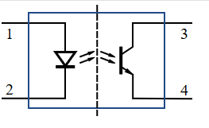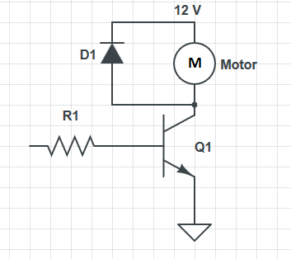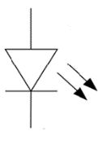

+5 V

To pin 3

on Arduino



R2

LED

1. Write a portion of code to turn the motor ON.
2. Assume the voltage between point 3 and 4 V34=2 V, what is the value of R1?
3. Assume the voltage between point 1 and 2 V12=1.8 V, and the LED forward voltage =1.7 V, what is the value of R2 such that the current goes into the Arduino is 10 mA?
4. Explain briefly, why should we use the diode D1

**Question 4: [15 points]**

True or False

1. SPI supports full duplex
2. In I2C, it is possible to connect one master with several slaves
3. Stepper motor is considered as a close loop control
4. Servo motor is considered as open loop control
5. Using DAC, it is possible to produce variable dc voltage
6. We need at least two static points to localize a mobile robot in 2D.
7. Using internal pull-up resistors, we can connect push buttons without the need to use external resistors
8. Atmega328p processor which is used in Arduino UNO is an 8-bit processor
9. Atmega328p processor which is used in Arduino UNO contains only 8 Timers
10. The code: (3 points)

DDRD=0x00

PORTD=0xF0

Makes all port D input

1. The code: (3 points)

DDRD=0x00

PORTD=0xF0

Connects all pins to pull-up resistors

**Question 5: [15 points]**

Use the ADC MCP3008, the temperature sensor TMP37, and raspberry pi to read the temperature.

1. Show the connections
2. Write python code
3. Assume the temperature is 25 oC. then Analog Voltage out=

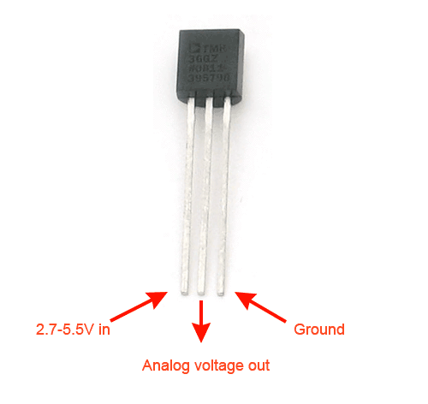

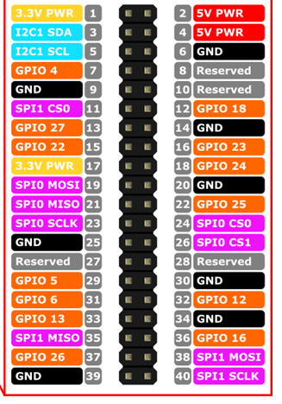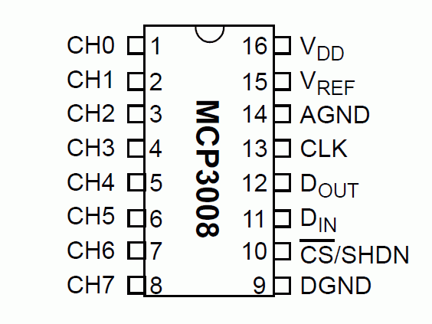

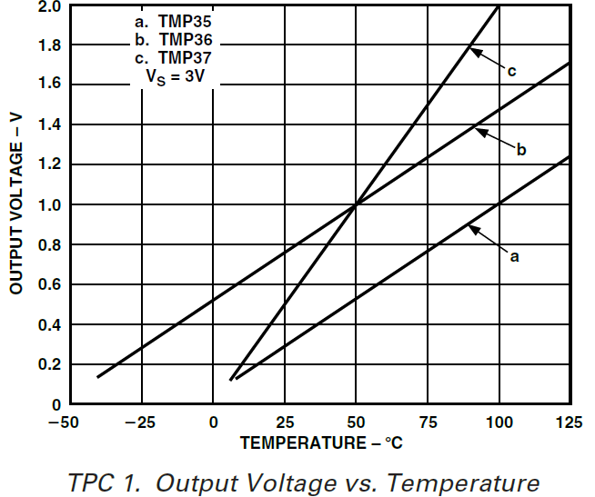

Write the code here

**Question 6: [25 points]**

You have a system which consists of an Arduino Uno, a Temperature Sensor, a DC-motor, and LCD.

The temperature sensor can read the temperature in the range -40 to +125 and is connected to pin A0 and has the following equation Vo= T*0.01+0.5 where Vo is the output voltage of the sensor and T is the temperature.

The LCD is connected to pins 2, 3, 4, 5, 6, 7.

The motor is connected to pin 9.

Write a complete Arduino Code that:

1. Reads the temperature every 25 seconds (**DO NOT USE DELAY**).
2. Calculates the average temperature (Tavg) during the last 2 minutes.
3. Write the Tavg on the LCD.
4. If the Tavg is larger than 29 ̊C, drive a DC motor (fan) with 25% duty cycle. And then increase the speed of the fan with 25% for every 5 ̊C increase above 29.

additional page