Birzeit University

Department of Electrical and Computer Engineering

ENCS438-Second Exam

**Student Name:_____________________________ID:________________**

Q#1 (10 points):

1. Explain briefly, how is it possible to communicate with several slaves using I2C? (2 points)
2. Assume using 250000 bps, 8-bit data, 1 stop bit, no parity. Draw the UART waveform when the decimal value 142 is sent. Indicate the first and last bit.(4 points)

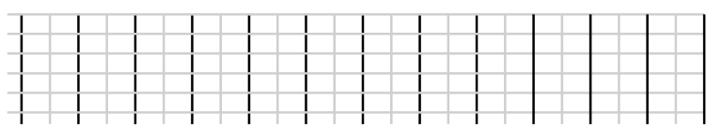

0 2 4 6 8 10 12 14 16 18 20 22 24 26 28 30 32 34 36 28 40 42 44

Time (us)

1. Explain briefly, why do we need a drive circuit (e.g., using a transistor) when connecting a motor to a microcontroller (2 points)
2. What is a servo motor? (2 points)

Q#2 (10 points):

1. A load needs 10 A to run. A MOSFET transistor needs at least VGS=10 volts to provide max of 28 A. show how it is possible to use NPN BJT transistor (hfe=20, VBE=0.7 and VCE=0.3, Icmax=600mA), to run ON/OFF the load using a Raspberry Pi. The maximum current comes from the Raspberry Pi should not exceed 10 mA. You can use any number of resistors. Give values for the resistors. (4 points)

+V

Load

+12 Volt

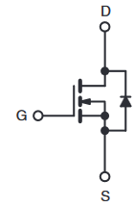

10 KΩ

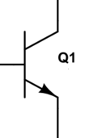

GPIO26

Write a code to turn the load **ON** using GPIO26. (2 points)



GND

1. A MOSFET has the following parameters:

Maximum Junction-to-Ambient (RthJA)=62 oC/W

Drain-Source On-State Resistance (RDS(on)) =0.077 ohm

max temperature =175 oC

1. Calculate the power dissipation at Id=10 A. (2 points)
2. Calculate the power dissipation at 120 oC? (2 points)

Q#3 (10 points):

1. A speaker is connected to GPIO26 Write python code to generate beep signal with frequency 1000 Hz on GPIO26 on Raspberry Pi. (3 points)
2. Consider the following code and a push button connected on GPIO4

#!/usr/bin/python

**import** RPi**.**GPIO **as** GPIO

**import** datetime

**import** time

GPIO**.**setmode**(**GPIO**.**BCM**)**

GPIO**.**setup**(**4**,** GPIO**.**IN**,** pull_up_down **=** GPIO**.**PUD_UP**)**

**def** printFunction**(**channel**):**

**print(**'function'**)**

GPIO**.**add_event_detect**(**4**,** GPIO**.**RISING**,** callback**=**printFunction**,** bouncetime**=**300**)**

**while** **True:**



GPIO4

GND

**if(**GPIO**.**input**(**4**)==**0**):**

**print(**'while'**)**

time**.**sleep**(**20**)**

1. What is the output on the screen if the push button is pressed **ONE** time? (2 points)
2. What is the output on the screen if the push button is pressed **THREE** times with two seconds interval, i.e. at time=0 , time=2 and time=6 seconds? (2 points)
3. To achieve maximum speed of a stepper motor, how long should be the delay between two steps when connecting the following motor. (3 points)

Motor Specifications: voltage: 12 Volt, step angel: 1.8 deg, Rated current 1.7 A, phase resistance: 1.5 ohm, phase inductance: 2.8 mH

**End**

______________________________________________________________________________

**Using PWM in RPi.GPIO**

To create a PWM instance:

p = GPIO.PWM(channel, frequency)

To start PWM:

p.start(dc) # where dc is the duty cycle (0.0 <= dc <= 100.0)

To change the frequency:

p.ChangeFrequency(freq) # where freq is the new frequency in Hz

To change the duty cycle:

p.ChangeDutyCycle(dc) # where 0.0 <= dc <= 100.0

To stop PWM:

p.stop()