1. Flash ADCs are so fast but not as fast as successive approximation ADCs.

The correct answer is 'False'.

1. The main purpose of the sample and hold circuit is to preserve the input constant during conversion time.

The correct answer is 'True'.

1. INA 128 below is one of the best instrumentation amplifiers in the market since it provides excellent gain with a high common-mode rejection ratio and all resistors are integrated into the same chip.

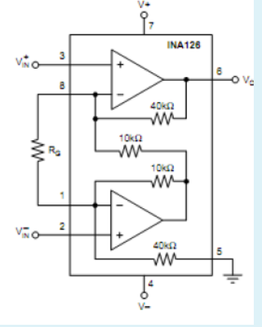

The correct answer is 'False'.

1. A bipolar DAC has 12 bits and a reference of 5 V.

The correct answer is:  -Digital input that gives a zero output voltage is:  → (1000 0000 0000)B, - The output if the input is  (3E)H is:  → -2.424V

1. Aliasing could happen if we sample at less than twice the highest frequency of the signal.

The correct answer is 'True'.

1. Successive approximation ADC are much faster than single ramp ADC since its conversion is less than by nearly 2nsteps, where n is the number of bits.

The correct answer is 'True'.

1. The output impedance of opamps should be as small as possible to avoid the loading effect when driving loads.

The correct answer is 'True'.

1. The output current :in the circuit below depends on the load resistor .

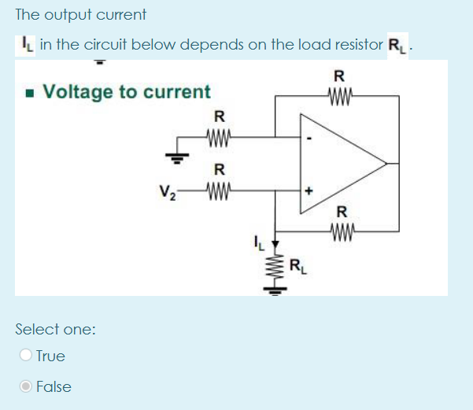

The correct answer is 'False'.

1. We use real opamps in open-loop mode frequently,  since mainly their bandwith is high.

The correct answer is 'False'.

1. We would like to develop a system using Arduino Uno to control the lights of street lamps automatically, i.e. when the sun shines fully the lamps are off and when the shining of the sun decreases the light of lamp increases and vice versa.

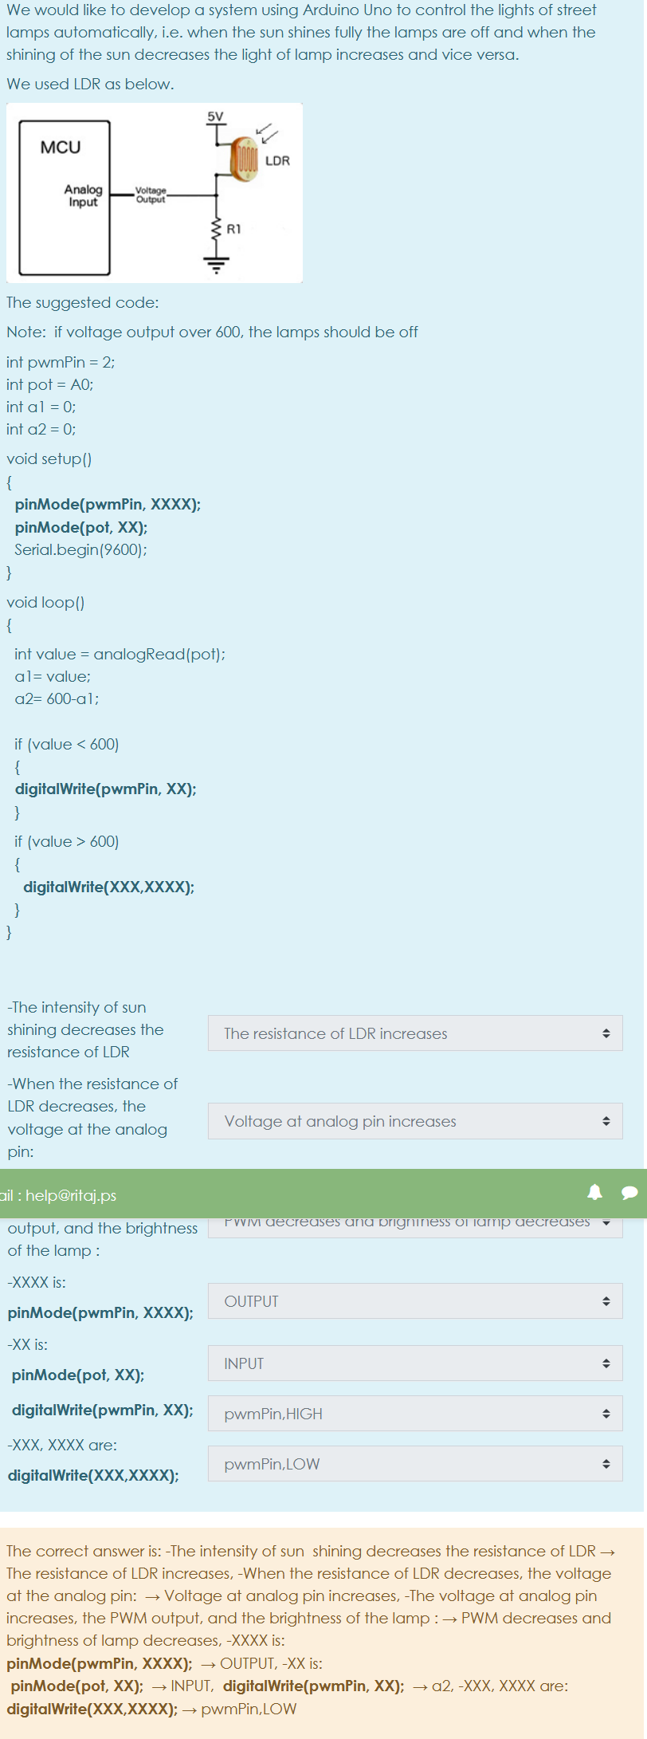

The correct answer is: -The intensity of sun  shining decreases the resistance of LDR → The resistance of LDR increases, -When the resistance of LDR decreases, the voltage at the analog pin:  → Voltage at analog pin increases, -The voltage at analog pin increases, the PWM output, and the brightness of the lamp : → PWM decreases and brightness of lamp decreases, -XXXX is:   
**pinMode(pwmPin, XXXX);** → OUTPUT  
**pinMode(pot, XX);**  → INPUT,

**digitalWrite(pwmPin, XX);**  → a2  
**digitalWrite(XXX,XXXX);** → pwmPin,LOW

1. Dual slope ADCs are slow ADCs because they need a long time to fill in the counter and then a long time for the integrator to return to zero

The correct answer is 'True'.

1. Common mode rejection ratio CMRR is preferable to be as high as possible in any amplifier circuit.

The correct answer is 'True'.

1. The main purpose of the sample and hold circuit is to follow the input during conversion time.

The correct answer is 'False'.

1. Suppose we want to design an active low pass filter with a cutoff frequency 2500 Hz and at least 70dB attenuation at 7500Hz.

The correct answer is: values of R and C  → R should be in Kohms and C should be in microfarad, The minimum order of the filter should be  → 8, To realize the filter, we need  → 4 stages 2-pole sections

1. Consider the following ADCs: Single ramp ,Dual slope ,Successive approximation ,Flash ,Delta-sigma

The correct answer is: Precision limited by the quality of components   → Successive approximation, The fastest ADC is : → Flash ADC, The most converter used in Audio applications   → Delta sigma, Most of the circuitry in the converter is digital  → Delta sigma ADC, The converter that should sample much higher than Nyquist Rate  → Delta sigma ADC, The most converter used in multimeters  → Dual Slope ADC, The most insensitive to clock drift  → Dual Slope ADC, The Most expensive ADC  → Flash ADC

1. Successive approximation ADC are much faster than single ramp ADC since its conversion is less than by nearly nsteps, where n is the number of bits.

The correct answer is 'False'.

1. An 10-bit ADC with a 3.3V reference.    It  has an input of 1.230 V

The correct answer is:   
 The digital output word is  : → (17D)H, Suppose the output is 1101011001 of the ADC.  The input voltage is:  → 2.761V, The range of input voltages that would produce this same output → 1.227-1.231V

1. The circuit below is a buffer and an amplifier for the speaker 8ohm with gain of 1.

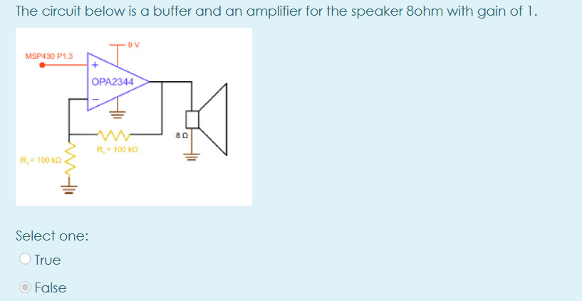

The correct answer is 'False'.

1. Opamp from inside like 741  usually consists of more than 100 transistors.

The correct answer is 'False'.

1. BJT transistors are current-controlled devices

The correct answer is 'True'.

1. Opamp from inside like 741  usually consists of more than 15 transistors.

The correct answer is 'True'.

1. Aliasing could happen if we sample at higher than twice the highest frequency of the signal.

The correct answer is 'False'.

1. SPDT relay is more efficient than SPST one.

The correct answer is 'True'.

1. npn transistors have a faster switching speed than pnp transistors.

The correct answer is 'True'.

1. Dual slope ADCs are slow ADCs because they do not have DAC to increase the speed of the converter.

The correct answer is 'False'.

1. npn transistor operates in the linear region as an amplifier

The correct answer is 'True'.

1. Zener diode could work as a rectifier when forward biased.

The correct answer is 'False'.

1. The gain of the circuit below is independent of the input impedance of the opamp even if the opamp is not ideal.

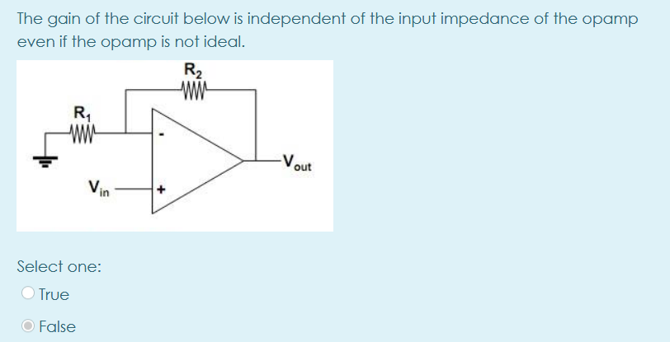

The correct answer is 'False'.

1. The gain-bandwidth product of the opamp is always constant.

The correct answer is 'True'.

1. Successive approximation ADC are much faster than single ramp ADC since its conversion is less than by nearly nsteps, where n is the number of bits.

The correct answer is 'False'.

1. Droop effect is the gradual discharge on the capacitor during the sampling mode

The correct answer is 'False'.

1. MOSFETs are current-controlled devices

The correct answer is 'False'.

1. The circuit below  is called buffer since its output is not affected by the output resistance of input voltage Vin

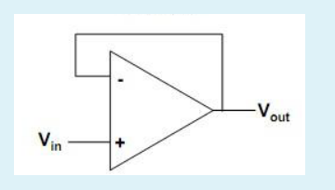

The correct answer is 'True'.

1. There is no need for a low pass filter in DC power supply.

The correct answer is 'False'.

1. The main advantage of the transistor is its capability to operate as an amplifier as well as an electromechanical switch.

The correct answer is 'False'.

1. Flash ADCs are so fast but need a huge number of opamps.

The correct answer is 'True'.

1. INA 128 below is one of the best instrumentation amplifiers in the market since it provides excellent gain with a high common-mode rejection ratio.

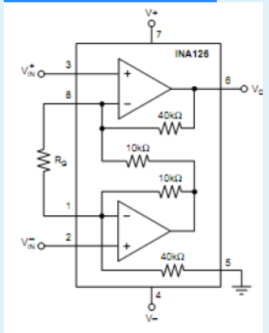

The correct answer is 'True'.

1. The gain-bandwidth product of the opamp is not always constant.

The correct answer is 'False'.

1. The gain of ideal opamp is not  infinity

The correct answer is 'False'.

* The circuit below is a buffer and an amplifier for the speaker 8ohm with gain of 2

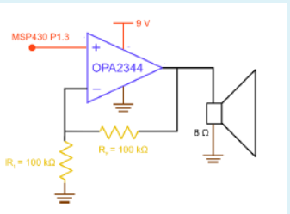

The correct answer is 'True'.

* The gain of ideal opamp is not  infinity

The correct answer is 'False'.

* Opamp from inside like 741  usually consists of more than 15 transistors.

The correct answer is 'True'.

* The main purpose of the sample and hold circuit is to follow the input during conversion time.

he correct answer is 'False'.

* Successive approximation ADC are much faster than single ramp ADC since its conversion is less than by nearly nsteps, where n is the number of bits.

The correct answer is 'False'.

* The circuit below  is called buffer since its output is not affected by the output resistance of input voltage Vin

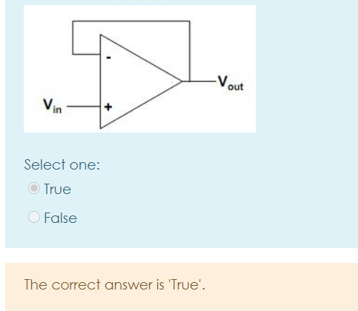

* For the circuit below, the output will be  3.3V on P1.2 , when the resistance of the photocell is greater than 2.7 K ohm.

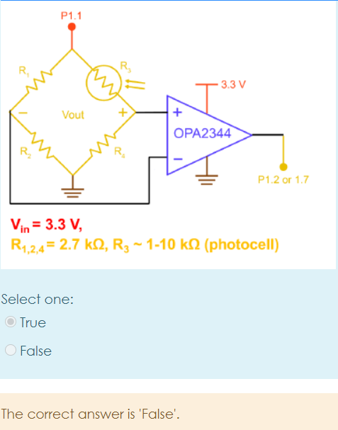

* Dual slope ADCs are slow ADCs because they need a long time to fill in the counter and then  a long time for the integrator to return to zero

The correct answer is 'True'.

* Aliasing could happen if we sample at higher than twice the highest frequency of the signal.

The correct answer is 'False'.

* An 10-bit ADC with a 3.3V reference.    It  has an input of 1.230 V

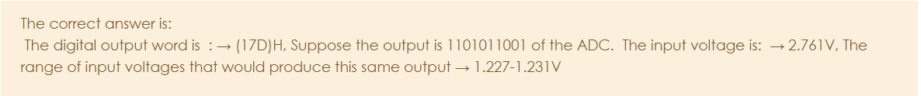

* Droop effect is the gradual discharge on the capacitor during holding mode

The correct answer is 'True'.

The gain of real opamp is infinity.

* The correct answer is 'False'.
* Zener diode could work as a rectifier when forward biased.

The correct answer is 'False'.

* The main purpose of the sample and hold circuit is to preserve the input constant during conversion time.

The correct answer is 'True'.

* Flash ADCs are so fast but not as fast as successive approximation ADCs.

The correct answer is 'False'.

* Common mode rejection ratio CMRR is preferable to be as high as possible in any amplifier circuit.

The correct answer is 'True'.

* The output current

 in the circuit below depends on the load resistor .

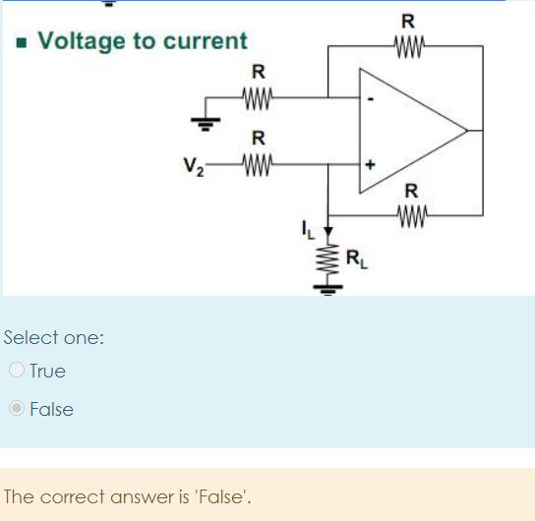

* 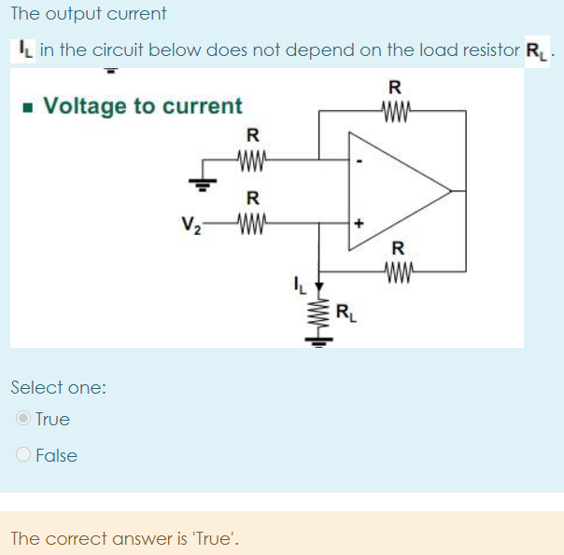
* Common mode rejection ratio CMRR is infinity in the practical difference amplifier circuit.

The correct answer is 'False'.

* The main advantage of the transistor is its capability to operate as an amplifier as well as an electromechanical switch.
* The correct answer is 'False'.
* Droop effect is the gradual discharge on the capacitor during the sampling mode

The correct answer is 'False'.

* npn transistor operates in the linear region as an amplifier

The correct answer is 'True'.

* Dual slope ADCs are slow ADCs because they do not have DAC to increase the speed of the converter.

The correct answer is 'False'.

* A bipolar DAC has 12 bits and a reference of 5 V.

he correct answer is: - The output if the input is  (3E)H is:  → -2.424V,  -Digital input that gives a zero output voltage is:  → (1000 0000 0000)B

Question **1**

Complete

Mark 0.00 out of 1.00

Flag question

Question text

The circuit below is a buffer and an amplifier for the speaker 8ohm with gain of 1.

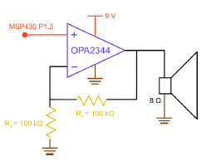

Select one:

True

False

Feedback

The correct answer is 'False'.

Question **2**

Complete

Mark 2.67 out of 8.00

Flag question

Question text

An 10-bit ADC with a 3.3V reference.    It  has an input of 1.230 V

|  |  |
| --- | --- |
| The digital output word is  : | Answer 1 |
| The range of input voltages that would produce this same output | Answer 2 |
| Suppose the output is 1101011001 of the ADC.  The input voltage is: | Answer 3 |

Feedback

The correct answer is:  
 The digital output word is  : → (17D)H, The range of input voltages that would produce this same output → 1.227-1.231V, Suppose the output is 1101011001 of the ADC.  The input voltage is:  → 2.761V

Question **3**

Complete

Mark 1.00 out of 1.00

Flag question

Question text

Flash ADCs are so fast but not as fast as successive approximation ADCs.

Select one:

True

False

Feedback

The correct answer is 'False'.

Question **4**

Complete

Mark 1.00 out of 1.00

Flag question

Question text

The main purpose of the sample and hold circuit is to preserve the input constant during conversion time.

Select one:

True

False

Feedback

The correct answer is 'True'.

Question **5**

Complete

Mark 1.00 out of 1.00

Flag question

Question text

Relays are less efficient than transistors as large currents are needed to energize the coil of the relay.

Select one:

True

False

Feedback

The correct answer is 'True'.

Question **6**

Complete

Mark 0.00 out of 1.00

Flag question

Question text

The output impedance of opamps should be as small as possible to avoid the loading effect when driving loads.

Select one:

True

False

Feedback

The correct answer is 'True'.

Question **7**

Complete

Mark 0.50 out of 4.00

Flag question

Question text

Consider the following ADCs:

-Single ramp

-Dual slope

-Successive approximation

-Flash

-Delta-sigma

|  |  |
| --- | --- |
| Most of the circuitry in the converter is digital | Answer 1 |
| The converter that should sample much higher than Nyquist Rate | Answer 2 |
| The most converter used in Audio applications | Answer 3 |
| The fastest ADC is : | Answer 4 |
| The most converter used in multimeters | Answer 5 |
| The Most expensive ADC | Answer 6 |
| Precision limited by the quality of components | Answer 7 |
| The most insensitive to clock drift | Answer 8 |

Feedback

The correct answer is: Most of the circuitry in the converter is digital  → Delta sigma ADC, The converter that should sample much higher than Nyquist Rate  → Delta sigma ADC, The most converter used in Audio applications   → Delta sigma, The fastest ADC is : → Flash ADC, The most converter used in multimeters  → Dual Slope ADC, The Most expensive ADC  → Flash ADC, Precision limited by the quality of components   → Successive approximation, The most insensitive to clock drift  → Dual Slope ADC

Question **8**

Complete

Mark 1.00 out of 1.00

Flag question

Question text

npn transistor operates in the linear region as an amplifier

Select one:

True

False

Feedback

The correct answer is 'True'.

Question **9**

Complete

Mark 1.00 out of 1.00

Flag question

Question text

Flash ADCs are so fast but need a huge number of opamps.

Select one:

True

False

Feedback

The correct answer is 'True'.

Question **10**

Complete

Mark 1.00 out of 1.00

Flag question

Question text

MOSFETs are current-controlled devices

Select one:

True

False

Feedback

The correct answer is 'False'.

Question **11**

Complete

Mark 0.00 out of 9.00

Flag question

Question text

A bipolar DAC has 12 bits and a reference of 5 V.

|  |  |
| --- | --- |
| - The output if the input is  (3E)H is: | Answer 1 |
| -Digital input that gives a zero output voltage is: | Answer 2 |

Feedback

The correct answer is: - The output if the input is  (3E)H is:  → -2.424V,  -Digital input that gives a zero output voltage is:  → (1000 0000 0000)B

Question **12**

Complete

Mark 0.00 out of 1.00

Flag question

Question text

The gain-bandwidth product of the opamp is not always constant.

Select one:

True

False

Feedback

The correct answer is 'False'.

Question **13**

Complete

Mark 1.00 out of 1.00

Flag question

Question text

Dual slope ADCs are slow ADCs because they need a long time to fill in the counter and then  a long time for the integrator to return to zero

Select one:

True

False

Feedback

The correct answer is 'True'.

Question **14**

Complete

Mark 0.00 out of 1.00

Flag question

Question text

The gain of the circuit below is independent of the input impedance of the opamp even if the opamp is not ideal.

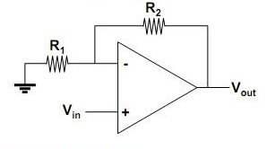

Select one:

True

False

Feedback

The correct answer is 'False'.

Question **15**

Complete

Mark 0.00 out of 6.00

Flag question

Question text

Suppose we want to design an active low pass filter with a cutoff frequency 2500 Hz and at least 70dB attenuation at 7500Hz.

|  |  |
| --- | --- |
| The minimum order of the filter should be | Answer 1 |
| To realize the filter, we need | Answer 2 |
| values of R and C | Answer 3 |

Feedback

The correct answer is: The minimum order of the filter should be  → 8, To realize the filter, we need  → 4 stages 2-pole sections, values of R and C  → R should be in Kohms and C should be in microfarad

Question **16**

Complete

Mark 1.00 out of 1.00

Flag question

Question text

Relays can handle large currents like 220 AC voltage.

Select one:

True

False

Feedback

The correct answer is 'True'.

Question **17**

Complete

Mark 1.00 out of 1.00

Flag question

Question text

The gain of the circuit below is independent of the input impedance of the opamp if the opamp is ideal.



Select one:

True

False

Feedback

The correct answer is 'True'.

Question **18**

Complete

Mark 0.00 out of 1.00

Flag question

Question text

Successive approximation ADC are much faster than single ramp ADC since its conversion is less than by nearly 2nsteps, where n is the number of bits.

Select one:

True

False

Feedback

The correct answer is 'True'.

Question **19**

Complete

Mark 1.00 out of 1.00

Flag question

Question text

Successive approximation ADC are much faster than single ramp ADC since its conversion is less than by nearly nsteps, where n is the number of bits.

Select one:

True

False

Feedback

The correct answer is 'False'.

Question **20**

Complete

Mark 0.00 out of 1.00

Flag question

Question text

Aliasing could happen if we sample at higher than twice the highest frequency of the signal.

Select one:

True

False

Feedback

The correct answer is 'False'.

Question **21**

Complete

Mark 1.00 out of 1.00

Flag question

Question text

For the circuit below, the output will be  3.3V on P1.2 , when the resistance of the photocell is greater than 2.7 K ohm.   
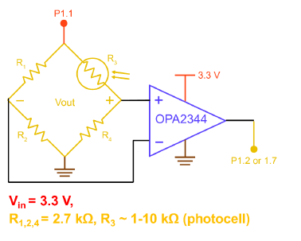

Select one:

True

False

Feedback

The correct answer is 'False'.

Question **22**

Complete

Mark 1.00 out of 1.00

Flag question

Question text

Common mode rejection ratio CMRR is infinity in the practical difference amplifier circuit.

Select one:

True

False

Feedback

The correct answer is 'False'.

Question **23**

Complete

Mark 0.00 out of 1.00

Flag question

Question text

Dual slope ADCs are slow ADCs because they do not have DAC to increase the speed of the converter.

Select one:

True

False

Feedback

The correct answer is 'False'.

Question **24**

Complete

Mark 1.00 out of 1.00

Flag question

Question text

The gain of real opamp is infinity.

Select one:

True

False

Feedback

The correct answer is 'False'.

Question **25**

Complete

Mark 0.00 out of 1.00

Flag question

Question text

We use the opamp circuit below with a gain factor R2/R1* (V2-V1),  while the noise affects both inputs of the opamp will be reduced.

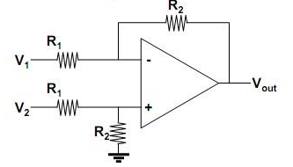

Select one:

True

False

Feedback

The correct answer is 'True'.

Question **26**

Complete

Mark 1.00 out of 1.00

Flag question

Question text

INA 128 below is one of the best instrumentation amplifiers in the market since it provides excellent gain with a high common-mode rejection ratio.   
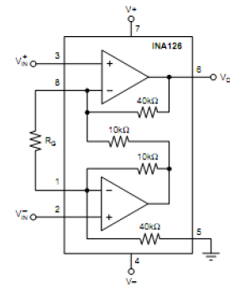

Select one:

True

False

Feedback

The correct answer is 'True'.

Question **27**

Complete

Mark 1.00 out of 1.00

Flag question

Question text

Droop effect is the gradual discharge on the capacitor during the sampling mode

Select one:

True

False

Feedback

The correct answer is 'False'.

Question **28**

Complete

Mark 7.14 out of 10.00

Flag question

Question text

We would like to develop a system using Arduino Uno to control the lights of street lamps automatically, i.e. when the sun shines fully the lamps are off and when the shining of the sun decreases the light of lamp increases and vice versa.

We used LDR as below.

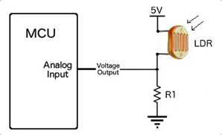

The suggested code:

Note:  if voltage output over 600, the lamps should be off

int pwmPin = 2;   
int pot = A0;   
int a1 = 0;    
int a2 = 0;

void setup()    
{  
 **pinMode(pwmPin, XXXX);   
  pinMode(pot, XX);**  
  Serial.begin(9600);  
}

void loop()  
{

  int value = analogRead(pot);  
  a1= value;   
  a2= 600-a1;           
    
  if (value < 600)  
  {  
 **digitalWrite(pwmPin, XX);**   
  }

  if (value > 600)  
  {  
    **digitalWrite(XXX,XXXX);**  
  }  
}

|  |  |
| --- | --- |
| -The intensity of sun  shining decreases the resistance of LDR | Answer 1 |
| -When the resistance of LDR decreases, the voltage at the analog pin: | Answer 2 |
| -The voltage at analog pin increases, the PWM output, and the brightness of the lamp : | Answer 3 |
| -XXXX is:  **pinMode(pwmPin, XXXX);** | Answer 4 |
| -XX is:  **pinMode(pot, XX);** | Answer 5 |
| **digitalWrite(pwmPin, XX);** | Answer 6 |
| -XXX, XXXX are:  **digitalWrite(XXX,XXXX);** | Answer 7 |

Feedback

The correct answer is: -The intensity of sun  shining decreases the resistance of LDR → The resistance of LDR increases, -When the resistance of LDR decreases, the voltage at the analog pin:  → Voltage at analog pin increases, -The voltage at analog pin increases, the PWM output, and the brightness of the lamp : → PWM decreases and brightness of lamp decreases, -XXXX is:   
**pinMode(pwmPin, XXXX);** → OUTPUT, -XX is:   
**pinMode(pot, XX);** → INPUT, **digitalWrite(pwmPin, XX);**  → a2, -XXX, XXXX are:   
**digitalWrite(XXX,XXXX);** → pwmPin,LOW