[](http://www.google.ps/url?sa=i&source=images&cd=&cad=rja&docid=TNC2o42g4wGV0M&tbnid=n9SnL2A2yBmR1M:&ved=0CAgQjRwwAA&url=http://sites.birzeit.edu/comp/ArabicOntology/news-events/siera-kick-off-conference-in-the-news/&ei=3wMlUZ6uGPKK4gT864CIAw&psig=AFQjCNG7NukYdzV3_HLvAhGHpdxIJPGq1Q&ust=1361466719460852)

**Department of Computer System Engineering**

**COMPUTER DESIGN LAB**

**ENCS 411**

**PRELAB2**

**Experiment No. 3**

***Controlling Stepper Motor***

**Student Name: Othman Alkhamra**

**Student Number: 1110017**

**Instructor: Dr. Ahmad Afaneh**

**Section: 3**

**Date: 24/03/2014**

* **What is the effect of assembly instructions ROR, ROL?**

ROR: shift each bit to the right and the least bit on the right is shifted to the first position and is assigned to the carry.

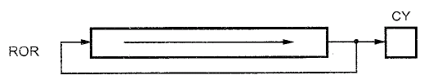

ROL: is the opposite of ROR where the least bit on the left is shifted to the last position and is assigned to the carry.

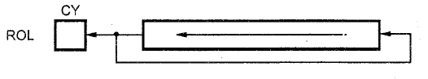

* **What does “stepper motor resolution” means?**

It is a unit degree, it is the degrees by which a stepper motor rotates per pulse. For example, a 6 degree resolution means that the stepper motor rotates by 6 degrees per pulse and that mean it needs 60 (3600 /6) pulses to complete a full rotation (3600 ).

* **Fill the 1-phase excitation table (counter-clockwise), 2-phase excitation table (clockwise).**

|  |  |  |  |  |  |  |  |  |  |  |  |  |  |
| --- | --- | --- | --- | --- | --- | --- | --- | --- | --- | --- | --- | --- | --- |
| 1-Phase  Excitation  Table |  | A | B | A’ | B’ | HEX | 2-Phase  Excitation  Table |  | A | B | A’ | B’ | HEX |
| Step 1 | 1 | 1 | 1 | 0 | 0EH | Step 1 | 0 | 0 | 1 | 1 | 03H |
| Step 2 | 1 | 1 | 0 | 1 | 0DH | Step 2 | 1 | 0 | 0 | 1 | 09H |
| Step 3 | 1 | 0 | 1 | 1 | 0BH | Step 3 | 1 | 1 | 0 | 0 | 0CH |
| Step 4 | 0 | 1 | 1 | 1 | 07H | Step 4 | 0 | 1 | 1 | 0 | 06H |