[](http://www.google.ps/url?sa=i&source=images&cd=&cad=rja&docid=TNC2o42g4wGV0M&tbnid=n9SnL2A2yBmR1M:&ved=0CAgQjRwwAA&url=http://sites.birzeit.edu/comp/ArabicOntology/news-events/siera-kick-off-conference-in-the-news/&ei=3wMlUZ6uGPKK4gT864CIAw&psig=AFQjCNG7NukYdzV3_HLvAhGHpdxIJPGq1Q&ust=1361466719460852)

**Department of Computer System Engineering**

**COMPUTER DESIGN LAB**

**ENCS 411**

**Report 1**

**Experiment No. 2**

***Control of Dot Matrix and 7 –Segment***

**Student Name:**

**Ibrahim Abu Farha 1110024**

**Othman Alkhamra 1110017**

**Instructor: Dr. Ahmad Afaneh**

**Section: 3**

**Date: 24/03/2014**

# Abstract:

In this experiment different devices will be controlled using 82C55 PPI by programming it using Assembly Language to Interface it with different Components, such as Seven Segment display, 8x8 dot Matrix, and so a simple counter can be made using the seven segment and a letter can be displayed on a dot Matrix.

# Introduction

In this section the 82C55 PPI will be introduced, and other components that will be interfaced with the PPI such as 8X8 dot Matrix and Seven Segment display.

## Programmable Peripheral Interface (82C55 PPI):

The 82C55 PPI (see Fig.1.1) is an I/O port chip used for interfacing I/O devices with microprocessor, the 82C55 is a popular interfacing component, that can interface any TTL-compatible I/O device to a microprocessor [1].

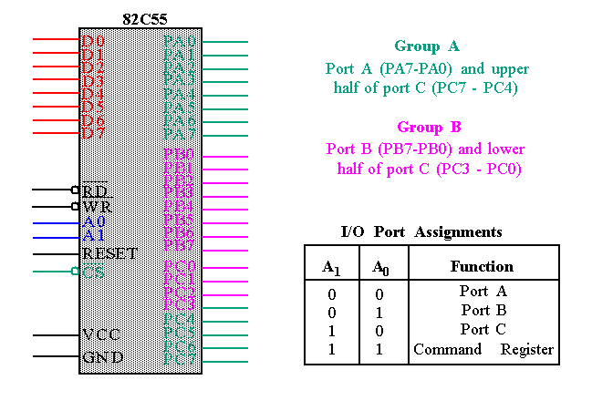

**Fig.1.1 (82C55 PPI –IC chip) [2]**

The 82C55 PPI chip has 40 pins, Consist of three 8-bits width Port (A, B and C), 8 bit Data Bus and control signals WR, RD ,RESET ,CS ,A0 ,A1 , VCC and GND as shown in Fig.1.1 . The 82C55 PPI Requires insertion of wait states if used with a microprocessor using higher that an 8 MHz clock [2].

There are three different modes of operation where PPI ports can be programmed to work in:

* Mode 0: (Buffered input latched output).
* Mode 1: (Strobe input strobe output).
* Mode 2: (Bidirectional input output).

The mode of the port is determined using the command Register in the PPI that is used to control the direction and the mode of the ports as shown in Fig.1.2 [1].

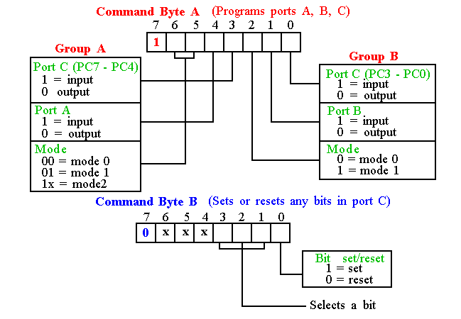

**Fig.1.2: (Command Register & modes of Operation for PPI) [1]**

From Fig.1.2 we can see that group A (Port A and the upper part of port C) works in all modes (mode 0, 1 and 2), whereas group B (Port B and the lower part of port C) works only in modes 0 and 1.

## Dot Matrix 8X8

The Dot Matrix (see Fig.1.3) consists of 8X8 Red LEDS and 8X8 Green LEDS. These LEDS can be controlled using PORT A, Port B and Port C to display any character we want on it.



**Fig.1.3: (Dot Matrix ) [3]**

Ports A and B are used to drive the cathode of the LEDs, while Port-C would drive the anodes terminals. Port-A drives the green LEDs while port-B drives the red LEDs. If the two LEDs with the same coordinates are enabled then the outcome will be an orange dot. Ports A and B select the rows while Port-C select the columns as shown in Fig.1.3 [3].

## Seven Segment Display

A **seven-segment display**  (**SSD**), or **seven-segment indicator (see Fig.1.4)**, is a form of electronic [display device](http://en.wikipedia.org/wiki/Display_device) for displaying [decimal](http://en.wikipedia.org/wiki/Decimal) [numerals](http://en.wikipedia.org/wiki/Numeral_system) that is an alternative to the more complex [dot matrix](http://en.wikipedia.org/wiki/Dot_matrix) displays. Seven-segment displays are widely used in [digital clocks](http://en.wikipedia.org/wiki/Digital_clock), electronic meters, and other electronic devices for displaying numerical information [4].

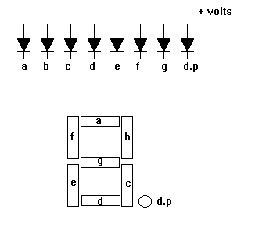

**Fig.1.4: (Seven Segment Display) [5]**

The display consists of seven active low segments (A, B, C, D, E, F, G) and an active low decimal point (P). The segments and P are driven by the 82C55 Port-A signals as shown in Table 1.1. For example to display 2 we need 10100100B => A4H sent to port A.

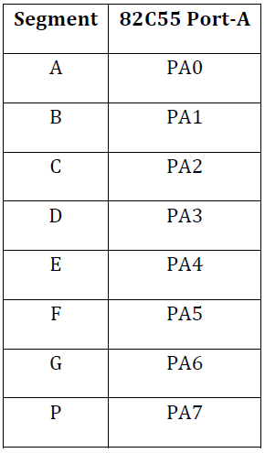

**Table 1.1: (Port A Signals) [3]**

# References:

# [1] teacher.en.rmutt.ac.th/ktw/13-104-252/7%208255.ppt

**Access date: 23-03-2014**

[2] [**http://www.ece.unm.edu/~jimp/310/slides/8086_IO2.html**](http://www.ece.unm.edu/~jimp/310/slides/8086_IO2.html)

**Access date: 23-03-2014**

[3] Manual Sheet, Experiment 2 Control of Dot Matrix and 7-Segment MDA-8086 Kit – PPI

Application, Spring Semester 2013/2014.

**Access date: 23-03-2014**

[4] <http://en.wikipedia.org/wiki/Seven-segment_display>

[5] <http://www.hobbyprojects.com/components/images/7segment.gif>