

**Electrical Engineering Department**

**Prelab1**

**Student Name: abed.hmeadan Id:1161306**

**Instructor:** Dr. jaser saed section:1

Date:15/9/2018

Part A: Kirchhoff’s Laws 1. Simulate the circuit of Figure 3.4 using PSPICE to find the voltage across and the current through each resistor.

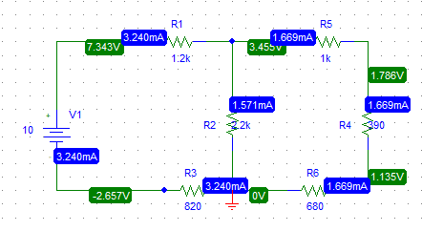

Figure 3.4

Part B: Voltage Divider 1. Simulate the circuit of Figure 3.5 using PSPICE to find the voltages V1-2, V2-3, and V3-0.

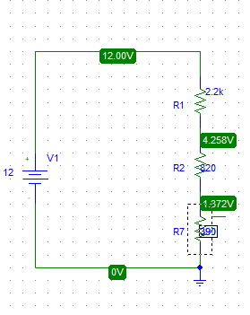

Figure 3.5

V1-2 = v1-v2 = 12-4.285 =7.715

V2-3 = v2-v3 = 4.258-1.372 = 2.886

V3-0 = 1.372

2. For the circuit of Figure 3.6: Rp is a 10 kΩ potentiometer (three-terminal resistor), Calculate RAB and RBC so that Vo = 3 V

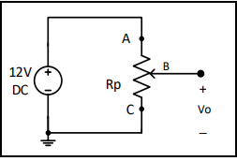  
 Figure 3.6

I = 12/10k = 1.2 mA

RAB = 12-3/1.2 mA = 7.5 kΩ

RBC = 3/1.2mA = 2.5 kΩ

3. For the circuit shown in Figure 3.7, use PSPICE to find the value of VO for RL = 1 kΩ, 10 kΩ, 100 kΩ, 500 kΩ.

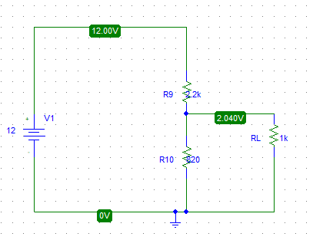

|  |  |  |  |  |  |
| --- | --- | --- | --- | --- | --- |
|  |  |  |  |  |  |

|  |  |  |  |  |
| --- | --- | --- | --- | --- |
| RL | 1k | 10k | 100k | 500k |
| V0 | 2.04 | 3.075 | 3.293 | 3.254 |

Part C: Current Divider 1. Simulate the circuit of Figure 3.8 using PSPICE to find the value of current in each resistor in the circuit

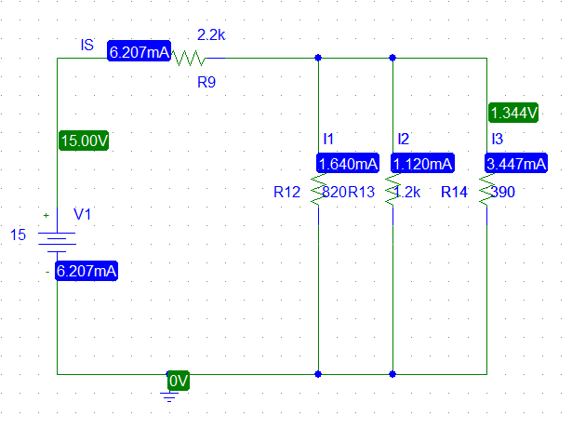

Figure 3.8

Part D: Short-and-Open Circuited Resistor in Series-Parallel Circuits 1. Simulate the circuit of Figure 3.9 using PSPICE to find the voltage across and the current through each resistor.

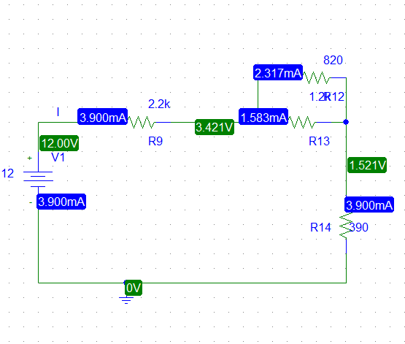

Figure 3.9