

**Birzeit University**

**Faculty of Engineering & Techonology**

**Department of Electrical & Computer Engineering**

**ENEE**

**“Prelab Exp#10”**

**Student : Mohamad Bornat #1130842**

**Instructor: Dr.Jasser Sa’ed**

**Date: 25\7\2016**

|  |  |  |
| --- | --- | --- |
|  |  |  |
| **Problem #1** |  |  |

**Transfer function**





|  |  |  |
| --- | --- | --- |
| **Problem 2** |  |  |

**Transfer Function :-**



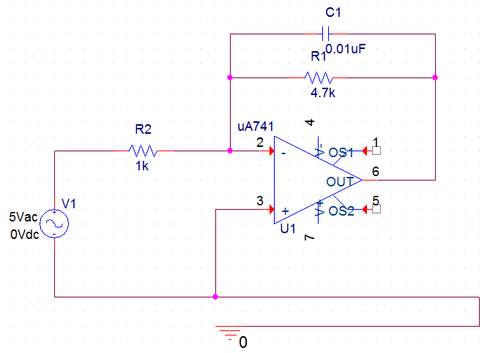

Frequency response



The same response of the previous circuit but in **db**, not that the fc is shown on the graph . (at -3dB of the max)



|  |  |  |
| --- | --- | --- |
|  |  |  |
| **Problem 3 Design** |  |  |

**The filter circuit to be designed is:-**



$$f_{c}=1k Hz .$$

$$k=1.5$$

$$k=\frac{R_{2}}{R_{1}}$$

let R1=1kohm

R2=R1*k = 1.5kohm

$$wc=\frac{1}{CR_{1}}$$

$C=\frac{1}{\left( R_{1} ×2πf_{c}\right)}=0.15uF≅0.1uF$

Transfer function:-







**K=1.5, R2=1.5kohm, R1= 1kohm**

**Simulation:note that the capacitor value was rounded to be 0.1uF this fc to increase but the available is o.1 uF**

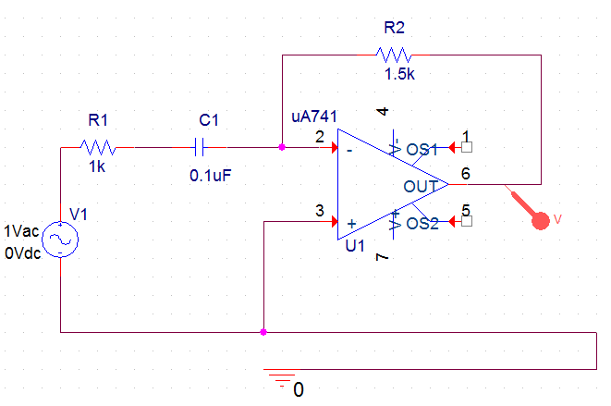

**Frequency response of the output :-**



**In DB**



|  |  |  |
| --- | --- | --- |
|  |  |  |
| **Problem 3** |  |  |

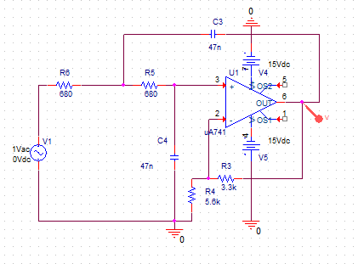

**Frequency response**

